Q..1 Haddpan Seal and Terracotta Figure and sealing of haddpan

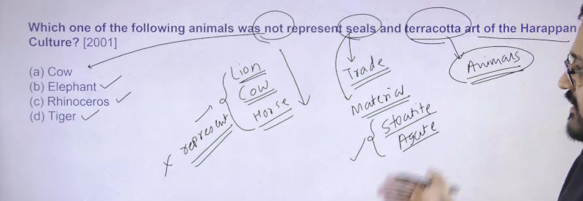
In the Indus Valley Civilization, sealing means the impression made by a seal on clay.
Merchants used seals to stamp wet clay placed on goods, containers, or trade packages. This clay impression is called a sealing.
- Seal → the carved object (usually made of steatite).
- Sealing → the clay impression made by pressing the seal on wet clay.
In the Harappan Civilization, a sealing refers to the clay impression made by pressing a seal on goods or packages to mark ownership and control trade.
Seals signify trade, and seals were used on trade cartons. They indicate Signify the large scale of trade at Harappan sites.

The materials used to make seals include steatite and agate. These are two types of stones used for making seals. Apart from these, different materials such as gold, copper, and bronze were also used to make seals. different type of material has also been used in order to make the seal
Terracotta figurines of different kinds of animals have also been discovered.
There are three type of animals that are not present on Harappan seals, such as the cow, lion, and horse. These three animals are not represented in Harappan art. Different types of animals have been depicted, but these animals have not. Animals like deer, buffalo, rhinoceros, and elephant are shown on the seals. Thus, various kinds of animals were depicted there.
These animals (cow, lion, and horse) are not represented on Harappan seals as well as in Harappan art.
This is the basic information regarding the seals and sealings of the Harappan civilization.
like deere is there buffalo is there rhino is there elephant is there so thes type of different kind of animal has been depicted there
It is believed that the seals were used for commercial purposes. A few seals were also carried as amulets, perhaps as a kind of identity card. All the seals have pictures of animals with something written in a pictographic script (which is yet to be deciphered).
Terracotta figurines in the Harappan Civilization indicate the religious beliefs, artistic skills, and aspects of daily life of the Harappan people.
Terracotta figures, particularly from ancient civilizations like the Indus Valley, indicate the following:
- Religious Beliefs: They commonly represent deities, such as the Mother Goddess, indicating fertility cults and worship practices.
- Daily Life & Culture: They depict animals, birds, and humans (including toys like carts), reflecting the daily life, fauna, and material culture of the period.
- Artistic Skills: They show the maturity and dexterity of artisans in modeling, detailing, and baking clay.
- Social Structure: The variety of figures (attendants, dancers) points to social diversity and clothing styles.
- Cultural Significance: They were often used as votive offerings, toys, or decorative, affordable art for common people.

Harappan seals indicate a highly organized society with advanced commerce, administrative control, and distinct religious beliefs. Primarily made of steatite, they were used to authenticate goods, representing ownership in trade, while their animal motifs (like the unicorn) suggest a structured bureaucracy.
- Commercial & Administrative Function: Used for sealing jars and tagging goods for trade, often found in Mesopotamian and Central Asian sites, confirming long-distance trade.
- Social & Political Structure: The "unicorn" motif, present on over two-thirds of seals, likely signifies elite, merchant, or administrative authority.
- Religious & Mythological Beliefs: The Pashupati seal (a yogic figure surrounded by animals) points to early religious practices, possibly a deity. Other seals show worship of a Mother Goddess, trees, and animals.
- Writing & Art: The undeciphered script, read right-to-left, suggests a sophisticated, literate society.
- Cultural Practices: Some, like the "amulet" seals, might have been worn to denote social status or for protection.

Harappan seals (mostly steatite, some terracotta) and terracotta figurines are foundational artifacts of the Indus Valley Civilization (c. 2500–1500 BCE), serving as essential tools for trade, identification, and religious expression. They depict animals (unicorns, bulls), deities, and undeciphered script, while terracotta represents Mother Goddesses and toys.
Harappan Seals
- Material and Shape: Primarily made of soft, heat-treated stone called steatite, though terracotta, agate, chert, faience, and ivory were also used. The standard seal is a 2x2 inch square.
- Purpose: Primarily used by merchants to stamp goods for trade (sealing, ), as well as amulets worn for identification or religious protection.
- Motifs: Features detailed, intaglio-style carvings of animals—most notably the unicorn, hump-less bull, rhinoceros, elephant, and tiger.
- Key Examples: The Pashupati Seal (proto-Shiva), the unicorn seal with inscription, and the Peepul Tree Seal.
- Significance: Evidence of script, religious beliefs, and international commerce.

Harappan Terracotta
- Nature: Terracotta (fired clay) was widely used due to its affordability and abundance.
- Figurines: Common figures include the Mother Goddess (symbolizing fertility), male deities, toys (whistles, carts, animals), and models of ploughs.
- Artistic Style: Often handmade, featuring, simple, stylized, and sometimes crude, designs.
- Seals and Sealings: While many seals were stone, some were made of terracotta. Terracotta sealings—clay impressions of seals—have been found, sometimes showing thread marks, indicating their use in securing goods.
- Usage: Used for religious worship, children's toys, and probably household decorative items.
These artifacts, found in cities like Mohenjo-Daro and Harappa, indicate a highly organized, artistic society with complex administrative and spiritual, practices.

हड़प्पा की मुहरें (Seals) मुख्य रूप से स्टीएटाइट (Steatite) नामक नरम पत्थर से बनी होती थीं, जिन पर नक्काशी (engraving) की जाती थी। ये 2500-1500 ईसा पूर्व के बीच सिंधु घाटी सभ्यता में व्यापार और प्रशासन के लिए उपयोग की जाती थीं। एगेट (Agate), तांबा, मिट्टी (terracotta) और हाथीदांत जैसी अन्य सामग्रियों का भी इस्तेमाल होता था, लेकिन स्टीएटाइट सबसे आम थी।
हड़प्पा की मुहरों के बारे में मुख्य बातें:
- सामग्री (Material): ज्यादातर मुहरें स्टीएटाइट (सॉफ्ट स्टोन) से बनी थीं, जिन्हें नक्काशी के बाद कठोर बनाने के लिए आग में पकाया जाता था।
- आकार (Shape): ये अक्सर वर्गाकार (square) होती थीं, लेकिन आयताकार और गोलाकार भी पाई गई हैं।
- नक्काशी (Carving): इन पर जानवरों (जैसे- बैल, हाथी, गैंडा) और मानव आकृतियों की बहुत सूक्ष्म नक्काशी होती थी।
- लिपि (Script): इन मुहरों पर एक चित्रात्मक (pictographic) लिपि अंकित है, जो आज तक नहीं पढ़ी जा सकी है।
- उपयोग (Usage): मुख्य रूप से व्यापार के लिए, वस्तुओं की पहचान और प्रशासन के लिए इनका उपयोग किया जाता था।
एगेट (Agate) और स्टीएटाइट (Steatite) में अंतर:
- स्टीएटाइट: यह एक नरम पत्थर है जो नदी के किनारों पर पाया जाता था। यह नक्काशी के लिए बहुत उपयुक्त था।
- एगेट (अगिया): यह एक कठोर, अर्ध-कीमती पत्थर (semi-precious stone) है, जिसका उपयोग भी मोहरों और मनकों (beads) के लिए किया जाता था, लेकिन स्टीएटाइट की तुलना में कम।
Heritage: Journal of Multidisciplinary Studies in Archaeology +3
निष्कर्ष: हड़प्पा की मुहरों के लिए स्टीएटाइट सबसे प्रमुख और मुख्य सामग्री थी, न कि एसीटेट (जो एक आधुनिक प्लास्टिक सामग्री है)।
- अन्य सामग्री: कुछ मुहरें टेराकोटा (पकी मिट्टी), तांबा, अगेट (गोमेद), चर्ट, हाथीदांत, और फेयेंस (Faience) से भी बनी पाई गई हैं।
हड़प्पा की मुहरें (Seals) मुख्य रूप से स्टीएटाइट (Steatite) नामक एक नरम पत्थर से बनाई जाती थीं, जिसे 'सोपस्टोन' (Soapstone) भी कहते हैं। यह पत्थर नक्काशी के लिए आसानी से उपलब्ध और मुलायम था। मुहरों को मजबूत बनाने के लिए अक्सर उन पर आग में पकाया जाता था।

Indus Valley Civilization (Harappa) me amulets chhote-chhote taabeez (lucky charms) hote the.
Amulets kya hote the (short me):
👉 Amulet = suraksha aur shubh ke liye pehna jane wala chhota object
Harappa me kaise hote the:
- Material: stone, faience, shell, copper se bane hote the
- Shape: janwar, devta jaisa design ya simple shapes
- Use:
  - buri nazar se bachne ke liye
  - protection ke liye
  - kabhi-kabhi fashion/jewellery ke roop me
Simple line:
👉 “Amulets Harappa me log apni suraksha aur good luck ke liye pehnte the.”
Agar chaho toh main examples ya images ke through aur clear kar sakta hoon 👍
Definitions from Oxford Languages · Learn more
New: Indic definitions

English & Hindi


amulet
‍ˈऐम्‌युलट्‌

noun
plural noun: amulets
a piece of jewellery that some people wear because they think it protects them from bad luck, illness, etc.
एक प्रकार का आभूषण जो बीमारी, दुर्भाग्य आदि से रक्षा करने के उद्देश्य से पहना जाता है तावीज़
Harappan amulets were small, often mass-produced objects used for protection, identity, or status, typically featuring animal, floral, or geometric shapes. Common types include molded faience figures, animal-shaped pendants, and copper tablets inscribed with script. These, along with steatite seals, were worn on the body and served as magical or identification markers.
Key Types of Harappan Amulets
- Figurines: Examples include a triple monkey amulet in a tight embrace and feline figures with feline faces, fangs, and horns.
- Copper Tablets: Rectangular or square tablets, often with an animal on one side and script on the other.
- Pendants: Animal or bird-shaped pendants, sometimes in the shape of marine shells.
- Geometric Shapes: Crescent-shaped, disc-shaped, and "gamesman" shaped pendants were common.
- Terracotta Masks: Various masks used as protective items.
Key Characteristics
- Materials: Frequently made of steatite (like seals), faience, terracotta, copper, ivory, and agate.
- Function: Many served as "amulets" when not in use as sealing instruments for trade. Some were likely worn as jewelry to signify status, protect from evil, or act as urban passports.
- Imagery: Often depicted "totemic" animals like the unicorn, tiger, rhinoceros, and zebu bull, or natural motifs like spikes and flowers.
Usage Context
Unlike jewelry that was passed down through families, ancient amulets were often worn for life and sometimes intentionally disposed of in burials or specific shrines, according to this article from Persée

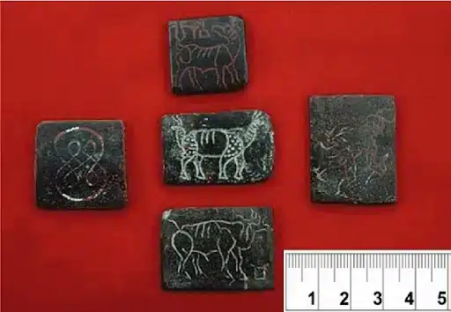ss
Harappan seals, numbering in the thousands and dating roughly 2500–1900 BCE, are small, mostly square (often
inches) soapstone (steatite) artifacts from the Indus Valley Civilization. Primarily used for commercial authentication by stamping clay on trade goods, they feature engraved animals (unicorns, bulls, elephants) and undeciphered pictographic script, including famous examples like the Pashupati and unicorn sealsKey Aspects of Harappan Seals:
- Materials: Predominantly soft, white steatite (baked to create a durable, glazed surface), though some were made of terracotta, gold, agate, ivory, and faience.
- Design and Structure: Standardized square shape with an engraved image on the front (intaglio) and a perforated "boss" (handle) on the back for wearing or carrying.
- Most Common Motifs: The "Unicorn" (a single-horned creature facing an altar-like structure) is the most frequent, followed by zebus (bulls), rhinoceroses, tigers, and elephants.
- The Pashupati Seal: A famous seal discovered at Mohenjo-daro showing a seated, possibly horned, figure in a yogic pose surrounded by animals (tigers, rhinos, buffalo, elephants), often interpreted as a "proto-Shiva," though this is debated.
- Purpose: Served to authenticate goods, acting as personal branding for merchants and traders. They were used for internal trade and found as far as Mesopotamia, indicating extensive maritime and land commerce.
- Script: Nearly all seals contain a short script of 3–400 known pictographic signs. It is believed to be written in a right-to-left direction.
These seals are crucial for understanding Harappan trade, administrative organization, and artistic traditions.

Seals of Harappan Civilization FAQs
QQ1. What type of figures are commonly depicted on the Harappan Seals?-
Ans. Harappan seals often depict animals, human figures, and mythological creatures in various artistic forms.

QQ2. What does the term "Proto-Siva Seal" of Harappan Civilization refer to?-

Ans. The "Proto-Siva Seal" refers to the Pashupati Seal, depicting an early form of Shiva.

QQ3. Which materials were primarily used to make Harappan seals?-

Ans. Harappan seals were primarily made from steatite and occasionally faience, a ceramic material.

QQ4. What is the significance of the Harappan Seals concerning trade and administration?-

Ans. Harappan seals were used for identifying goods and verifying transactions in trade and administration.

QQ5. What is the unicorn seal of Harappa?-

Ans. The unicorn seal depicts a single-horned creature, possibly representing a mythical or composite animal
नहीं, हड़प्पा की मुहरें (seals) सिर्फ एगेट (agate) और स्टीटाइट (steatite) की नहीं बनी थीं, हालांकि स्टीटाइट (soapstone) सबसे आम सामग्री थी। स्टीटाइट (नरम पत्थर) के अलावा, मुहरें टेराकोटा (पकी मिट्टी), तांबा, चर्ट, हाथीदांत, सोना और फ़ाइनेस से भी बनाई जाती थीं।
5
- मुख्य सामग्री: अधिकांश मुहरें स्टीटाइट से बनी होती थीं, जिन पर नक्काशी के बाद उन्हें कड़ा करने के लिए गर्म (fire) किया जाता था।
- अन्य सामग्रियां: एगेट, चर्ट, तांबा, टेराकोटा, और हाथीदांत।
- आकार: ज्यादातर मुहरें वर्गाकार (square) होती थीं, लेकिन आयताकार, गोलाकार और बेलनाकार मुहरें भी मिली हैं।
- चित्र: उन पर अक्सर जानवरों (बैल, गेंडा, बाघ) और एक अनपढ़ी लिपियों का चित्रण होता था।
हड़प्पा सभ्यता की मोहरें (Seals) मुख्य रूप से 2x2 इंच (लगभग
सेमी) के वर्ग आकार की होती थीं। हालांकि, कुछ मोहरें छोटी या बड़ी भी हो सकती थीं, जो मुख्य रूप से मुलायम पत्थर यानी 'सेलखड़ी' (Steatite) से बनी होती थीं और जिन पर एक सींग वाले जानवर (Unicorn) या पशुपति के चित्र होते थे।
हड़प्पा कालीन मोहरों की प्रमुख विशेषताएं:
- सामग्री: अधिकांश मोहरें सेलखड़ी (Steatite) से बनी होती थीं, लेकिन कुछ टेराकोटा, सोने, एगेट, चर्ट, हाथीदांत और फेयेंस से भी बनी होती थीं।
- आकार: अधिकांश मोहरें वर्गाकार (Square) थीं।
- औसत नाप: सबसे आम आकार लगभग
था।
- अन्य उदाहरण: मोहनजोदड़ो से मिली कुछ मोहरों का आकार लगभग
भी पाया गया है 3.56 cm by 3.53 cm।
- पशुपति मोहर: यह एक प्रमुख मोहर है जो वर्गाकार रूप में मिली।
- उपयोग: इन मोहरों का उपयोग मुख्य रूप से व्यापारिक गतिविधियों और संभवतः ताबीज के रूप में किया जाता था।
ये मोहरें सिंधु घाटी सभ्यता के व्यापारिक और सांस्कृतिक पहलुओं के बारे में महत्वपूर्ण जानकारी प्रदान करती हैं।
Seal banane ka process (short me):
- Material lena
Zyada tar seals steatite (soft stone) se banti thi.
- Shape dena
Pathar ko kaat kar chhota square/rectangle shape banate the.
- Design banana (engraving)
Upar janwar (jaise bull, unicorn) aur script (likhai) ko ulta (reverse) carve karte the.
- Polish aur heat karna
Seal ko smooth karke heat/fire me pakaya jata tha taki wo hard aur durable ho jaye.
- Use karna
In seals ko mitti (clay) par dabaya jata tha → mark ban jata tha (trading ya identification ke liye).

👉 Simple me:
Stone → shape → carving → heating → ready seal
Agar chaho toh main diagram ya image se bhi samjha sakta hoon 👍
stone ko pakane per wo tuta tonahi tha
Achha question hai 👍
Short answer:
👉 Nahi, stone toot ta nahi tha — kyunki usse sahi tareeke se aur controlled heat me pakaya jata tha.
Kaise nahi tootta tha:
- Soft stone use hota tha (steatite)
Ye pehle se hi naram hota hai, isliye carving aasaan hoti hai.
- Dheere-dheere heat karte the
Achanak tez aag me nahi dalte the → warna crack aa sakta tha.
- Controlled temperature
Ek fixed temperature par pakate the jisse stone hard aur strong ho jata tha.
- Chemical change hota tha
Heat ke baad steatite aur zyada tough (ceramic jaisa) ban jata tha.

👉 Simple line:
“Sahi temperature aur dheere heating ki wajah se stone toot ta nahi, balki aur strong ban jata tha.”
Agar tum chaho toh main bata sakta hoon ki wo kitne temperature par pakate the 👍

Steatite, commonly known as soapstone, is a soft, metamorphic rock primarily composed of talc, making it rich in magnesium silicate. Renowned for its smooth, greasy feel and easy carveability, it has been used since ancient times for carving seals, beads, and pots. It is highly heat-resistant, durable, and used today in ceramics, electrical insulators, and cookware.

हड़प्पा मुहरों (Harappan seals) पर दिखने वाला 'यूनिकॉर्न' (Unicorn) एक पौराणिक, एक सींग वाला जानवर है, जो सिंधु घाटी सभ्यता की सबसे आम और महत्वपूर्ण सील आकृति है। यह संभवतः कुबड़ रहित बैल, नीलगाय या गज़ेल का मिश्रित रूप है, जिसके गले में पट्टा, धनुषाकार सींग और एक पवित्र पात्र (offering stand) के सामने खड़ा दिखाया जाता है।
हड़प्पा सील के यूनिकॉर्न की मुख्य विशेषताएं:
- सबसे लोकप्रिय प्रतीक: यह यूनिकॉर्न मुहरों में सबसे आम रूपांकन है, जो मोहनजो-दारो और अन्य स्थलों से बड़ी संख्या में पाई गई हैं।
- चित्रण और बनावट: इसमें एक सींग वाला जानवर है, लेकिन इसकी बनावट मृग या गज़ेल जैसी नाजुक होती है और बैल जैसे खुर होते हैं। इसकी गर्दन धनुषाकार होती है और उस पर पीपल के पत्ते के आकार का एक कंबल या आभूषण उकेरा गया होता है।
- पौराणिक महत्व: यह शायद कोई वास्तविक जानवर नहीं, बल्कि एक काल्पनिक या दिव्य प्राणी है, जो प्राचीन फेसबुक के इस समूह पोस्ट के अनुसार, व्यापार या धार्मिक उद्देश्यों के लिए इस्तेमाल किया जाता था।
- पवित्र पात्र (Offering Stand): यूनिकॉर्न के सामने हमेशा एक विशिष्ट अनुष्ठानिक वस्तु/पात्र (जिसे 'पवित्र अंगीठी' या 'फिल्टर' कहा जाता है) होती है, जिसके ऊपर तरल बूंदें दिखाई देती हैं।
- व्यापार और रूतबा: यह मुहरें शायद उच्च वर्गीय व्यापारियों, धार्मिक नेताओं, या प्रशासनिक वर्ग (Elite/Ruling class) का प्रतीक थीं, जो शासन और व्यापारिक नेटवर्क को नियंत्रित करते थे।
कुछ विद्वानों का मानना है कि यह एक सींग वाली आकृति वास्तव में दो सींगों वाले जानवर को पार्श्व (side) दृश्य से दिखाने की एक शैली हो सकती है
हड़प्पा (मोहनजोदड़ो) से प्राप्त 'पशुपति मुहर' (लगभग 2500 ईसा पूर्व) एक स्टीएटाइट पत्थर की मुहर है, जिसमें एक योगी को योग मुद्रा (पालथी मारकर) में बैठे हुए दिखाया गया है। इसे शिव के प्रारंभिक रूप या "आदि-शिव" (Proto-Shiva) माना जाता है, क्योंकि वे पशुओं के स्वामी की तरह जंगली जानवरों (बाघ, हाथी, गैंडा, भैंस) से घिरे हैं।
पशुपति मुहर की मुख्य विशेषताएं:
- स्थान और सामग्री: यह मोहनजोदड़ो से प्राप्त हुई थी और मुख्य रूप से स्टीएटाइट पत्थर से बनी है।
- चित्रण: केंद्रीय आकृति के सिर पर सींग वाला मुकुट है, और वह योग मुद्रा में बैठी है।
- पशु: दाईं ओर हाथी और बाघ, बाईं ओर गैंडा और भैंस, और नीचे दो हिरण बैठे हैं।
- महत्व: इसे सिंधु घाटी सभ्यता का सबसे प्रमुख कलाकृति माना जाता है, जो प्रारंभिक धार्मिक विश्वासों को दर्शाती है।
हालांकि कुछ विद्वान इसे 'पशुपति' (पशुओं के भगवान) के रूप में शिव का सबसे पुराना चित्रण मानते हैं, लेकिन अन्य लोग इसे सिर्फ एक योगिक या तांत्रिक आकृति भी मानते हैं।
The Pashupati seal is a 4,500-year-old steatite artifact from the Indus Valley Civilization (c. 2500 BCE) found at Mohenjo-daro. It depicts a three-faced, horned figure sitting in a yoga pose (mulabandhasana) surrounded by animals. Widely considered a "Proto-Shiva" or "Pashupati" (Lord of Animals) seal, it is a key piece of evidence for early yoga and worship practices.
Key Details of the Pashupati Seal:
- Discovery: Found during the 1928–29 excavations at Mohenjo-daro, now housed in the National Museum, New Delhi.
- Depiction: A central seated human figure wearing an elaborate horned headdress. The figure is interpreted by some as having three faces and seated in a complex yoga pose, often called mulabandhasana.
- Surrounding Animals: The figure is surrounded by four wild animals: a tiger, a rhinoceros, an elephant, and a buffalo. Two deer are depicted beneath the throne.
- Interpretation: Sir John Marshall dubbed it the "Pashupati seal," interpreting it as a prototype of the Hindu god Shiva, representing him as the "Lord of Animals," a form of a yogi.
- Significance: It serves as evidence of advanced yoga practices and potential early religious traditions resembling Shiva worship in the Indian subcontinent's history.
Note: Some scholars hold more cautious views, stating that the interpretation of the figure as a "yogi" or "proto-Shiva" is speculative, and the script on the seal remains undeciphered Facebook post.

टेराकोटा (पकी हुई मिट्टी) की मूर्तियों और अवशेषों में हमें प्राचीन सभ्यताओं (विशेषकर सिंधु घाटी) से मानव आकृतियाँ (जैसे 'मदर गॉडेस'), बैल, बंदर, कुत्ते और बकरियों के खिलौने मिले हैं। इनके अलावा, पहियेदार गाड़ियां, सीटी, सजावटी बर्तन, ताबीज, गहने और मिट्टी के पाइप भी टेराकोटा कला के प्रमुख अवशेष हैं।
टेराकोटा अवशेषों से मिली मुख्य चीजें:
- मानव आकृतियाँ: मुख्य रूप से मातृदेवी (Mother Goddess) की मूर्तियां मिली हैं, जो गर्भ, उर्वरता और कृषि से संबंधित मानी जाती हैं। ये मूर्तियां हाथ से बनी हैं और कुछ साँचे से भी।
- पशु आकृतियाँ: बुल (बैल), हाथी, भेड़, और गेंडे के खिलौने या मूर्तियां बहुत अधिक मात्रा में पाई गई हैं।
- खिलौने और मनोरंजन: टेराकोटा से बने पहिये वाले पशु, सीटी, रैटल (झुनझुने), और छोटी गाड़ियां मिली हैं, जो बच्चों के खिलौनों के रूप में इस्तेमाल होती थीं।
- घरेलू वस्तुएं: मिट्टी के बर्तन, सजावटी वस्तुएं, चूड़ियां, और मालाएं।
- अन्य: मोहरें, ताबीज और ड्रेन पाइप (अपशिष्ट जल पाइप)।
टेराकोटा कला की विशेषताएं:
- निर्माण तकनीक: मूर्तियों को हाथ से गूंथकर (Hand-modeled) और साँचे (Mould-made) दोनों तरह से बनाया जाता था।
- सामग्री: प्राकृतिक मिट्टी को धूप में सुखाकर फिर भट्टी में पकाया जाता है, जिससे यह लाल-भूरे रंग की मजबूत आकृति बन जाती है।
- सांस्कृतिक महत्व: ये कलाकृतियां प्राचीन समय में धार्मिक रस्मों, घरेलू सजावट और बच्चों के खेल के लिए उपयोग की जाती थीं।

Indus Valley Civilization (IVC) seals (c. 2500–1500 BCE) were predominantly small, square-shaped, and crafted from fired steatite, featuring an undeciphered pictographic script and intricate carvings of animals like unicorns, bulls, and elephants. Primarily used for trade (marking goods), administration, and personal identification, thousands have been found in the Indus region and Mesopotamia.
Key Features of Indus Seals
- Primary Material: Mostly made of soapstone (steatite), which hardened upon firing. Other materials include terracotta, agate, copper, ivory, and occasionally gold.
- Shape and Size:
Standard seals were square with a
inch dimension. Other shapes included rectangular and circular, often featuring a perforated boss (button) on the back for handling or carrying.
- Motifs: Often depicted animals in profile, including unicorns, humped bulls, elephants, rhinos, tigers, and goats.
- Script: Nearly all seals possess a brief, undeciphered pictographic script.
- Most Famous Example: The "Pashupati Seal" found in Mohenjo-daro, depicting a human figure sitting in a yogic pose with animals (elephant, tiger, rhino, buffalo) surrounding him.
Functions and Significance
- Trade and Commerce: Used for sealing clay tags on trade goods, acting as personal or guild branding to identify ownership.
- Cultural Exchange: Numerous seals have been found in ancient Mesopotamian cities, proving direct trade links.
- Religious Significance: Many seals were likely used as amulets or tokens to represent religious beliefs.
Discovery
- The first unusual "stone seal" was documented by Alexander Cunningham in 1875.
- Their discovery in the 1920s was crucial in helping archaeologists like Sir John Marshall identify the Indus Valley as a new, distinct ancient civilization.
Cambridge University Press & Assessment
हड़प्पा सभ्यता की मुहरें मुख्य रूप से मोहनजोदड़ो और हड़प्पा (पाकिस्तान) से मिली हैं, जहाँ 90% से अधिक मुहरें खोजी गई हैं। अन्य महत्वपूर्ण स्थलों में लोथल (गुजरात), धोलावीरा (गुजरात), कालीबंगन (राजस्थान), और चनहुदड़ो शामिल हैं। ये मुहरें (ज्यादातर सेलखड़ी/स्टीटाइट से निर्मित) व्यापार और पहचान के लिए इस्तेमाल की जाती थीं।
मुख्य स्थल जहाँ से मुहरें प्राप्त हुईं:
- मोहनजोदड़ो (सिंध, पाकिस्तान): यहाँ से प्रसिद्ध पशुपति मुहर और 'यूनिकॉर्न' (एक-श्रृंगी) वाली मुहरें मिली हैं।
- हड़प्पा (पंजाब, पाकिस्तान): यहाँ से भी भारी मात्रा में मुहरें और उत्कीर्ण वस्तुएं मिली हैं।
- लोथल (गुजरात, भारत): यह एक प्रमुख बंदरगाह था, यहाँ से मेसोपोटामिया और फारस की खाड़ी की मुहरें (फारसी सील) मिली हैं, जो व्यापारिक संबंध दर्शाती हैं।
- धोलावीरा (गुजरात, भारत): यहाँ से विभिन्न प्रकार की मुहरें मिली हैं।
- कालीबंगन (राजस्थान, भारत): यहाँ से भी मुहरें मिली हैं, जो इस क्षेत्र में व्यापार की पुष्टि करती हैं।

हड़प्पा की मुहरें (Seals) मुख्य रूप से मेसोपोटामिया की सभ्यता (आधुनिक इराक, कुवैत और सीरिया के हिस्से) में पाई गई हैं, जो उनके व्यापारिक संबंधों को दर्शाती हैं। इसके अलावा, ये फारस की खाड़ी (Persian Gulf) और मध्य एशिया (Central Asia) के प्राचीन स्थलों पर भी मिली हैं। ये मुहरें बताती हैं कि हड़प्पावासी सुमेरियाई सभ्यता के साथ व्यापार करते थे।
प्रमुख विवरण:
- मेसोपोटामिया (Mesopotamia): सुसा (Susa) और उर (Ur) जैसे शहरों में हड़प्पा की मुहरें मिली हैं।
- फारस की खाड़ी (Persian Gulf): यहां से भी सील मिली हैं।
- मध्य एशिया (Central Asia): पुरातत्वविदों को यहाँ भी ये मुहरें मिली हैं।
- साक्ष्य: Nippur (निप्पुर) में एक सील मिली है जिस पर हड़प्पा की लिपि और एक यूनिकॉर्न (एक सींग वाला जानवर) बना है।

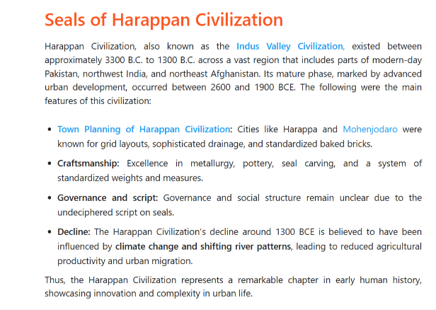
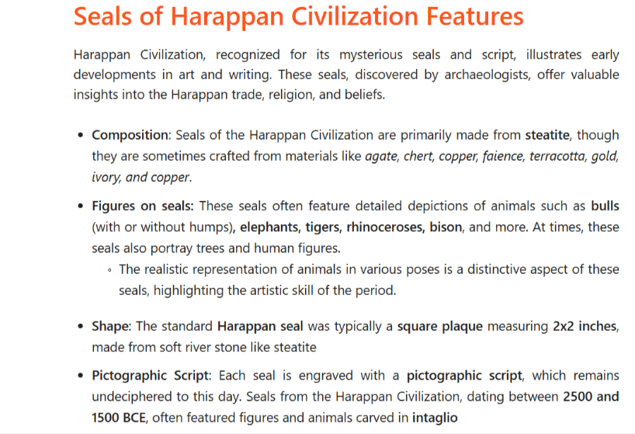
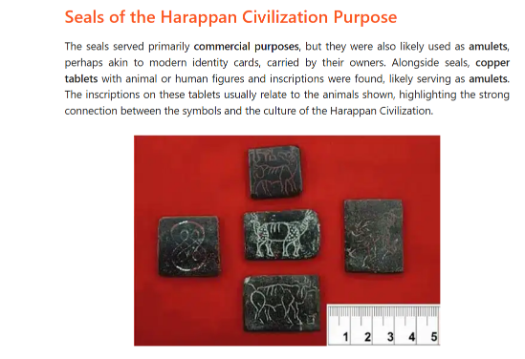

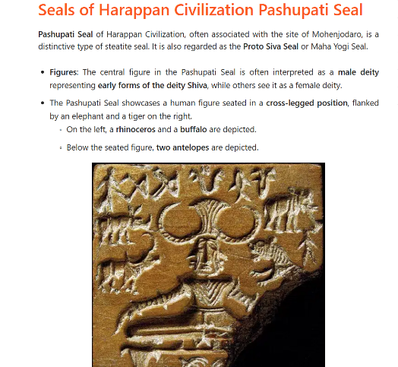
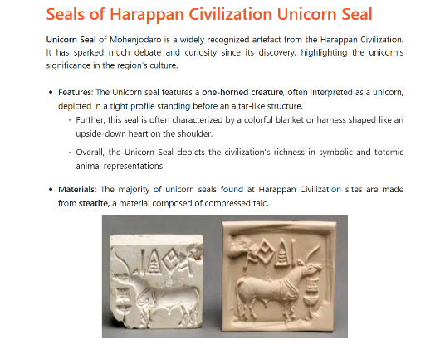
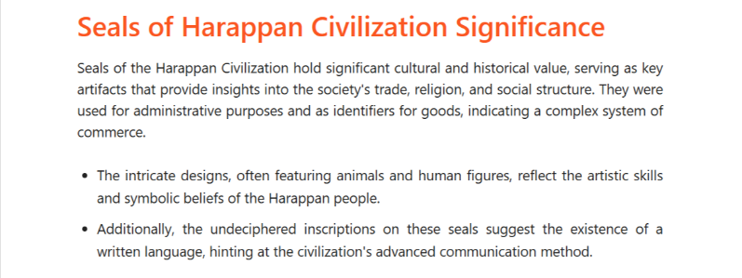

Q..2 Fire Altar= Lothal+Kalibanga+ Banawali
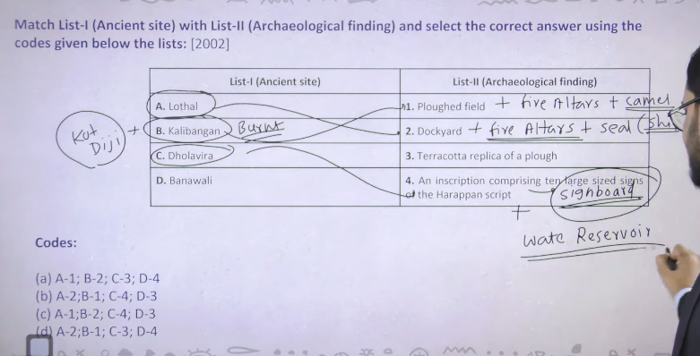

  - Lothal – Gujrat is quiet famoaus because of Dockyard +Fire altar +Seal (ship) different type of ship are represented so ship boat is representd on lothal seal. so fire altar signify that there was some sort of religion is there

  - Kalibangan -Rajasthan - Ploughed field + fire altars + bones of camel

  - Kalibanga fire altars suggesting ritualistic practices, a two-part fortified city (citadel/lower town), camel bones, and evidence of an early earthquake that ended the pre-Harappan settlement.

  - Rakhigarhi, the largest Harappan site (5th–3rd millennium BCE) in Haryana, India, is composed of seven (or possibly eleven) interconnected mounds.

- Lothal, is famously known for the discovery of a joint/couple burial (shared pit with both male and female skeletal remains).

Kalibangan & Kotdiji- Burnt City
Apart from this kalibang town is find as burn twon jala hua town and yaha se jail hue chudyia bhe mile ahi and ye haddpan town pura ka pura jala hua mila hai
Kotdiji= ye town bhe hume pura jala hua mila hai ye Pakistan me hai

  - Banawali- Haryaan – Terracota Hal Plough

  - Dholaveera –Gujrat- Sign Board + Water reseivoire (tank) total 6 + dholaverea ke street ke upar ek sign board mila hai
Dhola verea se hume 6 water reservioir mile hai inke beauty ye hai ki ye 6 ke 6 vo reservoir underground pipe line se ek dusre se connected haii water of one reservioir can be transferred to the another reservoir via using this underground pipe line
Jisse ye pata chalta hia key aha ek elaborate political centere hote hoge
Dholavira is located in the Kachchh district of Gujarat, India. Situated on the arid island of Khadir Bet, this UNESCO World Heritage Site is a major, well-preserved Harappan-era city known for its sophisticated water management system and unique urban planning. It is one of the five largest Harappan sites in the subcontinent.

Gujarat – Dholaveera + Lothal

Indus Valley Civilization में fire altars (अग्निकुंड) कुछ प्रमुख स्थलों पर मिले हैं:
Fire altars, representing specialized, raised, brick-lined ritualistic structures, were predominantly found in the Harappan cities of Kalibangan (Rajasthan) and Lothal (Gujarat). Evidence suggests they were also present at other sites like Banawali and Rakhigarhi.
- Kalibangan: Excavations revealed a series of mud-brick platforms with rows of fire altars (about seven in one complex) containing terracotta cakes and bones, suggesting community fire rituals.
- Lothal: These were found in residential, high-status courtyard areas, indicating domestic or small-group ritualistic use.
- Significance:
These structures are generally attributed to the late Harappan phase and indicate ritualistic practices involving fire, often associated with the presence of immigrants.

Q..3 Religion in Indus valley-Materialistic Civilization
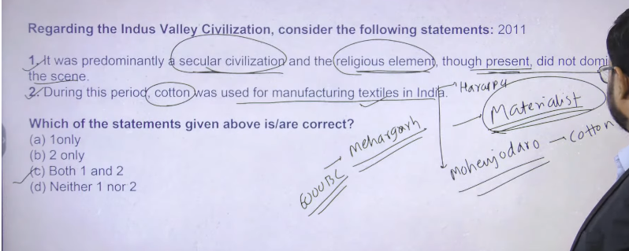

सिंधु घाटी सभ्यता मुख्य रूप से एक धर्मनिरपेक्ष (secular) सभ्यता थी, और यद्यपि उसमें धार्मिक तत्व मौजूद थे, लेकिन वे समाज के पूरे जीवन पर हावी नहीं थे।
सरल भाषा में मतलब 📚
- इस सभ्यता में धर्म मौजूद था (जैसे देवी-देवताओं की मूर्तियाँ, मुहरों पर धार्मिक चिन्ह)।
- लेकिन पूरी सभ्यता धर्म पर आधारित नहीं थी।
- लोगों का ध्यान व्यापार, नगर योजना, प्रशासन और दैनिक जीवन पर अधिक था।
✅ Short meaning:
सिंधु घाटी सभ्यता में धर्म था, लेकिन वह समाज और जीवन के हर हिस्से पर हावी नहीं था।

Secular (धर्मनिरपेक्ष) का मतलब:
👉 जहाँ धर्म सबसे ज़्यादा महत्वपूर्ण चीज़ न हो।
मतलब लोग सिर्फ धर्म के बारे में ही नहीं सोचते, बल्कि
- व्यापार करते हैं
- शहर बनाते हैं
- रोज़मर्रा का जीवन जीते हैं
उदाहरण (Indus Valley Civilization)
इस सभ्यता में
- धर्म था (देवी-देवता की मूर्तियाँ मिली हैं)
- लेकिन पूरी सभ्यता सिर्फ धर्म पर आधारित नहीं थी
✅ एक लाइन में:
Secular = जहाँ धर्म जीवन की सबसे बड़ी या मुख्य चीज़ नहीं होता।
“Got an idea” का हिंदी में मतलब है: 👉 “समझ में आ गया” 👉 “मुझे विचार/आइडिया मिल गया”
Example:
- Now I got an idea.
अब मुझे समझ में आ गया / अब मुझे एक आइडिया मिल गया। 😊

Indus valley civilization ko materialistic civilization bhe bola jata hai
Materialistic civilization ka matlab hota hai ke apke civilization me jo puja aur jine bhe religious element hai wo ku kyia jate ahi
There are two kind of puja ek puja bhakit aur moksh ke lyie hote hai jitney bhe sadhu sanyasi ya preiettsly class hai wo puja archana karta hua milega
Dusre puja puja matieralsitic chezao ke prapt ke lyei ya sansareek such ke prapte k lyie ke jate hai
So ultimate purpose of your life is something that determine character of your religioun means agar app dharm ke peechoe ho leking kudh ke material gain k lyie ho to wo materiasitc religion hoga aur agar apke civilization me maxiumum log yahe soch rakhte hai to app usko bologe materialsitc civilization
Like today ka india bhe materialsitc hai kuki hum jo puja archana karte hai wo world ke pleasure ko gain krne k lyie krte hai
1 Religious element hai wo socity me dikhente hai but uska utna society per asar nahi padta hai moksh is something that is secondary purpose so first statement is correct
2 cotton ka jo earliest evidence mila hai wo hum logo ko mehrgarsh (Pakistan ) 6000 BCE onward
By the time of haddpan civilization we can see that inke paas cotton textile tha ki haddapan ke jo toys the wo terracotta toys ke bante the jin per unhone kapde bhe pahna kr rakhe hai
Haddpan se bahut sare spindle holes bhe mile hia jo kapde seene k lyie use hote the
Textile – means kapda

Mohnjado se hum eke cotton ka cloth bhe mila hai
Acorosss the Indus valeey civlizaiton jo teracotta figure hai un per kapdo ke design bhee mile hai

Earliest evidence of Cotton production is

The earliest evidence of cotton, dating to the 6th millennium BC (roughly 6000-5000 BC), was found at the Neolithic site of Mehrgarh in Pakistan. Mineralized cotton fibers were discovered inside copper beads, indicating the use of this textile plant thousands of years before its widespread cultivation in the Indus Valley Civilization.
- Earliest Evidence (6th Millennium BC): Mineralized fibers found at Mehrgarh, Kachi Plain, Pakistan, inside a string of copper beads.
- Significance: Pre-dates evidence of cotton cultivation and textile use, suggesting an early origin in South Asia.
- Other Early Finds: While the earliest is in Pakistan, evidence of cotton fibers (possibly traded) has been found in the Near East at Tel Tsaf, Jordan Valley, dating to around 5,200 BCE.
- Later Evidence: Cultivated cotton, specifically Gossypium arboreum, was well established in the Indus Valley (Mohenjo-daro) by 2600-1900 BC.
सबसे प्राचीन सूती कपास (cotton) के प्रमाण, जो छठी सहस्राब्दी ईसा पूर्व (लगभग 6000–5000 ईसा पूर्व) के हैं, पाकिस्तान के नियोलीथिक स्थल महरगढ़ (Mehrgarh) में पाए गए। तांबे के मोतियों (copper beads) के अंदर खनिजीकृत (mineralized) सूती तंतु (fibers) की खोज हुई, जो यह दर्शाती है कि इस कपास का उपयोग हज़ारों साल पहले ही हो रहा था, इससे पहले कि यह व्यापक रूप से सिंधु घाटी सभ्यता में उगाई जाने लगी।
प्रमुख बिंदु:
- सबसे प्राचीन प्रमाण (6वीं सहस्राब्दी ईसा पूर्व): महरगढ़, काची मैदान (Kachi Plain), पाकिस्तान में तांबे की मोतियों के तार में खनिजीकृत तंतु पाए गए।
- महत्त्व: यह सूती कपास की खेती और वस्त्र निर्माण के प्रमाण से पहले का है, जिससे यह स्पष्ट होता है कि दक्षिण एशिया में इसका शुरुआती उपयोग हुआ।
- अन्य प्रारंभिक खोजें: जबकि सबसे पुराना प्रमाण पाकिस्तान में मिला, कुछ सूती तंतु (संभवतः व्यापार के माध्यम से) नियर ईस्ट (Near East) के टेल त्साफ (Tel Tsaf), जोर्डन वैली (Jordan Valley) में लगभग 5200 ईसा पूर्व पाए गए।
- बाद का प्रमाण: खेती की गई कपास, विशेषकर Gossypium arboreum, सिंधु घाटी (Mohenjo-daro) में 2600–1900 ईसा पूर्व तक अच्छी तरह से स्थापित हो चुकी थी।
हाँ, मैं समझाता हूँ कि तांबे की मोतियों (copper beads) में सूती तंतु कैसे मिले। 😊
- तांबे की मोतियाँ और सूती तंतु:
  - महरगढ़ (Mehrgarh) में तांबे की छोटी मोतियाँ बनाई जाती थीं।
  - इन मोतियों को धागे या सूत (cotton fibers) के साथ बांधा या गूँथा जाता था।
  - समय के साथ, धागा सड़ कर खनिजीकृत (mineralized) हो गया, लेकिन उसका निशान अभी भी मिट्टी में बचा रहा।
- खनिजीकरण की प्रक्रिया:
  - मिट्टी और नमक तत्वों के कारण धागे धीरे-धीरे खनिजों में बदल गए।
  - वैज्ञानिकों ने माइक्रोस्कोप और रासायनिक परीक्षणों से यह पता लगाया कि ये तंतु सच्ची सूती कपास के हैं।
- संक्षेप में:
तांबे की मोतियों के साथ बंधे पुराने सूती धागों के खनिजीकृत अवशेष वैज्ञानिकों को मिले। इसका मतलब है कि उस समय लोग कपास से धागा बनाकर मोतियों या गहनों में इस्तेमाल करते थे।
अगर तुम चाहो तो मैं इसे एक लाइन में आसान हिंदी में समझा दूँ कि “क्यों और कैसे सूती तंतु तांबे की मोतियों में मिला”।
क्या मैं ऐसा कर दूँ?
minieralize hokar to saad gyay hoga fir kaise
बिलकुल, ये थोड़ी जटिल लेकिन दिलचस्प प्रक्रिया है। 😄
खनिजीकृत (mineralized) होना मतलब यह नहीं कि पूरी चीज़ मिट गई।
- ख़ास बात:
  - जब सूती धागा (cotton fiber) मिट्टी में या किसी धातु/मोटियों के पास पुराना हो गया,
  - उस पर धीरे-धीरे खनिज (minerals) जमा हो गए, जैसे कैल्शियम, सिलिका, लोहा या तांबे के आयन।
- क्या हुआ:
  - धागा सड़ तो गया, यानी उसका जैविक हिस्सा नष्ट हो गया।
  - लेकिन खनिज उस धागे के आकार और निशान को बचा लेता है, जैसे कोई ढांचा (impression)।
- वैज्ञानिक इसे कैसे पहचानते हैं:
  - माइक्रोस्कोप और रासायनिक विश्लेषण से पता चलता है कि यह पहले कपास था, सिर्फ उसका जैविक हिस्सा अब खनिज में बदल गया है।
✅ संक्षेप में आसान भाषा में:
सूती धागा सड़ गया, लेकिन मिट्टी और खनिजों ने उसका आकार और निशान बचा लिया, इसलिए वैज्ञानिक इसे पहचान सकते हैं।
अगर चाहो, मैं इसे एकदम छोटा, exam में लिखने लायक लाइन में भी बता दूँ।
क्या मैं बता दूँ?
Create your first image
Got an idea? Try one of our new curated styles and filters or imagine something from scratch.
Try now

The Indus Valley Civilization (IVC) provides the earliest known evidence of cotton cultivation and textile production, dating back to roughly 7000 BCE at Mehrgarh, Pakistan. Evidence includes charred cotton seeds, fibers, and mineralized cloth fragments found on copper beads, silver jars, and tools like spindle whorls at sites like Mohenjo-daro and Harappa.
Key Evidence of Cotton in the IVC:
- Earliest Evidence: The oldest evidence of cotton, Gossypium arboreum, was discovered in a 6th/7th millennium BCE Neolithic burial at Mehrgarh in Balochistan, where cotton was found attached to a copper bead.
- Textile Artifacts: Fragments of cotton cloth were discovered at Mohenjo-daro (c. 2600–1900 BCE), with some attached to a silver vase, indicating developed, skilled, and potentially dyed textile production
.
- Production Tools: Numerous spindle whorls, used for spinning yarn, have been found in abundance at major sites, pointing to a widespread, well-established cotton industry.
- Cultivation Evidence: Charred cotton seeds have been excavated at Mehrgarh, confirming early domestication of the crop.
- Trade and Use: Cotton was likely a major trade commodity for the Harappans, connecting them to Mesopotamia. It was used to make textiles for clothing, with evidence from figurines suggesting both simple and elaborate garments.
The Harappans were among the first in the world to master the, cultivation, spinning, and weaving of cotton, laying the foundation for the region's long history of cotton textiles.

The earliest evidence of cotton dates back to the 6th millennium BCE (approx. 6000-5000 BCE) at Mehrgarh, Pakistan. Archaeological finds, including mineralized cotton threads inside copper beads, indicate that early inhabitants of the Indus Valley cultivated and processed cotton. Early tools included spindle whorls, bone, and wood implements for weaving.
Earliest Evidence of Cotton
- Location: Mehrgarh, Balochistan (Pakistan), in the Indus Valley.
- Time Period: 6th Millennium BCE (c. 6000–5000 BCE).
- Findings: Mineralized cotton threads, seeds, and early fabric impressions.
- Other Early Sites: Peru (approx. 6000 BCE - Gossypium barbadense) and Tel Tsaf in the Jordan Valley (c. 5200 BCE).
- Ancient Civilization Usage: The Indus Valley Civilization (Harappa/Mohenjo-daro) cultivated and traded Gossypium arboreum.
Early Tools Used for Cotton Processing
- Spindle Whorls: Used for spinning raw fiber into yarn, frequently discovered at Indus Valley sites like Mohenjo-daro.
- Bone and Wood Tools: Used in weaving and textile production.
- Hand Processing: Cotton was traditionally cleaned and processed by hand for thousands of years before mechanical inventions.
Cotton was commonly referred to as "tree wool" and was a highly valued, luxurious, and breathable fabric in the ancie
Indus Valley Civilization में टेक्सटाइल (कपास और अन्य कपड़ों) बनाने के लिए उपयोग किए जाने वाले उपकरण निम्न थे:
- Spindle whorls (सुतली/सुई की चक्की)
  - धागा (thread) बनाने के लिए इस्तेमाल होता था।
  - मिट्टी या पत्थर के छोटे गोल डिस्क, जिन्हें spindle पर लगाया जाता था।
- Needles (सुई)
  - जानवरों की हड्डी या कांस्य की सुई से कपड़े सिलने या सजाने के काम आते थे।
- Looms (करघा)
  - कपड़े बुनने के लिए लकड़ी के सरल करघे।
  - कुछ खंडित लकड़ी और धागे के अवशेष मिले हैं, जिससे बुनाई का प्रमाण मिलता है।
- Beads and threads (मोतियाँ और धागे)
  - कपड़े, आभूषण या सजावट में इस्तेमाल।
  - धागा बनाने और मोतियों को जोड़ने के लिए।
- Stone/terracotta weights (पत्थर या टेराकोटा के वजन)
  - करघे में धागा तानने के लिए।
✅ Short exam answer:
Harappan Civilization में कपड़ा बनाने के लिए spindle whorls, needles, looms, threads, beads और weights जैसे उपकरण इस्तेमाल होते थे।
अगर चाहो तो मैं इसे एक लाइन में सबसे आसान ढंग से भी लिख दूँ।
Get smarter responses, upload files and im

Q..4 Religion in Indus
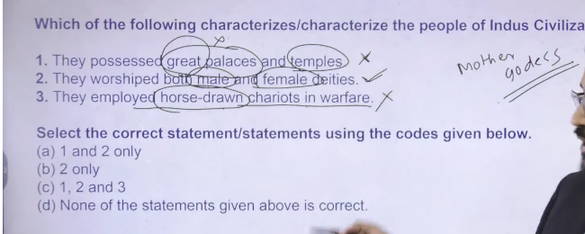
- hum logo ko tmple and palaces mile hai but the extremist of th e statement negates the entire statement that jo temple and palace the wo great nhi the so hum logo ko temple and palace dono mile hai but wo great nhai the
- so palaces were there and temple were there but greatness not found
- worship mother goddess earliest mothere goddess element found from Neolithic settlement of mehrgarh
- we have got the certain evidence of mother goddess on chaloclithc , neolithc and haddpan time
- male worship is genetal of male
- haddpan ke pahele Neolithic and chalogithci india n seletelemtn me wahah per hose ke evidence find hue hai but haddapna se hume horse kaoi koi evidence nhi mila hai it is still matter of debate so hadpan se hume lion and horse ke evidence nhai mile hai
Indus Valley Civilization (IVC) people worshipped a variety of deities, likely centered on a Mother Goddess (representing fertility) and a male "Proto-Shiva" or Pashupati figure, often depicted on seals in a yogic pose surrounded by animals. Nature worship was prominent, including the Pipal tree, animals (bulls), and possibly water.
Key Deities and Religious Beliefs:
- Mother Goddess: Numerous terracotta figurines suggest a dominant fertility cult.
- Pashupati (Proto-Shiva): A three-faced, horned male deity seated in a yogic posture, surrounded by animals (elephant, tiger, buffalo, rhinoceros, deer), found on the famous Pashupati seal.
- Nature and Animal Worship: Reverence for the Pipal tree (often associated with a deity), bulls (often with one horn), snakes, and other animal figures.
- Symbolism: Use of symbols like the swastika and potentially phallic stones (lingas).
- Rituals: Evidence points to ritual bathing (suggested by the Great Bath at Mohenjo-Daro).
While some early researchers suggested direct links to modern Hinduism (e.g., Shiva, Shakti), modern scholars note that without deciphering the script, the exact meanings and names of these deities remain speculative.

1. प्रमुख देवी-देवता (Deities)
- मदर गॉडेस (Mother Goddess) – उर्वरता (fertility) और मातृत्व की प्रतीक।
- सती देवता/ब्रह्मा जैसे देवता – जानवरों, साँप और हाथी से जुड़े चिन्ह मिले।
- प्रकृति पूजा – पेड़, पानी और जानवरों का सम्मान।
2. धार्मिक चिन्ह और प्रतीक
- मुहरों (seals) पर सिंह, हाथी, बैल, नाग, योग मुद्रा में व्यक्ति।
- सिंहासन, त्रिशूल, योग मुद्रा से यह पता चलता है कि धर्म और संस्कृति जुड़े थे।
3. सांस्कृतिक और सामाजिक धर्म
- कोई बड़े मंदिर नहीं मिले → धर्म सामाजिक जीवन का मुख्य केंद्र नहीं था।
- यह सभ्यता मुख्य रूप से धर्मनिरपेक्ष (secular) थी, यानी धर्म समाज पर हावी नहीं था।
4. पूजा और अनुष्ठान
- Fire altars (अग्निकुंड) – Kalibangan और Banawali में मिले।
- जानवरों और प्राकृतिक तत्वों से जुड़ी पूजा।
Harappan Civilization में धर्म में मदर गॉडेस, प्रकृति पूजा, मुहरों के धार्मिक प्रतीक और अग्निकुंड शामिल थे, लेकिन यह सभ्यता मुख्य रूप से धर्मनिरपेक्ष (secular) थी।

Q..5 Tribhanga pose best describe- Dancing Girl
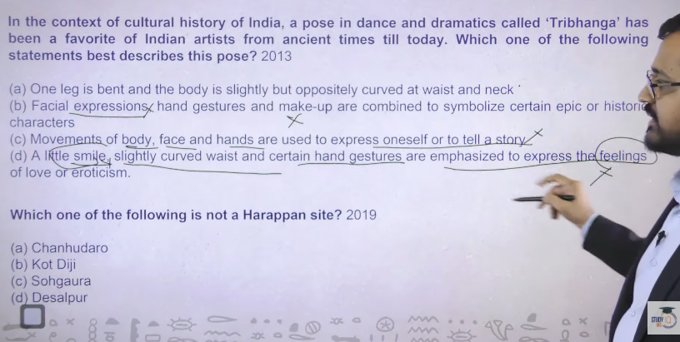

Ans: a
Trebangh basically three different bend in your body ek neck ke paas ek kamar waist and ek pair ke aroud hoga hum lgogo ko kek bronze dancing girl mile hai haddpan ke time ke in teen bend ko he treebangh mudra bolte hai haddpan period se ye trebangh mudra milne chalu hue hai

2 isme koi expression nahi ate hai bas teen bent ate hai eaariliest type sirf teen bend ka tha usme koi facial expression nahi tha medvial time me facial expression and different type of other fomr dalna chalu hua tha
Baad me treebangh mudra ke different version jo hai wo classical dance form of india me adopt kran chalu kr dyai

Tribhanga in the context of the Harappan civilization (specifically the "Dancing Girl" of Mohenjo-daro) best describes a standing body position where one leg is bent and the body is oppositely curved at the waist and neck, creating a gentle "S" shape.
Key details regarding this posture in Harappan art:
- Definition: Literally meaning "three parts break," it is an "S" shaped, asymmetrical, and dynamic pose characterized by bends at the neck, waist, and knee.
- Representation: It is most prominently featured in the 4,500-year-old bronze "Dancing Girl" sculpture from Mohenjo-daro, which is regarded as a masterpiece of ancient metal casting.
- Significance: It highlights the sophisticated artistry, knowledge of lost-wax casting, and early existence of dance traditions in the Indus Valley.
- Context: While widely used in later Indian classical dance (like Odissi) and temple sculpture, its presence in the Harappan civilization shows a very early origin of this graceful pose.
The Dancing Girl is a 10.5 cm tall bronze figurine from ~2500 BCE, discovered in 1926 at Mohenjo-daro (Indus Valley Civilization) using the lost-wax casting method. She is depicted nude, wearing numerous bangles on her left arm and a necklace, in a confident pose with one hand on her hip.
Key Aspects of the Dancing Girl
- Discovery and Location: Found by Ernest Mackay at Mohenjo-daro in 1926, it is currently housed in the National Museum, New Delhi.
- Artistic Style: The figure represents an advanced, sophisticated understanding of metallurgy and art, showcasing both realistic and stylized features.
- Pose and Appearance: The statue is in a naturalistic pose, sometimes described as a tribhanga
(three-bend) pose, with her right hand on her hip and left arm covered in 24-25 bangles.
- Cultural Significance: As one of the earliest known bronze sculptures, it suggests that dancing was a part of Harappan culture.
- Physical Features: The figurine has large eyes, a flat nose, and a confident expression.
The sculpture is considered a masterpiece of prehistoric art, demonstrating that Harappan society was not purely utilitarian but also appreciated aesthetic, symbolic art.

Q..6 Sohgaura is Mauryan site
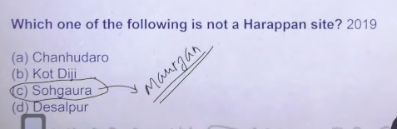
Sohgaruya is mauryan site
Isme local admistratin ko direct order dyia tha chandragutpa murya ne koshtagara ka means hai store of grain sohargaura se muaryan time ke inscription mila hai
Remaining are haddpan site

Q..7 Dholavira- Water management- Signboard-Gujrat+ Only Town has Three Fold Classification

Ans:a
Dholavera me six different tank hai jisme undergourng water channel hai jo ek dusre ko connect krte hai
Haddapn town basically 2 folds me he divedid hai bahut km town hai jaah per citadel middle and lower town classification milta hai
But dholavera me 3 type ke town classification milte hai citadel, middle , lower
General settlement pattern is only classified into tow part citadel and lower
Horse ka pura civilization me sirf ek jagah se he evidence mila hai wo hai surkotada ek he tukada mila raha hai bone ka Same theory is for bronze plough

Dholavira is the primary Indus Valley site known for its unique three-fold city classification. While most Indus cities, such as Harappa and Mohenjo-daro, were divided into two parts—a citadel and a lower town—Dholavira was divided into three distinct parts.
Three-Fold Classification of Dholavira:
- The Citadel (Acropolis): The highest, strongest, and most heavily fortified area.
- The Middle Town: A specifically fortified, distinct central area.
- The Lower Town: The largest residential area for the general population, also enclosed by walls.

“channelising water into connected reservoirs in Dholavira”
👉 “Paani ko raasta (nali/canal) bana kar alag-alag tanks (reservoirs) me le jana, jo aapas me jude hue the.”
- Baarish ka paani aaya 🌧️
- Logon ne uske liye channels (naliyan) banayi
- Wo paani ek tank me gaya
- Fir us tank se dusre tank me 👉 sab tanks connected the
👉 “Dholavira me paani ko naliyon ke through ek se dusre jude hue jalashayon me bheja jata tha.” 👍
“Reservoir (tank) ko canal/nali ke through jodna aur paani ko unke beech flow karwana.”
Aur simple:
- Tanks (reservoirs) bane hote the
- Unhe canal/nali se joda jata tha
- Paani ek se dusre me jata tha
👉 Isi process ko bolte hain channelising water
👉 “Canal ke through tanks ko jodkar paani ko flow karana = channelising water” 👍

Water harvesting
बारिश या अन्य स्रोतों से पानी इकट्ठा करना और उसे सुरक्षित रखना ताकि बाद में उपयोग किया जा सके।
👉 पानी को इकट्ठा करके बचाना और उपयोग के लिए रखना।
उदाहरण:
- छत पर पानी का टैंक
- तालाब, कुआँ, या झरनों से पानी संचित करना
Water harvesting = बारिश या स्रोतों से पानी इकट्ठा करना और भविष्य में इस्तेमाल के लिए रखना।

Water reservoir
एक बड़ा तालाब, झील या कृत्रिम संरचना जहाँ पानी को इकट्ठा करके रखा जाता है।
👉 पानी संग्रहीत करने की जगह।
उदाहरण:
- बांध के पीछे का पानी
- सिंचाई के लिए तालाब या झील
Water reservoir = पानी को इकट्ठा करके रखने का स्थल या संरचना।

Indus Valley Civilization में जल प्रबंधन (water management) और जलाशयों (reservoirs) के लिए प्रसिद्ध साइट है:
1. Dholavira
- यह साइट अत्यधिक व्यवस्थित जल प्रबंधन प्रणाली के लिए प्रसिद्ध है।
- यहाँ टैंक, तालाब और जलाशय (reservoirs) मिले हैं।
- वर्षा के पानी को संग्रहीत करने और पीने के पानी की आपूर्ति के लिए विशेष जलसंग्रह प्रणाली थी।
2. Mohenjo-daro
- यहाँ भी सिस्टेमेटिक नाले (drainage) और पानी की आपूर्ति प्रणाली मिली है।
- घरों के पास सिंक, कुएँ और पानी जमा करने की जगहें थीं।
Harappan Civilization में Dholavira जल प्रबंधन और जलाशयों के लिए सबसे प्रसिद्ध था, और Mohenjo-daro में भी उन्नत जल आपूर्ति प्रणाली थी।

Dholavira, located on Khadir Bet island in Gujarat’s Rann of Kutch, is a premier Indus Valley Civilization site (c. 3000-1500 BCE) renowned for its sophisticated urban planning, advanced water management, and extensive stone architecture. As a 2021 UNESCO World Heritage Site, it features a unique three-part city division (citadel, middle town, lower town) and massive stone-cut reservoirs.
Key Features of Dholavira:
- Urban Structure: Unlike other Harappan cities divided into two, Dholavira had three, separated by fortified walls: a castle (for rulers), a middle town, and a lower town.
- Water Management: The site boasts one of the world's oldest and most sophisticated water-harvesting systems, including large, stone-cut reservoirs designed to store rainwater in an arid region.
- Architecture & Materials: Extensively used stone for construction, rather than just mud bricks.
- Significant Finds: An, "inscription signboard" with ten large Indus script characters, bead-making workshops, gold, ivory, and pottery.
- Location: Situated in the Kutch Desert Wildlife Sanctuary, with the site surrounded by the white Rann.
Discovered in 1968 by J.P. Joshi and excavated between 1990-2005 by Dr. R.S. Bisht, the site offers insight into a highly organized, multicultural, and prosperous 3rd-millennium BCE society

धोलावीरा (Dholavira), जो गुजरात के कच्छ जिले में स्थित है, हड़प्पा सभ्यता का सबसे उत्कृष्ट जल प्रबंधन (Water Management) स्थल है। यहाँ 5,000 साल पुरानी बेहतरीन इंजीनियरिंग तकनीकें मिली हैं, जिसमें 16 से अधिक बड़े जलाशयों (reservoirs), बांध, नहरें और वर्षा जल संचयन (rainwater harvesting) की प्रणाली शामिल है, जो सूखे क्षेत्र में भी पानी की कमी को पूरा करती थी।
धोलावीरा के जल प्रबंधन की मुख्य विशेषताएं:
- विशाल जलाशय: यहाँ पत्थरों को काटकर बनाए गए कई विशाल जलाशय मिले हैं, जिनमें से एक का आकार ओलंपिक स्विमिंग पूल से 9 गुना बड़ा बताया जाता है।
- वर्षा जल संचयन: शहर को चारों तरफ से जलाशयों से घेरा गया था ताकि मानसून का हर बूंद एकत्र किया जा सके।
- नहर प्रणाली: मन्सार और मनहर नामक दो बरसाती नदियों के पानी को रोकने के लिए बांध बनाकर नहरों के माध्यम से इन जलाशयों तक लाया जाता था।
- शहरी योजना: जल प्रबंधन के साथ-साथ यह शहर अपने अनूठे तीन भागों (गढ़, मध्यम नगर, निचला नगर) वाले नियोजन के लिए भी प्रसिद्ध है।
Wikipedia के अनुसार, धोलावीरा के इन जलाशयों में 325,000 घन मीटर से अधिक पानी जमा करने की क्षमता थी।

Dholavira, located in Gujarat's Kutch district, is the Harappan site most famous for its sophisticated water management system. Dating from 3000-1500 BCE, it features a unique, advanced network of stone-cut reservoirs, dams, and channels used to collect and store rainwater, with capacity exceeding 325,000 cubic yards.
Key details about Dholavira's water management include:
- Reservoirs: The city was encircled by, or had within its walls, numerous large, interconnected reservoirs, with two major ones measuring 73×29m and 33×9m.
- Water Harvesting: The system, which included canals and dams, was designed to channel water from the seasonal streams of Mansar and Manhar to the storage tanks.
- Significance: This elaborate, rock-cut water system was essential for survival in an arid region, showcasing advanced engineering skills, according to the UNESCO World Heritage Centre.
- Additional Sites: While Dholavira is renowned for its reservoirs, other sites like Lothal (dockyard) and Rakhigarhi (massive reservoir) also show advanced hydraulic engineering

Dholavira Gujarat:
Vajiram andravi
Dholavira, the southern centre of the Harappan civilization, is known as a lake city or a jala durga (water fort) due to its efficient water conservation system
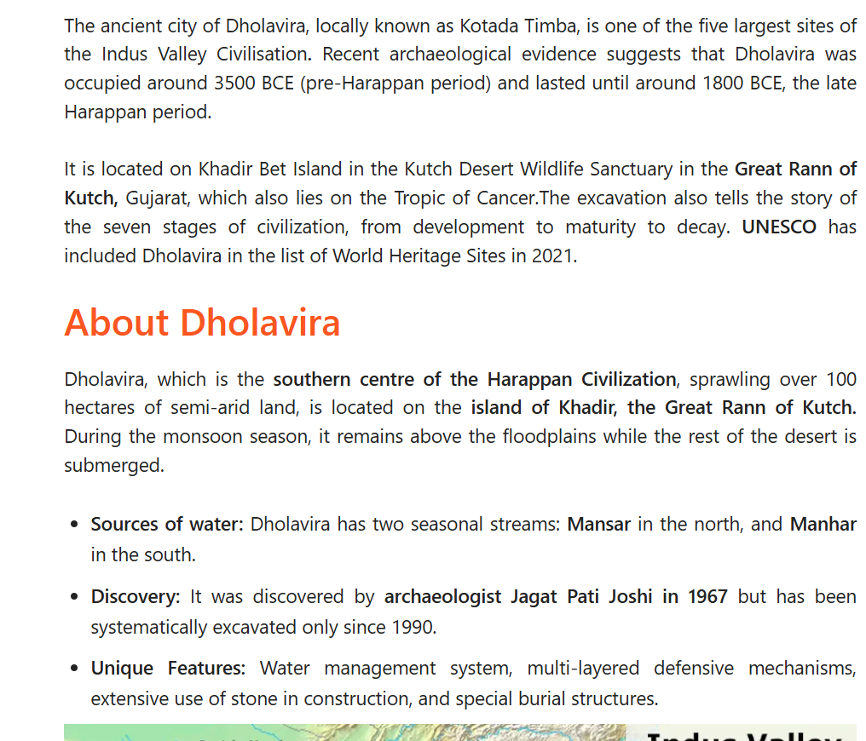

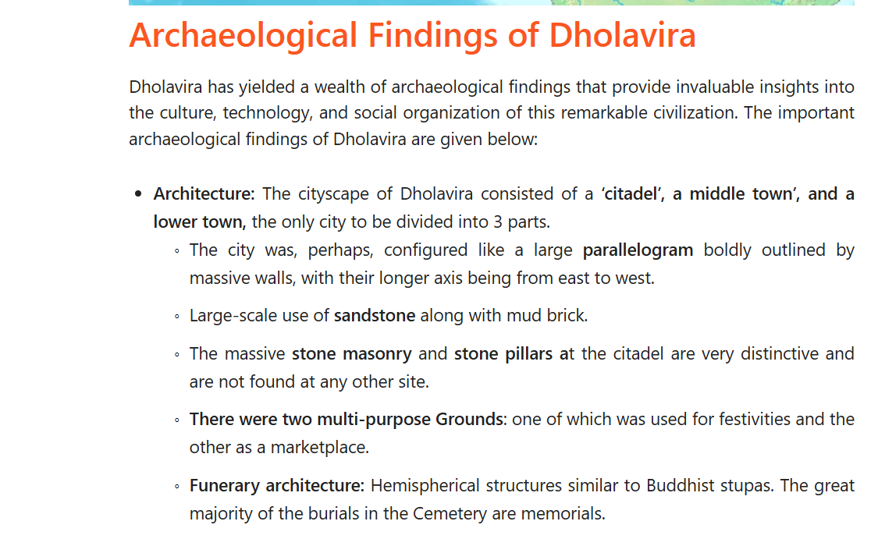

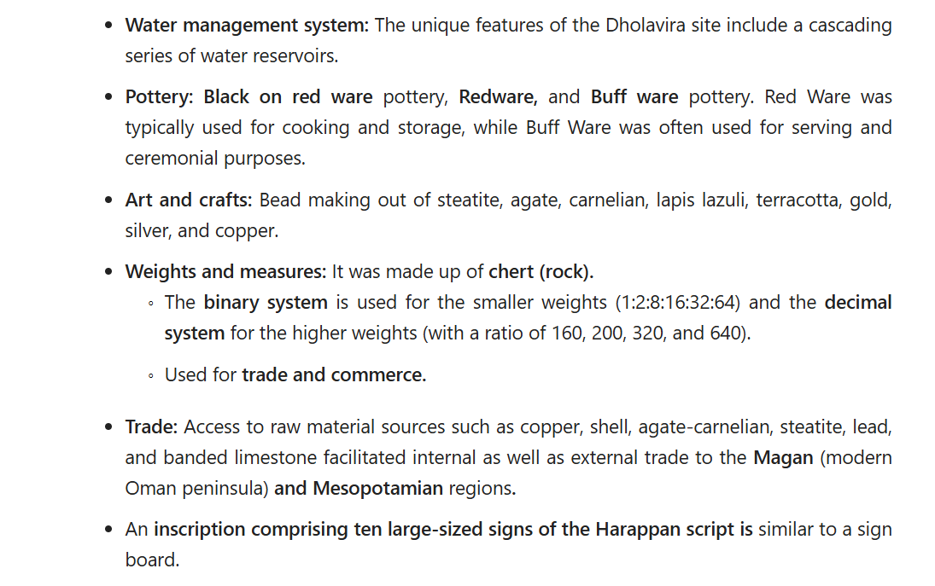

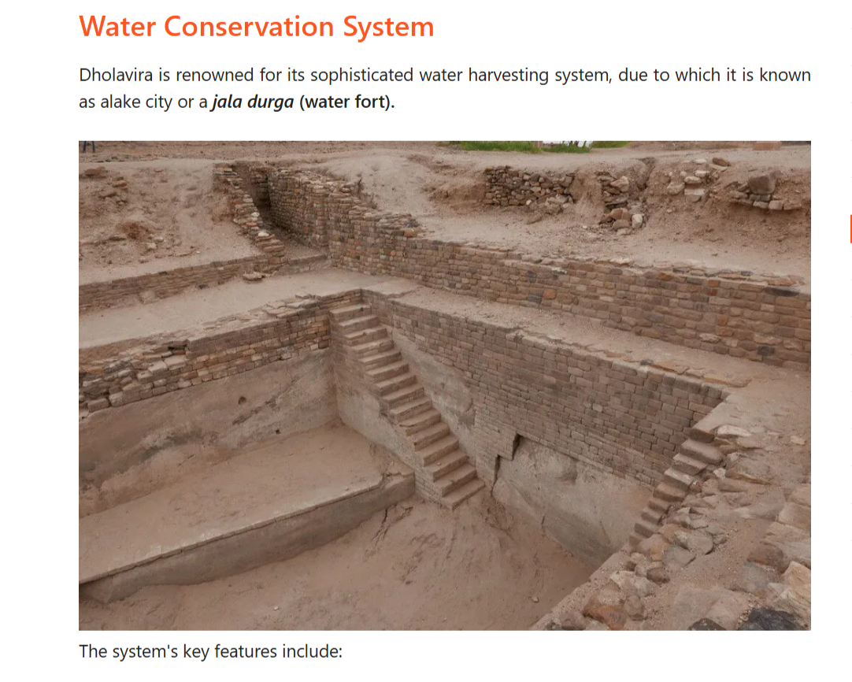
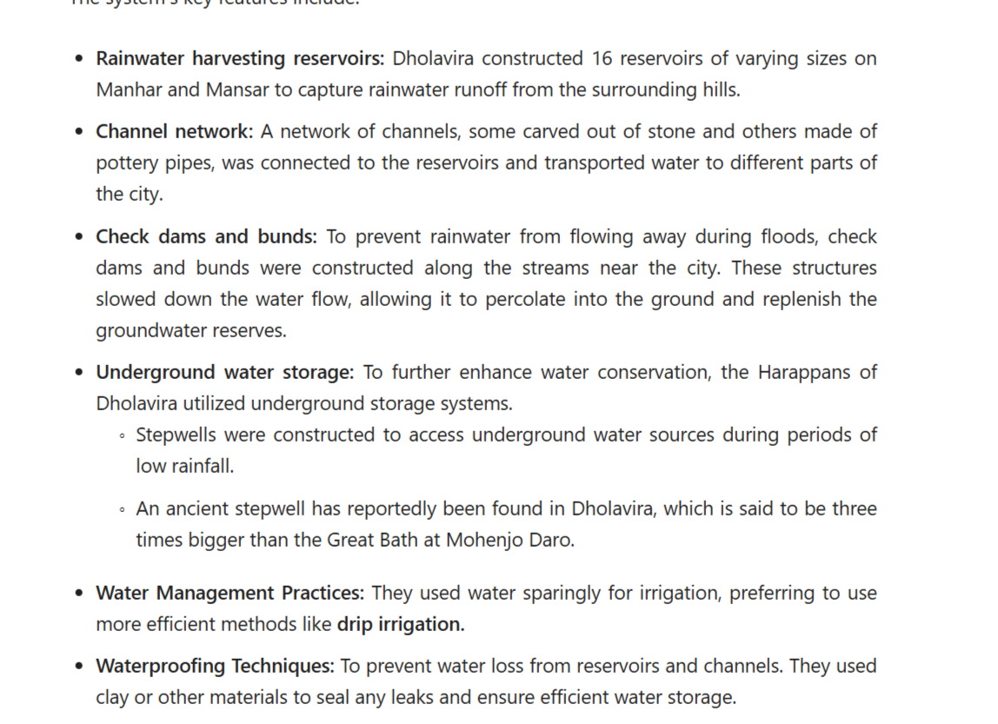
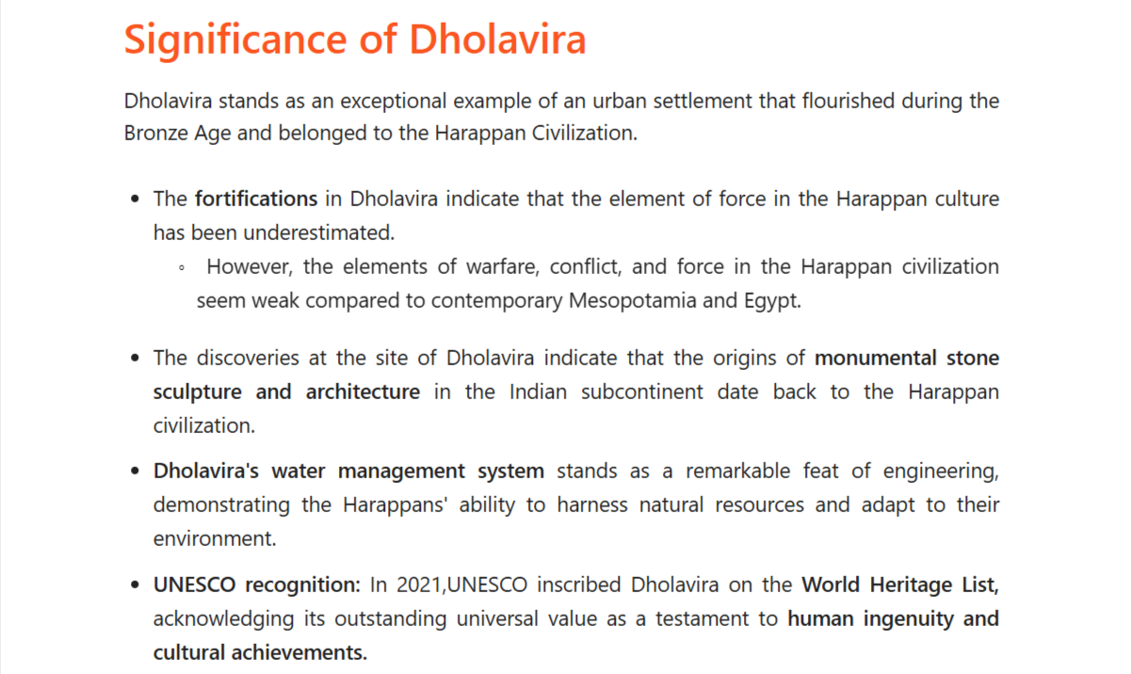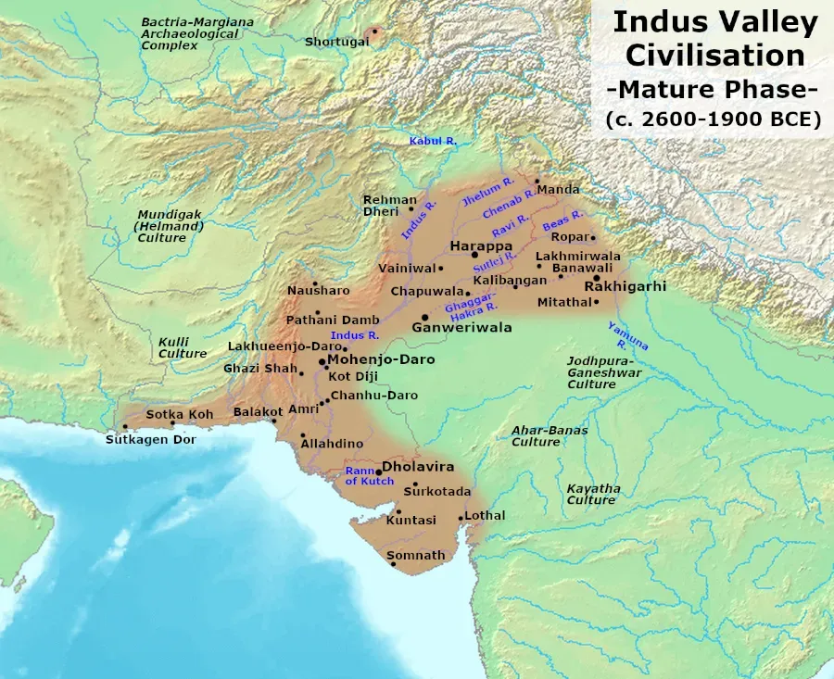
Q1. Where is Dholavira situated?-
Ans. Dholavira, which is the southern centre of the Harappan civilization, is located on the island of Khadir, the Great Rann of Kutch.

Q2. What is the significance of Dholavira?-

Ans. Dholavira's water management system stands as a remarkable feat of engineering, demonstrating the Harappans' ability to harness natural resources and adapt to their environment.

Q3. Who discovered Dholavira?-

Ans. The expansive site was discovered by archaeologist Jagat Pati Joshi in 1967 but has been systematically excavated only since 1990.

Q4. Is Dholavira added to the UNESCO World Heritage List?-

Ans. In 2021,UNESCO inscribed Dholavira on the World Heritage List, acknowledging its outstanding universal value as a testament to human ingenuity and cultural achievements

Q..8 Kalibangan- Rajasthan-Ploughed Field +camel +Fire Altar +This is Burnt Town
option hai https://vajiramandravi.com/upsc-exam/kalibangan/

Kalibangan is an ancient site of the Indus Valley Civilization, located on the banks of the Ghaggar River in the Hanumangarh district of Rajasthan. Kalibangan has emerged as an important site, offering valuable evidence about the Pre-Harappan and Harappan cultures that thrived in the region.

Kalibangan was the primary provincial capital of the Indus Valley Civilization. Kalibangan is known for its remarkable fire altars and the "world's earliest attested ploughed field."

About Kalibangan
The name Kalibangan is derived from two words: Kali and Bangan. Kali means black, and Bangan means bangle. Kalibangan was named after the myriad pieces of terracotta bangles excavated here. 👉 “यहाँ खुदाई में मिट्टी की चूड़ियों के अनेक टुकड़े मिले हैं।” 👉 “Myriad” ka matlab: “बहुत ज़्यादा / असंख्य” 👍

Location: It is located about 310 kilometres northwest of Delhi, along the left bank of the now-dry river Ghaggar in the Hanumangarh district of Rajasthan.

Kalibangan, an important Indus Valley Civilization site in Rajasthan, India, was discovered by Luigi Pio Tessitori, an Italian Indologist and linguist.
- Initial Discovery: Luigi Tessitori identified the prehistoric, pre-Mauryan nature of the site between 1887 and 1919 while researching ancient Indian texts.
- Identification as Harappan: After India's independence, Amlanand Ghosh (former Director General of the Archaeological Survey of India, or ASI) recognized the site as a part of the Harappan Civilization in 1952-1953 and flagged it for excavation.
- Excavation: Extensive excavations were later carried out from 1961 to 1969 under the direction of B.B. Lal and B.K. Thapar.
Kalibangan, meaning "Black Bangles," is famous for being a major provincial capital of the Indus Valley Civilization and for harboring the world's earliest attested ploughed field.

Structure:
Kalibangan consists of three mounds “मिट्टी या मलबे का ऊँचा ढेर / टीला” 👍
the largest in the centre, the smallest in the west, and the smallest in the east. The excavations revealed the grid structure of a Harappan metropolis, which was probably 'the earliest city' of Indian cultural heritage.
The most significant finding is the discovery of a pre-Harappan settlement beneath the remnants of the Harappan citadel.
After Amri, Harappa, and Kot Diji, Kalibangan became the fourth site with archaeological evidence of pre-Harappan cultures.
Kalibangan I (Pre-Harappan Phase): The pre-Harappan settlement was a fortified parallelogram surrounded by a mud-brick fortification wall. Evidence of the pre-Harappan period of Kalibangan, resembling Soti Siswal culture, was found in mound KLB-1.
Single-story houses with mud walls and underground ovens resembling tandoors are found in the region. These homes had cylindrical pits lined with lime plaster, which may have been used to store drinking water.
The remains of pottery were also found at sites near Soti, which belong to the Soti Siswar culture, an early Harappan culture.
This Period's notable finds included small blades of chalcedony and agate, beads, bangles, and terracotta objects like a toy cart-wheel and a copper bull.
Kalibangan II (Harappan):
The Harappan period saw the settlement divided into two parts: the citadel on the west and the lower city on the east.
The citadel was a fortified parallelogram with massive platforms and residential buildings.
The lower city was also fortified, with streets arranged in a grid pattern. The lower city contained fire altars for ritual purposes.
Chronology: The duration of the pre-harappan period is estimated at 2450–2300 B.C. Based on the evidence available, it is possible to infer that the Harappan period at Kalibangan began approximately 2300 B.C. and continued until 1750 B.C.
Archaeological Findings of Kalibangan
Kalibangan has provided an abundance of archaeological finds that shed light on the Indus Valley Civilization. Excavations at the site found a well-planned Harappan metropolis as well as traces of a pre-Harappan settlement. The significant archaeological findings are given below:

Agricultural Development: Kalibangan excavation reveals ploughed fields with furrows intersecting at right angles, showcasing the evidence of multi-cropping. The site also shows evidence of manure and gypsum calcium sulphate being used as fertilisers.
Archaeological evidence suggests that the earliest form of artificial irrigation was practised.
Cattle were used for agricultural purposes as well.
Social Inequalities: Symbolic burials at Kalibangan reveal information about the existence of social inequalities.
An extended burial was probably used for an ordinary person.
Urn burials are probably used by those from lower social strata, as they take up less space than an extended burial.
Pot burial, which is a symbolic burial, involves an earthen pot with precious materials and other materials reflecting the belief in life after death.
Trepanning was also noticed in a few instances.
Trade: Mesopotamian pottery was discovered at Kalibangan, showing trade relations. Many semi-precious stones, such as Maulla, moonga, shells, and sometimes lapiz-lazuli, were found, reflecting that trading was a significant activity, as they were not naturally found in the region.
Metallurgy: Kalibangan imported metals such as copper from Khetri mines in Rajasthan and chert from the Rohiri Hills in Pakistan. A copper bull showing the animal's dynamic mood and other copper objects, including a pin,were found.
Terracotta: Terracotta objects like a toy cart, an incised terracotta cake, a terracotta human head, a terracotta feeding cup with a cow’s head on the rim, a terracotta graduated scale (incomplete) and an ivory comb; bangles of copper, shell, and terracotta are found.
Seals: Most notable is a cylindrical seal depicting a female figure between two men fighting and threatening with spears.
Fire Altars: The most important discovery of Kalibangan has been fire altars. A series of brick platforms were found, which were probably used for fire altars. On one of them, a row of seven 'fire altars' and a pit holding animal bones and antlers were discovered, providing evidence of animal sacrifice.
Pottery: The potteryof this period was almost wheel-turnedand made of fine fabric. However, it was not as well-fired as Harappan pottery’

Kalibangan Significance
Kalibangan offers crucial insights into the Indus Valley Civilization's town planning, social structure, and agricultural practices. Notable archaeological findings include early evidence of cultivated fields, irrigation, and fire altars.

Archaeological Evidence:
Kalibangan is notable for its archaeological evidence of both the pre-Harappan period and the Harappan period. Kalibangan provides evidence of the fire altars and the practice of animal sacrifice.
Urban Planning Insights: Kalibangan's layout and architecture provide a window into the urban planning of the Harappan era.
Cultural Richness: Artifacts and structural remains offer a glimpse into the lifestyle, trade, and religious practices of the time.
Agricultural Innovation: Kalibangan's evidence of ploughing and irrigation practices marks it as a pioneering site in ancient agricultural techniques.
Surgical Knowledge: The discovery of trepanned skulls suggests an advanced understanding of human anatomy and early surgical practices.
Social Hierarchy: The distinct urban sections, along with the varied burial practices, provide insights into the social structure, indicating a stratified society with complex social norms.
Public and Private Spaces: The layout of public areas, such as marketplaces and ceremonial centres, alongside private residential spaces, illustrates the daily life and community interactions of the Harappan people

QQ1. What was Kalibangan famous for?-
Kalibangan is famous for being a major Indus Valley Civilization site with evidence of both pre-Harappan and Harappan cultures. It is also famous for pottery and black bangles.

QQ2. Who discovered Kalibangan in 1953?-
Kalibangan was discovered by Luigi Pio Tessitori, an Italian Indologist. Kalibangan was further excavated by Amlanand Ghosh of the Archaeological Survey of India in 1953.

QQ3. Where is the site of Kalibangan Harappan?-
The site of Kalibangan is located in the Hanumangarh district of Rajasthan, India, on the banks of the dried-up Ghaggar River (ancient Sarasvati).

QQ4. What is the significance of Kalibanga?-
Ans. Kalibangan was a key provincial capital of the Indus Valley Civilization, notable for its distinctive fire altars and the earliest known ploughed field.

QQ5. Why is Kalibangan known as black bangles?-
Ans. Kalibangan means "black bangles" in Hindi and is likely named after the numerous black bangles found at the site

Q..9 Rakhigari- Haryana(Hisar)-Largest Haddpan Site
option hai https://vajiramandravi.com/upsc-exam/kalibangan/

Rakhigarhi is the largest Harappan site in the Indian subcontinent. It is located in Hisar district (Haryana), in the Ghaggar-Hakra river plain.
Rakhigarhi, largest Indus Valley Civilization site. Sprawling over 350 hectares, it surpasses Mohenjo-daro (300 hectares) in size. It features at least seven to nine mounds and was a major city located in the Ghaggar-Hakra river plain.

Rakhigarhi is an ancient site of the Indus Valley Civilization, located on the banks of the now-dried Sarasvati River in the Hisar district of Haryana. Rakhigarhi has emerged as an important site, providing valuable insight into the Pre-Harappan and Harappan cultures that thrived in the region.

Rakhigarh is one of the five largest known townships of the Harappan civilisation on the Indian subcontinent. The other four are Harappa, Mohenjodaro, and Ganweriwala in Pakistan and Dholavira in Gujarat, India.

About Rakhigarhi
Rakhigarhi, about 150 km northwest of Delhi, is a village and an archaeological site belonging to the Indus Valley Civilisation in the Hisar District of Haryana. The site, excavated by Amarendra Nath of the Archeological Survey of India,
Size: Covering approximately 350 hectares, it is considered the largest known Harappan site.
- Location: Situated in the Hisar district of Haryana, India, it lies in the Ghaggar-Hakra river plain.
- Significance: It serves as a significant site providing insight into both Pre-Harappan and Mature Harappan cultures.
- Features: Excavations have revealed city infrastructure, including distinct mounds (such as mounds 9 and 8) containing burnt clay clots, furnaces, pottery, and terracotta bangles.
- Rethinking History: The size and finds at Rakhigarhi have led to it being recognized as a larger, potentially more central city than the previously known largest sites, Mohenjo-daro and Harappa.
Other major sites, sometimes considered in the top five, include Mohenjo-daro, Harappa, Ganeriwala, and Dholavira
Finding Importants
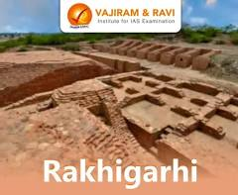
Rakhigarhi, located in Haryana, India, is the largest Harappan site (approx. 300–350 ha). Key findings include a 5,000-year-old well-planned city with mud-brick homes, advanced drainage, a granary, and burial sites. Recent DNA analysis on skeletal remains indicates that Harappan genetic roots go back to 10,000 BCE, suggesting no large-scale Aryan migration.
Major Excavation Findings:
- Town Planning & Structures: A highly organized city with 90-degree street intersections, multi-coursed brick walls, and residential houses.
- Industry & Craft: Evidence of a major lapidary industry (bead-making) with over 11,000 beads found, a gold refinery/foundry with 3,000 unpolished semi-precious stones, copper tools, and kiln-fired bricks.
- Artifacts: A cylindrical seal with five Harappan characters and an alligator symbol, terracotta bangles, animal figurines, and pottery (red ware).
- Rituals: Fire altars (triangular/circular) and animal sacrificial pits.
- Burials: Excavation of two 5,000-year-old female skeletons revealed details on diet and genetics. Another site revealed 11 skeletons with heads oriented north.
Significant Historical Implications:
- Oldest and Largest: As a District Hisar website notes, evidence of Hakra Ware suggests the site might predate the Mature Harappan phase, possibly pushing the Indus Valley civilization's history back to ~3000-2500 BC.
- DNA Analysis: Drishti IAS mentions that studies show local population continuity from the Harappan period to modern times, rather than a displacement by outside invaders.
- Continuity: Rituals and burial practices are thought to be ancestors to later South Asian traditions, as found in some studies on the Puratattva blog.
The site, composed of seven interconnected mounds, continues to reveal evidence of a thriving trade hub with links to Afghanistan and the coast.

It comprises two villages, Rakhi Shahpur and Rakhi Khas, which extend across nine mounds, of which two — mounds four and five — are thickly populated.
It belonged to the Indus Valley Civilization's mature phase, which spanned 2600–1900 BCE. At Rakhigarhi, three layers representing the Early, Mature, and Late stages of the Indus Valley civilisation have been discovered.

Major Findings of Rakhigarhi
The Harappan civilisation site excavated by the Archaeological Survey of India revealed a large number of findings that provide further insight into the Indus Valley civilisation. These include skeletons, town planning, rituals and burials, and others.

DNA analysis of Skeletal: While excavating the site, the Archaeological Survey of India found many skeletal remains. Subsequent DNA analysis revealed that the inhabitants of the Harappan civilisation had a distinct origin. This study negates the theory that the Harappan people have steppe pastoral or ancient Iranian farmer ancestry.
Town Planning: Land townships were enclosed with mud and burnt brick homes, each having an efficient drainage system and proper sanitation. Excavations at Mound number 3 have revealed the existence of an aristocratic settlement with burnt brick walls alongside mud-brick walls.
Lapidary: A large number of steatite beads, beads of semi-precious stones, shells, and objects made of agate and carnelian have been recovered. This discovery signifies that trading was a flourishing occupation. Various hunting tools, such as fish hooks, were also excavated at Rakhigarhi.
Granary: The granary discovered at Rakhigarhi was made of mud bricks, and the floor was rammed earth plastered in mud. It was enclosed within seven rectangular or square chambers, with traces of lime and decomposed grains suggesting a granary, possibly public or privately owned by the elite at the Rakhigarhi site.
Rituals and Burials: A ceremonial system was discovered when fire altars on mudflows were excavated, and traces of animal sacrifices were also located. The sacrificed animals' bodies were covered with mud walls and triangle fire altars.
Two 5,000-year-old female skeletons were discovered at Mound No. 7, along with pots and artefacts, indicating funerary rituals.
Pottery and Seals: A seal with an alligator symbol was discovered, with five Harappan letters on one side and a symbol on the other.
The site also yielded various antiquities, such as blades, shell bracelets, stone beads, animal figurines, and copper artefacts.
The redware ceramics collection included dishes-on-stands, vases, jars, bowls, beakers, perforated jars, goblets, and handles

Significance of Rakhigarhi
The Rakhigarhi site provides valuable insights into the Indus Valley Civilization, revealing its distinct origins and advanced cultural practices. Notably, it will be home to the largest museum in the world devoted to Harappan culture, emphasising how important this culture is to comprehending ancient history.

Largest museum of Harappan culture: Rakhigarhi is among the five iconic sites announced in the Union Budget 2020. The ASI, the state, and the central governments signed an MoU in 2022 to develop the Rakhigarhi Museum, which will be the world's largest museum dedicated to Harappan culture.
The DNA analysis revealed that the inhabitants of the Harappan civilisation had a distinct origin. This study refutes the theory that the Harappans had Steppe pastoral or ancient Iranian farmer ancestry.
Harappan sealings (impression of a seal on a surface) found at Rakhigarhi indicate that seals were used to mark objects belonging to specific people or communities.
Excavation of a wide variety of tools indicates the presence of toy culture in the area. Jewellery, stamps, and weights were also found, which led to the idea that standardised weight systems were followed in the Rakhigarhi.
In 2012, the watchdog Global Heritage Fund listed Rakhigarhi as one of Asia's ten most endangered heritage sites.

QQ1. What is Rakhigarhi famous for?-
Ans. Rakhigarhi is famous for being one of the largest and oldest known sites of the Harappan (Indus Valley) civilisation. It covers about 350 hectares.

QQ2. Is Rakhigarhi older than Harappa?-
Ans. No, the Harappan civilisation is older than the Rakhigarhi site. However, some parts of Rakhigarhi are older than Harappa

QQ3. What is the DNA of Rakhigarhi woman?-
Ans. DNA analysis of a 4,600-year-old woman from Rakhigarhi showed genetic links to ancient Iranians and Southeast Asian hunter-gatherers but no steppe ancestry.

QQ4. Which river is Rakhigarhi in?-
Ans. Rakhigarhi is located in the Ghaggar River plain, about 27 km from the seasonal Ghaggar River.

QQ5. Who excavated Rakhigarhi?-
Ans. Shri Amarendra Nath of the Archeological Survey of India excavated the Rakhigarhi site.

Q..10. Pashupati Seal And Mother Goddess

??Vedic age
T1
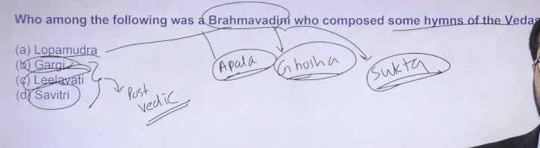

Brrahmvadini means regvedic period me in woman sages ke kuch hymes mile hai
Rigvedic period me women sages ko brahmavadini bolte the
Remaining three are post vedic period sages
Brahmavadini inko isley bola jata hai kuki
Brrahmvadini - They have comkpose different various song hymes in regvedic period

T.2


Indus valley civilization (2600 BCE- 1900)ko basically bola he jata hai sapt sindhu civliation
Satudri – Jhelum
Ganga- No Evidence in Vedic Period
Sarvaswati- Name is Naditarna No saraswati mention
Saraswati ka name in logo ne naditarna rakha tha jisko baad me saraswati ka naam dyiagayay tha
Early people of vedic period did not aware of the ganga but later on ganga ke evidence humko milne lage on the period of mahajanpada

The Sindhu (modern Indus River) is the most mentioned river in Rigvedic literature, appearing over 150 times, highlighting its central role in the economy and geography of the early Vedic Aryans. While the Saraswati is the most revered or "prominent" river, the Sindhu holds the record for highest frequency of mention.
Key details regarding rivers in Vedic literature include:
- Most Mentioned: The Sindhu (Indus) is the most frequently mentioned river.
- Most Prominent/Sacred: The Saraswati is considered the most sacred river, often praised as the best of rivers (Naditama).
- Sapta Sindhu Region: The Rigveda centers on the land of seven rivers, including the Sindhu, Saraswati, and five rivers of Punjab: Vitasta (Jhelum), Asikni (Chenab), Parushni (Ravi), Vipasa (Beas), and Shutudri (Sutlej)
.
- Other Rivers: The Ganga is mentioned only once, while the Yamuna is mentioned three times.

Vedic river names refer to the ancient names of rivers mentioned in the Rigveda, primarily located in the Sapta Sindhu (land of seven rivers) region, covering modern Punjab and surrounding areas.
Key rivers include the Sarasvati (mostsacred), Sindhu (Indus), Vitasta (Jhelum), Asikni (Chenab), Parushni (Ravi), Vipas (Beas), and Shutudri (Sutlej).

🌊 Rivers with Ancient Names
- Indus River → Sindhu
- Jhelum River → Vitasta
- Chenab River → Asikni
- Ravi River → Parushni
- Beas River → Vipasha
- Sutlej River → Shutudri (Shatadru)
- Ghaggar-Hakra River → Saraswati

👉 “1 Indus + 5 Punjab rivers + 1 Saraswati (Ghaggar)” = 7 rivers
➕ Later Vedic nadiyan:
- Ganges River → Ganga
- Yamuna River → Yamuna

T.3
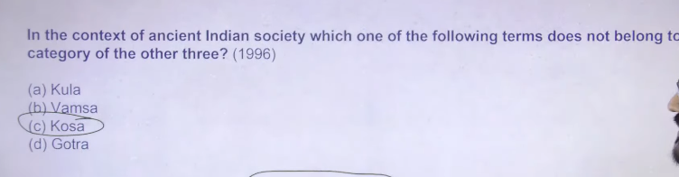
Royal treasure = kosa
And remaining three are family related term

T.4
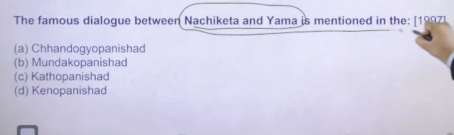

Chandogyaupanisd – is one of the largest and one of the oldest Upanishad hai
छांदोग्य उपनिषद सिखाता है कि आत्मा (आत्मन) और ब्रह्म एक ही हैं — “तत्त्वमसि”।

Mundakopanishad- humne satyamev jayate term lyia hai
मुण्डक उपनिषद सिखाता है कि सच्चा ज्ञान वही है जो ब्रह्म को जानने से मिलता है।
Ishabasoupanishd – recently in name lokpan jo 2020 me bana tha uska motot humen ishabasoupansihd se lyia tha

कठ उपनिषद सिखाता है कि आत्मा अमर है और ज्ञान से मृत्यु के रहस्य को समझा जा सकता है।

👉 Kena Upanishad:
केनोपनिषद सिखाता है कि हमारी इंद्रियों और मन को चलाने वाली असली शक्ति “ब्रह्म” है।
Kenopanishad = “कौन (केन) हमें सोचने और काम करने की शक्ति देता है?” का जवाब।
Kenopanishad (केनोपनिषद) एक प्राचीन हिन्दू ग्रंथ है जो वेद का हिस्सा है, खासकर सामवेद से जुड़ा हुआ है।
यह उपनिषद यह समझाता है कि “हमारे मन, वाणी और इंद्रियों को चलाने वाली असली शक्ति (ब्रह्म) क्या है?”
👉 यह सिखाता है:
- असली ज्ञान सिर्फ इंद्रियों से नहीं मिलता
- एक परम शक्ति (ब्रह्म) सब कुछ नियंत्रित करती है
- उसी को जानना ही सच्चा ज्ञान है

Upanishad kya hai?
👉 Upanishad Vedic granth ka wo hissa hai jisme Brahman (ultimate reality), Atma (soul) aur Moksha (mukti) ka gyaan diya gaya hai.
👉 “Upanishads are philosophical texts of the Vedas dealing with Atman, Brahman and Moksha.”
- Yeh Vedas ka last part hote hain
- Isliye inhe Vedanta bhi kaha jata hai
👉 “Guru ke paas baithkar gyaan prapt karna” (Upa = paas, Ni = neeche, Shad = baithna)

✨ Core ideas
- Atma = Brahman
- Jeevan ka antim lakshya = Moksha
- Gyaan se mukti milti hai

Vedas
↓
(4 parts)
↓
Samhita → Brahmana → Aranyaka → Upanishad
↓
Philosophy
↓
┌───────────────┬────────────
↓ ↓ ↓
Atman Brahman Moksha
(individual soul) (ultimate reality) (liberation)Upanishadon ki total sankhya (number) fixed nahi hai, lekin exam ke liye yeh yaad rakho 👇
📚 Standard Answer
👉 Vedas ka last part = Upanishad
👉 Upanishad ka focus = Gyaan + Moksha

🔑 One-line revision:
👉 “Upanishad = Vedas ka philosophical part jo Atma, Brahman aur Moksha samjhata hai.”

👉 Total 108 Upanishads maane jaate hain
- Yeh list Muktika Upanishad mein di gayi hai

⭐ Important for exams
👉 Inme se 10–13 Upanishads sabse important hain
(jinhe “Principal Upanishads” kehte hain)
Jaise:
- Isha Upanishad
- Kena Upanishad
- Katha Upanishad
- Chandogya Upanishad
- Brihadaranyaka Upanishad

🧠 One-line answer (UPSC)
👉 “There are 108 Upanishads, as mentioned in the Muktika Upanishad.”

Agar chaho to main 10 principal Upanishads ka easy trick bhi bata deta hoon 👍
Muktika Upanishad.”
Muktika Upanishad ek important Upanishad hai jo mainly Upanishadon ki list ke liye jaana jata hai 👇

📖 Basic jankari
- Yeh ek later (later period) Upanishad hai
- Isme 108 Upanishads ki poori list di gayi hai
- Isliye isi ko standard reference maana jata hai

🗣️ Special feature
- Yeh ek samvaad (dialogue) ke roop mein hai
👉 Lord Rama aur Hanuman ke beech baatcheet hoti hai

🧠 Main importance
👉 Is Upanishad ki wajah se hi hum kehte hain:
“Total 108 Upanishads hain”

📌 One-line (exam ke liye)
👉 “Muktika Upanishad lists 108 Upanishads and is considered the standard source for their number.”

Agar chaho to main iska short mnemonic ya list ka breakdown bhi bana deta hoon 👍
Isha Upanishad Kena Upanishad Katha Upanishad Chandogya Upanishad Brihadaranyaka Upanishad like nachiketa and yama samvad is from kathoupansiha like in upadnsike bhe jo importnace haiupsc k lyie do but short me
Bilkul 👍 UPSC ke liye important Upanishads + unke key points (short me) yaad rakhna best hai:

📚 Important Upanishads (UPSC Short Notes)
1️⃣ Isha Upanishad
👉 Key idea: “Ishavasyam idam sarvam”
👉 Sab mein Bhagwan, tyag + karm ka balance

2️⃣ Kena Upanishad
👉 Theme: “Brahman kya hai?”
👉 Indriyon se pare ek shakti (ultimate reality)

3️⃣ Katha Upanishad
👉 Famous: Nachiketa–Yama samvad
👉 Concept: Atma amar hai, mrityu ke baad bhi rehti hai

4️⃣ Chandogya Upanishad
👉 Famous line: “Tat Tvam Asi”
👉 Meaning: “Tu hi Brahman hai” (self = ultimate reality)

5️⃣ Brihadaranyaka Upanishad
👉 Sabse bada Upanishad
👉 Concepts:
- “Neti Neti” (yeh nahi, woh nahi)
- Atma aur Brahman ka gyaan

🧠 Super Short Trick:
👉 I-K-K-C-B
👉 (Isha, Kena, Katha, Chandogya, Brihadaranyaka)

📌 One-line for exam:
👉 “Upanishads mainly deal with Atma, Brahman, and Moksha, with famous dialogues like Nachiketa–Yama in Katha Upanishad.”

Agar chaho to main aur match-the-following type questions (UPSC style) bhi practice ke liye de sakta hoon 👍
brahman kya hai short me one line be bato
👉 Brahman ka matlab hai:
“Sarvavyapi, nirakar aur sabse uchch satya (ultimate reality)”
📌 One-line (UPSC):
👉 “Brahman is the ultimate, all-pervading reality in the universe.”
not understood brahman ko chez hai
Samajhne ke liye aur simple tareeke se 👇
👉 Brahman koi “cheez” nahi hai (jaise kursi, insaan, ya vastu)
👉 Brahman ek shakti / ultimate reality hai
jo har jagah maujood hai aur sab kuch usi se bana hai

🧠 Easy example:
- Jaise bijli (electricity) dikhti nahi
- Par har jagah kaam karti hai
👉 Waise hi Brahman dikhta nahi, par sab mein hai

📌 Super simple one-line:
👉 “Brahman wo shakti hai jisse pura sansar bana hai aur jo har jagah hai.”

Agar chaho to main Atma vs Brahman ka difference bhi easy example se samjha deta hoon 👍
brahman means iswar
Short answer: Partly correct, but not exactly same 👍
🧠 Samajh lo simple tareeke se:
👉 Brahman =
Ultimate, nirakar (formless), sabse bada satya
(jisme sab kuch samaaya hai)
👉 Ishwar (God) =
Wahi Brahman jab roop (form) lekar samajh aata hai
(jise hum poojte hain – jaise Vishnu, Shiva, etc.)

🔑 Easy line:
👉 “Brahman = nirakar satya, Ishwar = usi ka roop (form)”

📌 UPSC one-liner:
👉 “Brahman is the impersonal ultimate reality, while Ishvara is its personal form.”

Agar chaho to main isko ek diagram ya real-life example (water–ice type) se aur clear kar deta hoon 👍

T.5
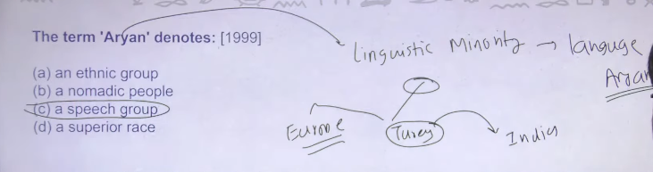
Inke jo language hai usko Aryan bola jata tha hum logog ko bahut sare central asian ke inscription mile hai bahastun inscription is there naksh inscription is there ye inscription hume information dete hai regarding Aryan ke Aryan kise jamane me central asia me rahte the central asia se neeche utar kee wo turkey me aye turkey se unka ek branch chala gayay india ke taraf aur ek branch chaal gayay Europe ke taraf
So turkey me joinscription se mile hai ussse humen yee derive kyia hai ke Aryan is a lagnauge
In today different type of lagnaute identify different type of region in india even till today in this way arayn signify the minority population of central asia
So central asia ke jo chote tribe the unme se one of the tribe is Aryan somewhere around 2000BCE ye log kabe to central aisa se nikal krrke ek branch inka Europe me chaal gaya aur ek india me aya
Hitler ne jo swastika use kyia tha because hitler also traces thee origin European origin to Aryan in same way north india is also traces their orin Aryan
So it is a speech group or it is a linguistic grouop

🧠 Sabse pehle: “Aryan” kya hai?
👉 “Aryan = ek linguistic (bhasha) group”
👉 Race ya blood group nahi hai
📌 Matlab:
- Jo log Indo-Aryan languages bolte the
- Jaise Sanskrit ke purvaj

🌍 Origin & Movement (simple flow)
- Aryan log originally Central Asia ke aas-paas the
- Around 2000–1500 BCE migration hua
Do main directions:
1️⃣ Ek branch → Europe
2️⃣ Ek branch → India (North India)
👉 Isliye dono jagah languages mein similarity milti hai

📜 Evidence (inscriptions)
👉 Jaise:
- Behistun Inscription
- Anatolia (Turkey region) ke records
📌 Inse yeh pata chalta hai:
- Ek Indo-European language family exist karti thi
- Aryan ek bhasha aur sanskriti se juda concept hai

❌ Important Correction (bahut important for UPSC)
👉 Aryan ≠ Tribe / Race (galat interpretation)
👉 Aryan = Language group (sahi interpretation)

⚠️ Hitler wala confusion
👉 Adolf Hitler ne:
- Aryan ko racial concept bana diya
- “Superior race” bola ❌ (yeh galat aur political misuse tha)
📌 Reality:
👉 Aryan ek linguistic-cultural term hai, race nahi

🧾 Final UPSC Answer (perfect line)
👉 “The term Aryan denotes a linguistic group belonging to the Indo-European family, not a race or tribe.”

🧠 Super simple samajh:
👉 Aryan = language bolne wale log
👉 Na ki koi khas khoon ya jaati

T.6 Ans: C
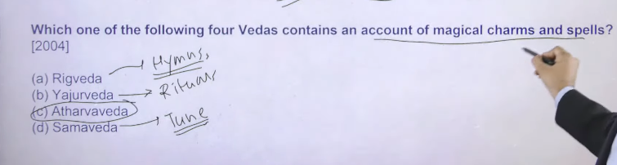
Rigveda me hymes mile hai means mantra
Samveda me humne isko tune dyia tha
Yajurveda – Start Rituals ( certain practices that arre to be followed along with hymes )
Example – agar ghar me vastu shanty karoge to home hawan hona zaroore hota hai but agar satyanarayn ke puja karoge to husme home hawan nahi hota hai
Different mantras ke sath app different rituals karoge
Rituasl – means different type of religious practices

Atharveda – magical charms and spells
Tb ke jo non Aryan the atharveda me uunke practices ke upar negative bate likh ke rakhta hai non Aryan ke jo religious practices the unko jadu tona he consider kyia jata tha

📚 4 Vedas – Correct & Clear Understanding

1️⃣ Rigveda
👉 Hymns (mantra / sukt)
👉 Devtaon ki stuti (Indra, Agni, Varuna etc.)
📌 Sabse purana Veda

2️⃣ Samaveda
👉 Rigveda ke mantron ko tune (music) diya gaya
👉 Gaane ke roop mein use hota tha (especially yajna mein)

3️⃣ Yajurveda
👉 Rituals (yajna, havan) ke rules + mantras
👉 Kaise puja karni hai, kaunsa mantra kab bolna hai
✔️ Tumhara example sahi direction mein hai:
👉 Different rituals = different mantras + procedures

4️⃣ Atharvaveda
👉 Magical charms, spells, healing, daily life problems
👉 Disease, evil spirits se bachne ke mantra
⚠️ Correction:
- Isme sirf “non-Aryan ko negative” nahi bola gaya
- Balki lok jeevan (common people life) aur beliefs bhi reflect hote hain
- Haan, kuch jagah “jadu-tona” type practices ka mention hai

🧠 Super Short Trick:
👉 R-S-Y-A
- Rig = Hymns
- Sama = Music
- Yajur = Rituals
- Atharva = Spells

📌 UPSC One-liner:
👉 “Rigveda contains hymns, Samaveda musical chants, Yajurveda ritual formulas, and Atharvaveda deals with spells and everyday practices.”

Agar chaho to main iska table ya MCQ traps (UPSC me kaise confuse karte hain) bhi bana deta hoon 👍

T.7
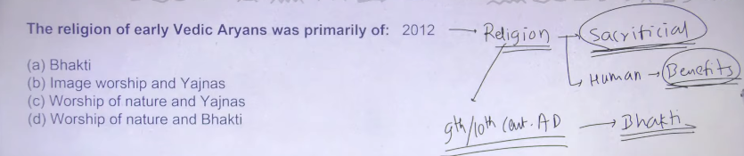
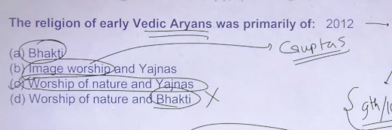

Dharma , Rita, Idol worship, Nature Worship , Yajna Temple
ANS : C
Aryans ke religion ko hum bolte hai sacrificial relilgion tha means humans ko certain benefit to chaye hote the bhagwan se bhangwan ko sush karne ke lyei ancient time per bhe aise he sacrificial elemnt milte hai jjjinme bhagawan ko kush krke materials tic world pleasure ko gain krne k lyiee hota tha
Regveda me bhe mante the ki sacrifice kro aur bhgwan kush hoga aur vardan dega
Is religios practices ko challenge milna chalu hua on 9th to 10th centary AD onward is cenatry me bhakit ka element hindu religion me aa chauka tha bhakti ka matlab tha ke apke life ko jo ultimate purpose hai earthly pleasure nahi hai life ka main purpose hai moksh moksh apko tb milega jab aap bhagwan ke sache man se puja archan karoge prarthan karoge
Isme mante the ki koi bhe sacrifice mat karo app sirf bhagan ke bhakte sache man se karo aur at the time of die apka jo eathly pleasue se attachment moh khtm ho jayga thb apko moksh milenga

Bhakti cult hai ye – medival india me statu hua 9 to 10 cenatry onward hindu religion ko revival karne ka kaam kyia tha aadi shankrachayra ne
Adi shankrachay brought the bhakit cult ke bhagwan ke puja archan karo with the purpose of moksh then ye cult apko sirf medival india me he dekhne
Fir jab modern india chalu hua tb fir se bhakti chale gae aur logon ne puja acrahcan sirf materialsitc chezo ke lyei karna start kr dyai kuchg earthily pleasure humko mile hum uske lyie puja archan krte hai modern n=inda me bhakti chalee gae we worship for materialstic world elment things

So bhakti word hai ye medival india me introduce hua tha ye vedic period me nahi tha
So 1 and 4 option is elemnate image worrdship stated in india gupta period onward so different type of Buddhist image jain image and different god image earliest time per kb banan chalue hue to answer is gupta period onward

To answer is c worship of nature and yajna rituals karoge to apko uske lyie yajna yugya karna padega regveda god hai – indra , agni, varun, soma ye sabhe jo hai wo natural element hai so nature worship is there and sacrifices karna hai to bade bade yugya karne padte the

Early Vedic religion (c. 1500–1000 BCE) was a nature-based, tribal faith centered on hymns and simple rituals honoring gods like Indra and Agni, without temples or idol worship. The Later Vedic period (c. 1000–600 BCE) saw a shift to complex rituals, animal sacrifices, and the rise of a dominant priestly class, with gods like Brahma, Vishnu, and Shiva becoming prominent.
Early Vedic Religion (1500–1000 BCE)
- Nature Worship & Deities: Early worshippers deified natural forces, dividing them into terrestrial, aerial, and celestial. Key deities included Indra (rain/war), Agni (fire/intermediary), Varuna (cosmic order), and Soma (divine drink).
- Rituals & Beliefs: Worship was conducted through prayers and sacrifices (yajnas) to secure herds, victory in war, and good harvests.
- No Idol Worship: There were no temples or temples or idol statues.
- Henotheism: A unique trend where worshippers believed in many gods but elevated one at a time as supreme in their prayers.
Later Vedic Religion (1000–600 BCE)
- Shifting Deities: The old nature gods lost importance to the "Trinity": Prajapati (Brahma - Creator), Vishnu (Preserver), and Rudra/Shiva (Destroyer).
- Complex Rituals: The simplicity of the Rigvedic era disappeared. Rituals became extremely expensive, long, and complex, requiring specialised knowledge, which greatly empowered the priest class (Brahmins).
- Emergence of Idolatry: While not universal, the beginnings of idol worship began in this phase, often tied to social stratification.
- Ritualistic Focus: The focus shifted from devotion to the precise execution of sacrificial rituals and chanting.
Key Differences
- Society: Early Vedic was nomadic and agrarian (egalitarian); Later Vedic was settled and urbanizing (stratified/Varna).
- Sacrifice: Early was focused on simple, communal rituals; Later was focused on complex, massive, and expensive sacrifices.
- Nature: Shifted from fearing/honoring natural elements to honoring personified deities that demanded strict loyalty.
According to Vajiram & Ravi's notes on the Later Vedic Period, post-Vedic (Later Vedic) worship shifted from simple prayers to elaborate, expensive sacrifices (Yajnas) like Ashvamedha, reflecting a rise in priestly authority. The early Rig Vedic gods like Indra and Agni lost importance, while new, prominent deities like Prajapati (creator), Vishnu (preserver), and Rudra (Shiva) emerged.
Key aspects of worship, as covered by Vajiram & Ravi's notes:
- Domination of Rituals: Sacrifices became central to religious life, with a strong focus on formulas, magic, and superstitions.
- Shifting Pantheons: While earlier, the focus was on natural forces (Indra, Agni, Varuna), the later Vedic period brought Prajapati and Rudra/Shiva to the forefront.
- Priestly Authority: The priestly class held supreme authority in organizing complex rituals and sacrifices.
- No Idol Worship: Despite the evolving rituals, Vajiram & Ravi notes that the practice of constructing temples or worshipping statues was absent during this entire phase.
- Focus on Outcomes: Rituals were increasingly focused on achieving specific earthly gains and prosperity.
Essentially, the religious practices became highly structured, complex, and dominated by Brahmans, setting the stage for the emergence of Buddhism and Jainism.
Based on the historical perspective often highlighted in UPSC studies (such as those provided by Vajiram and Ravi), idol worship in India began as a formal, widespread practice during the Gupta period (4th century AD - 6th century AD).
Here are the key points:
- Gupta Period (4th–6th Century AD): Known as the era of great transformation in Hinduism, this period marked the rise of Shaiva, Vaishnava, and Shakta sects, which brought wide prevalence to the worship of specific images of gods and goddesses.
- Temple Development: This era saw the building of temples, which further established the tradition of installing and worshipping idols (murtis or vigrahas).
- Pre-Aryan Traces: While formal temple-based idolatry began later, traces of deity worship, such as the Pasupathi seal, can be found in the Indus Valley Civilization (Pre-Aryan era).
- Epic/Post-Vedic Period: References in the Puranas, which were written in later periods, and the 2incorporation of native traditions indicate that the practice was evolving during the Post-Vedic and Early-Christian eras.
- Role of Bhakti Movement: The Bhakti movement (starting around the 7th century CE) further cemented the worship of idols as a means of personalized devotional surrender to a god.
Therefore, according to standard history notes focusing on the evolution of Indian temples and Puranic Hinduism, the Gupta period is cited as the peak beginning of widespread idol worship.
According to Vajiram & Ravi's notes on Indian history, the concept of Dharma (in the context of Hindu tradition, virtue, and right conduct) originated during the Vedic Period, which spanned from roughly 1500 BCE to 600 BCE.
Here are the key details based on Vajiram & Ravi’s study material:
- Earliest Mentions (c. 1500 BCE - 1000 BC): The earliest, most fundamental roots of dharma are found in the Early Vedic Period (or Rigvedic Period), when the Rigveda was composed, which is recognized as the source of Indian culture.
- Development and Codification: The moral, social, and spiritual codes of dharma were further codified during the Later Vedic Period (c. 1000 BCE – 600 BCE) through the composition of the Puranas and other philosophical texts.
- Significance: It was established as a guide for morality, virtue, and "the right way of living" in Hindu society.
Note on "Dhamma" (Ashokan):
Vajiram & Ravi also detail the "Policy of Dhamma" introduced by the Mauryan Emperor Ashoka in the 3rd Century BCE (roughly 269 B.C.E.), which was a specific set of edicts and a political philosophy focused on moral conduct and religious tolerance.
According to Vajiram & Ravi, the worship practices of the Indus Valley Civilization (IVC) primarily belong to the Mature Harappan Phase (2600 BCE to 1900 BCE), though religious practices evolved through the early and late phases (3300–1300 BCE). People worshipped deities like the Mother Goddess and a Pashupati (Proto-Shiva) figure, alongside nature.
Key details on Indus worship as per the framework of Vajiram & Ravi's UPSC notes:
- Period: The civilization thrived from 3300-1300 BCE, with high religious activity during the Mature Phase.
- Deities: Pashupati Mahadev (Proto-Shiva) on seals, Mother Goddess, animals (Unicorn), and trees (Peepal).
- Practices: Idol worship was practiced, but they did not construct temples.
- Artifacts: Worship was established through findings of terracotta figurines, amulets, and seals.
- Distinction: Unlike the later Vedic period (1500-600 BCE) which prioritized nature/fire, Indus people focused on fertility and Pashupati worship.
Ye confusion UPSC history mein kaafi common hai. Short answer:
Indus Valley Civilization mein kuch idol-like objects milte hain, lekin organized “murti puja (idol worship)” ka clear, continuous evidence Gupta period se milta hai. Isliye UPSC answers mein generally Gupta period onward likha jata hai.
1️⃣ Indus Valley Civilization (Sindhu Sabhyata)
Indus Valley Civilization
- Yahan se terracotta figurines, “mother goddess” type statues, aur kuch seals mili hain.
- Lekin historians sure nahi hain ki ye actual religious idol worship ke liye use hoti thi ya sirf symbols / toys / fertility symbols the.
- Temples ya regular puja system ka clear evidence nahi mila.
👉 Isliye exam answers mein ise confirmed idol worship ka start nahi maana jata.
2️⃣ Gupta Period (4th–6th century CE)
Gupta Empire
- Is period mein:
  - Hindu temples ka development
  - Stone idols of Vishnu, Shiva, Devi
  - Bhakti aur temple-based worship ka spread
- Archaeological evidence clear hai ki log murti ke saamne puja karte the.
👉 Isliye history books aur UPSC answer writing mein likhte hain:
“Organized idol worship became prominent from the Gupta period onward.”
Simple UPSC-ready line
Aap exam mein aise likh sakte ho:
Although figurines were found in the Indus Valley Civilization, clear archaeological evidence of organized idol worship and temple-based religion emerges prominently from the Gupta period onward.
Agar chaho to main UPSC ke liye short 3–4 line ka perfect answer format bhi bana deta hoon jo mains mein likh sakte ho.
I prefer this response
Yeh doubt kaafi common hai, aur tumhara point bhi galat nahi hai — bas “idol worship ka start” UPSC alag sense mein use karta hai. Chalo clearly samajhte hain 👇

1️⃣ Indus Valley Civilization mein kya mila?
Indus sites (Mohenjo-daro, Harappa) se:
- Mother Goddess ki chhoti moortiyan
- Pashupati type seal
- Chhote figurines
Isse historians kehte hain ki religious symbols aur figurines the.
Lekin:
- Mandir nahi mile
- Proper puja-vidhi ka proof nahi mila
- Organized murti-puja ka clear evidence nahi hai
Isliye isko early religious imagery bola jata hai, not full idol worship.

2️⃣ Gupta Period mein kya change hua?
Gupta period se:
- Proper temple architecture start hua
- Vishnu, Shiva, Devi ki regular idols banne lagi
- Mandir mein murti-puja ek organized religious practice ban gayi
Matlab yahan se idol worship systematic aur widespread ho gaya.

3️⃣ UPSC answer mein aisa kyon likhte hain?
UPSC generally yeh difference use karta hai:
- Indus → Figurines / religious symbols
- Gupta period onward → Organised idol worship in temples
Isliye books mein likha milta hai:
Idol worship became prominent from Gupta period onward.

4️⃣ Simple line jo exam mein likh sakte ho
“Although figurines were found in the Indus Valley Civilization, organised idol worship developed and became prominent only from the Gupta Period onward.”

Agar chaho to main is topic ka UPSC-style 5 marker answer bhi bana deta hoon 📚✍️
Dharma instance tracking—the recording, categorization, and enforcement of ethical, social, and legal duties (dharma)—was systematically established in ancient India during the Dharmasutra and Dharmashastra period (c. 600 BCE – 200 CE), with foundational roots in the Later Vedic period. The tracking evolved from an initial focus on ṛta (cosmic order) to the codification of Varnashrama dharma (class/stage duties) and Vyavahara (civil/legal procedure).
Key periods and methods of tracking dharma:
- Later Vedic Period (c. 1000–600 BCE): The concept of Dharma as "something established or firm" (dhárman) transitioned from cosmic order to concrete rules for rituals, individual obligations, and social roles (Varna and Ashrama).
- Dharmasutra Period (c. 600–200 BCE): This era marked the first systematic "guidebooks" on dharma, featuring prose maxims that defined righteous conduct and introduced early legal procedures (e.g., Gautama, Baudhāyana, Āpastamba). These texts established the "shishta" (good people) as a source for identifying dharma.
- Dharmashastra/Smriti Period (c. 200 BCE – 200 CE and later): This period saw the formalization of dharma into metrical verse (Shlokas), notably the Manusmriti (~2nd–3rd Century CE). These texts standardized rules on property, marriage, inheritance, and the 18 titles of law (vyavahāra).
- The Mauryan and Classical Era (3rd Century BCE – 5th Century CE): Emperor Ashoka’s inscriptions (3rd Century BCE) represent a significant instance of state-led tracking of dharma (using the term eusebeia in Greek), emphasizing public morality. Later, the Arthashastra (c. 300 BCE–100 BCE) merged state policy with dharma, while the Yājñavalkya Smṛti (4th–5th Century CE) refined legal procedures, including popular courts (Kula, Shreni, Gana).
The tracking involved defining svadharma (personal duty), rajadharma (duties of a king), and strict varnashrama duties, which were categorized by Smritis to regulate individual and social conduct.
Rita (Ṛta) in the Vedic period is the fundamental cosmic, natural, and moral order that regulates the universe, including the movement of planets, seasons, and human righteousness. As a foundational concept of Vedic thought, it represents universal harmony, preceding the concept of dharma. It is often protected by Varuna, the god-sovereign.
Key Aspects of Rita in the Vedic Period:
- Cosmic Order: It dictates that the universe operates in a lawful, organized manner (e.g., the sun rising, rivers flowing).
- Moral Law: It represents the path of righteousness and truth, often linked to the concept of Satya.
- Guardianship:
Varuna, often called the "keeper of Rita", is the primary deity responsible for maintaining this order.
- Relationship to Ritual: The correct performance of Vedic sacrifices (yajna) was believed to maintain this cosmic order.
- Predecessor to Dharma: Rita is considered the original concept that eventually evolved into the, broader moral and social doctrine of Dharma (duty) and Karma.
It is most frequently discussed in the Rig Veda (mentioned around 390 times), signifying its central importance in early Indian philosophy.
In the post-Vedic period, Rita (or Ṛta) evolved from its early Vedic role as the strict "cosmic order" into the foundation of moral law, transforming into the broader concepts of dharma (duty/righteousness) and karma. It represents the underlying, organized truth that governs both natural phenomena and ethical behavior, serving as the link between cosmic harmony and human duty.
Key Aspects of Rita in Post-Vedic Thought:
- Transition to Dharma: While in the early Rig Veda, Rita was the physical order maintained by gods like Varuna, it was later absorbed into the more comprehensive, practical concept of dharma—the social and moral obligations of individuals.
- Moral & Physical Order: It remained the underlying principle governing both the physical universe (seasons, sun) and the moral world (human actions, societal order).
- Karma Doctrine: Rita’s role as the principle ensuring harmony through order directly influenced the development of the doctrine of karma, where ethical actions bring corresponding results.
- Philosophical Significance: It signifies that the world is not chaotic, but fundamentally orderly, encouraging righteous living in accordance with this "path of rita".
Ultimately, while the term Rita itself becomes less common compared to the early Vedas, its essence is completely integrated into the foundational Hindu concepts of cosmic, social, and moral law, according to the Wisdom Library and RajRAS.

T.8
Ans: Mundkaupneshad D

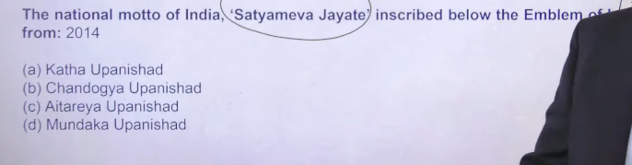
“कठ उपनिषद” और “काधो/काठो उपनिषद” अलग नहीं हैं — ये एक ही हैं। सही नाम है: कठ उपनिषद
ऐतरेय उपनिषद सिखाता है कि ब्रह्म ही इस सृष्टि का रचयिता है और आत्मा ही असली सत्य है।

T.9
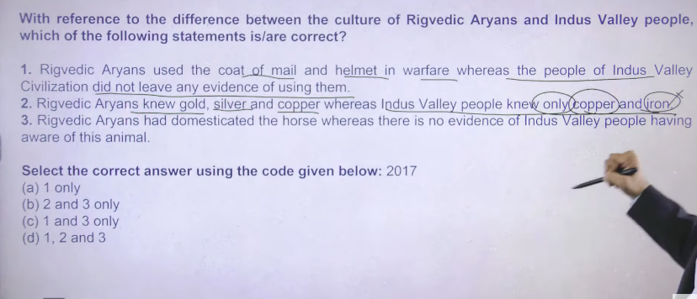

2- Indus people ke paas se hume gold silver, copper bronze ke seal mile hai but iron ke bare me inko nahi pta tha isley second statem is wrong
- veedic period me warfare society the jisme hume kuch aise evidence mile hai jisme log helmet, coat ka use krte the war ke time per warfare khlene jate ye sahe hai but aise kuch archeological evidence nahi mile hai but they have knowledge of iron obnly literary evidence he hume mile hai
3 ek hee bonee ka tukda mila hai wo bhe surkotda me to usska conculsion ye nikal ke wo dhaddpan ke baad me aya hua tukda hai kuki pure across the civilization agar hunke horse ke bare me pta tha to sirf ek he tukda mila isse humen ye anuman lagya ke unko horse ke pare me nahi pta tha to isley mante hia ke wo tukda harapan ke baad me aya hua tukada hai na ke haddpan ke time ka hai vedic people know about horse becuawse they are central asian tribe and aj bhe jo sabse bhetareen nasal ke khode hia wo central asia me milte hai

Hindu reglion ka aisa ko such founder to hai nahi lekin jab adi shankrachayra hinduu relion ko spread karna chalu kyia tha tb different type of people are there in across india to in different type of pople ko apne fold me lana hai to app kaise lauge to aise appka avtar concept imerge into the hindu religion to hare k gaon ka ek devta hota hai humne usko contribute krna chalu kry dyia as sucah a subsidiary god to su gon ke jo god ke follower hue that becomes the cult we are having more than 100 diffent type of cult in today wordl
Bhakit is also a type of cult because sab log bhakte nahi krte the there wrer many people who are doing pooja for the materilasitc god
Bhkti cult wo log hai jinhone apne pure life devotee kr dee bhagwan ko ku kuki unko moksh chaye tha

Swastika ka earliest evidence hai haddpan civilization me mila hai hum iskoo swastika bolte the haddpan isko kya btle the nhai pata
Vedic people ne isko swastika bolna chalu kyat ha
Fir Nazis ne bhe swastika symbol ka use kyia hai they also trace that it is typee of swastika itself

Same symbol humko ancient Persian culture me bhe humko dekhne ko milta hai
To is symbol ka exact gensis kaha hua hai it is still a matter of debate at the wold level

Abe isko common paralance me swastika bola jata hai

???Mahahjanpada
M.1
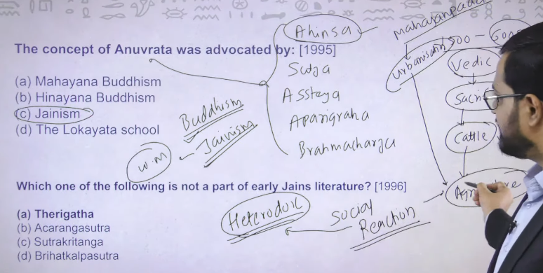

Ahinsa, astya, brahmacharya, stya, apareegrahat = these five are called anuvrata in Jainism
1500 BC to 600 Bc – is roughly called vedic period vedic period me sabse jayda problem that sacrificies to jab large scale sacrifices honge to apke country ka jo cattle population hai saome text said that around 2.5 lakh cattle has been sacrificed in single instances these cateel sacrifices effect agriculture
To mahajanpada 600 bc jo urbanization period thaw o jchalu hua to agar agriculture me surplus hai to wo ssurplus market me bikega aur sharm me app ghar me baidh kr khanan khaa paoge
Toward the later vedic age agriculture surplus reduce hone lag gayay tha to iske wajah se entire society me is vedic literatue kea gains anger tha so you can see at the time of mahajanpand perfod there were social reaction isee social reaction me heterodox sects ate hai heterodox me different from existing belief to existing belief vedic tha to vedic ko oppose krne k lyie different different religion society me aye to usem sabse bada religion tha Buddhism iska oriina he isse time per hua dusra bada religion tha Jainism Jainism ka oriing regvedic period me hai us time per bhe different different type ke jains m ke naamee milte hai
Verdhman mahaveera ka nam mahjanpada ke time per aya

Ye reiligon jo hai wo vedic religion ke against bane hue religion the ajj hum inko sect mante hai hindusim ka but inko follow kkrne wane isko algar religion he mante hai they did not consider himself as hindu it is the one of way to came these reiong in hindusm sects

So jo do imp religion hai 600 bce ke buddism and jainsm both religion strictly belief the practices of ahinsa ahinsa ku kuki thewer were created in the era at the time when the sacrifices is on the ordinary religion aur un sacrifices ko oppose karne ke lyei apko chaye peaceful relion
Siely in dono ke religion ke principal me bhaut saree similiarity hai satya, ahinsa,
Isme se char principal dyai tha parshavanath 23rd terthankar ne
Brahmacharya principal ko add kyia tha vardhman mahaveer himself ne vardhaman mahavera is last 24rd therdthankara (means dharma guru)

Theis is something related to the brief of the emergence of the heterodox sects

2
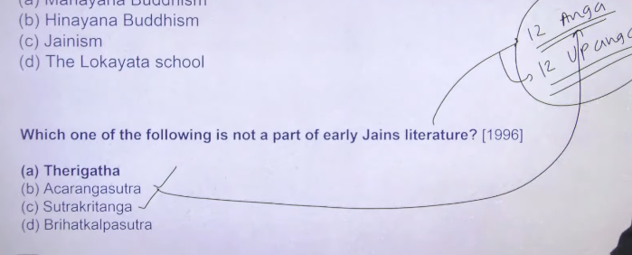

Ans: A

There are 12 anga and 12 upang in jain literature
Jiase ke buddhhist litratue has tripitaka vinay pitaka suttapitaka , abhhidhammpitaka
Angas type – Acarangasutra and sutrakritanga
Third is brihatkalspustra jaah jaha apko kalpsutra mile wo related to jain hoga jain literature me jjo biogriaphy likhe jate hai usko ye log kalpsutra ke naam se jante hai brihad namka ek saint tha uske biography

Ek hota hai therigatha aur ek hota hai teragatha both related to Buddhist both are imp Buddhist literature
Jb 6th cenatry BCe me budhism bana to budhhism ka ek monk or nun aya jisko sangh bola jata hai to sise sangh me monks ake rakhne lag gaye in monks ne apne puja archana ko poem ke form me bolna chalu kyia to in poems ko do part me divide kr dyia gayay thaw o poes jo women gate the wunko therigatha and jomail gate the usko thera gatha bote the so this is nothing but the collection of the poems these poesm sung during the different religious practices ofbuddhism in their monestary

In jainisme different different kalp sutra and biography are there jain kalp sutra , parshwanath kalp sutra

3 AnS : B 2, 3, 4
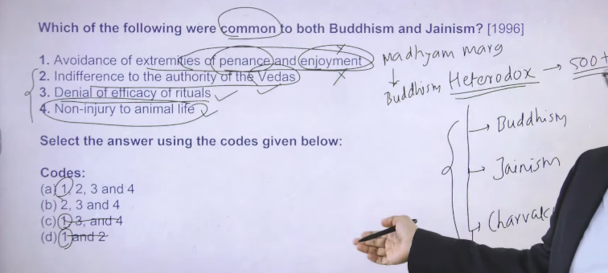
Indifference का मतलब होता है उदासीनता या कोई खास परवाह न करना।
Indifference = “मुझे इससे कोई फर्क नहीं पड़ता।”

आसान भाषा में
जब किसी चीज़ के बारे में
- न ज्यादा समर्थन हो
- न ज्यादा विरोध हो
- बस ध्यान न दिया जाए
तो उसे indifference कहते हैं।
उदाहरण
अगर कहा जाए “Indifference to the authority of Vedas”
तो इसका मतलब होगा:
👉 वेदों की authority को खास महत्व न देना / उन्हें अंतिम सत्य न मानना।
✅ Short meaning:
Indifference = उदासीनता / परवाह न करना।

“Denial of efficacy of ritual”
👉 “कर्मकांडों की प्रभावशीलता का इनकार”
या
👉 “धार्मिक कर्मकांडों की शक्ति/प्रभाव को अस्वीकार करना”
आसान भाषा में
इसका मतलब है कि यज्ञ, पूजा, बलि जैसे धार्मिक कर्मकांडों से मोक्ष या सच्चा ज्ञान नहीं मिलता — ऐसा मानना।

👉 इसका मतलब है – यह मानना कि पूजा-पाठ, यज्ञ या कर्मकांड करने से ही मोक्ष या सच्चा ज्ञान नहीं मिलता।
और सरल शब्दों में
कुछ लोग मानते थे कि
- सिर्फ यज्ञ, पूजा, हवन करने से सब ठीक हो जाएगा।
लेकिन कुछ धर्मों और विचारकों ने कहा कि
- सिर्फ कर्मकांड करने से कुछ नहीं होगा,
- अच्छा आचरण, ज्ञान और सही जीवन ज्यादा जरूरी है।
उदाहरण
- Gautama Buddha ने कहा कि सिर्फ यज्ञ करने से मुक्ति नहीं मिलती।
- Mahavira ने भी कर्मकांडों से ज्यादा आचरण और तपस्या पर जोर दिया।
✅ एक लाइन में:
Denial of efficacy of ritual = यह मानना कि सिर्फ पूजा-पाठ या यज्ञ से मोक्ष नहीं मिलता।

“Indifference to the authority of Vedas” का सरल मतलब है:
👉 वेदों को अंतिम या सबसे बड़ा अधिकार न मानना।
आसान भाषा में
कुछ परंपराएँ मानती थीं कि Vedas ही सबसे बड़ा और सही ज्ञान है।
लेकिन कुछ धर्मों और विचारकों ने कहा कि:
- वेद ही सब कुछ नहीं हैं
- सच्चा ज्ञान अनुभव, आचरण और सोच से भी मिल सकता है
उदाहरण
- Gautama Buddha ने वेदों को अंतिम authority नहीं माना।
- Mahavira ने भी वेदों की authority को स्वीकार नहीं किया।
✅ एक लाइन में:
Indifference to the authority of Vedas = वेदों को सर्वोच्च और अंतिम प्रमाण न मानना।

Ye sare ke heterodox sect hai aise kitne heterodox sect humko pta hai to more than 500+ lekin abhe survive kaun se kr rahe hai to buddhsm and jaisism they are the social reaction iske alwa ek do auur important hai charvaka ,, ajeeveka these are heterodox sects because they challenge the practices of veedic religion

Extermistis of penance and enjoyment means madhyam marg madhyam marg kiska hai to answer is budhha ka but if you go into jainisme then Jainism me extreme penance ko prefere kyia gaya hai extreme penance ka matlab hai ke apko kise ko nahi marna hai lke na pedh paudhe na insaan vegetable etc to agar app kise ko nahi margo to iska kyam matbl hua app kuch kao kebhe nahi
Extreme tapascharya ko matne hai

Iske follower jo hai trading class se jayda the agrarian and other lower class ke log nahi the agar agrarian log is religion ko follow krte to unko agriculture ya khete chodne padte because the could not kill the plant and something else to in jainisme avoidance of extreme pleasure is there in the jainsm

Extreme penance means extreme tapascharya
But Buddhism mne bola expremme mpenance nai chaye madhyam marg me chal lenna
Indifference to the authority of the Vedas- means ye vvedic reglison ke against bane hue religion hai they always used to criticis vedic reglion and sacrifiece that have been given in the vedic literature
- denial of efficacy of rituals mena s rituals ko support na kran oppose karna ye beeh dono me common hai
- non injury to animal means ahinsa ye bhe dono me common hai because anti sacrificial religion hai
this is the ultimate principal fo budddhhism and jainsim is ahinsa

4
483 bc me Buddha died parnervana Buddha ka earthly life se chale jana to obvious hai godly figure ka earth se chale jana koo mara hua consider nahi krnege use lyie bolte hai mahaparenirvana 483 me he Buddhism apne peak per tha jb Buddha died uske baad unke follower ne meeting chalu ke ke kya karna chaye kya nahi karna chaye
In these context there were 4 buddhis council undertaken 1 is 483bc then after 100 year second is 383 bc 3rd is in 250bc then fourth time period is in expetion becuae tht time period is kanshika kahisha has two time 78AD but ye time period galt consider kyia jata hai pahel hum consider krte the ke kansishka 78ad se 140ad ke around rule kyia hai but latest information hai ke wo 140ad se 160ad ke around rule krta tha
Isley 4 the Buddhist council 1 2nd cenarty ad ke around hua tha iska jo patroniser hai gwo great kanishka emperor of kushana isse budhist council me buddhim divided into heeenyana and mahayaan

Mahayana consider Buddha as god and bodhisattva so bodhisattva is nothing the god of Buddhism
To jo earliest teen bodhisattva hai unke name hai
1 maitreya – mahayaan ka manaan tha maitreya is future Buddha future god
Buddhism me bhe belief hai ke there will be god there is maitreya bodhisattva aur maitreya kya karega wo once he is on earth wo har insaan ko salvation ke taraf lekar jayega aur jb tk wo nahi ata moksha nahi delta tb tk we are having Manjushree, vajrapan, thereafter avlokoteswara
Tb tk ye teen bodhisattva apna pana kaam karte rahenge
2 manjushri = he is god of wisdom
- vajrapani = he is god of compassion
- hum logi me sarawati ko god of wisdom and paravati ko god of compassion
manjushhri logo ko gyaan dega ke aap lgo moksh ke raha per chalo worldly pleasur ke rahah per mat chalo worldy pleasure ke raha per chalne per jindgi me apko dus=kh he milenaga aur algla janm agyega jisme bhe apko dukh he milega
vajrapani means agar apne kuch galat cheese ke to apko kis bhagawnke pas jakar mafi magne hai to vajrpani ke paaas jakar maffi magne hai to vajrapani si thegod of compassion
and thereafter is avlokeswr is guide lgogo ko life me salvation ya moksh ke taraf lekar jane wala hai w hai avloketswara
in teeno god ke different different naam hai buddhsim me jo hum logo ko yaad karne ke jarrorat nahi hai
padamapni is nothing it is the name of avlokteswara
Ans: C
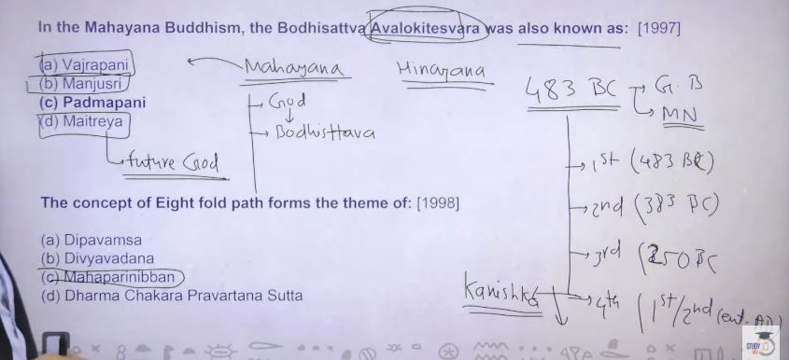
God of compassion god of wisdom and guider god ultimately ye teeno ttb tk kaam karenge jb tk maitreya nahi aa jata hai maitreya is nothing it is the future Buddha
Ye sare concept apko kahah milege to answer is Mahayana me
To inhone pahle Buddha ko god bola god mane bodhisattva aur bodhisattva me inhone 551 previous birth of Buddha ke bare me bhe jankare de de
Heenyaan they used to consider Buddha as mere man and budhda ke teaching ko inhone ethical significance de dyai ye log thoda bhole the society ke against jakar kuch kar rahe the agar insaan se uska religionnikal doge to kaise chalega bhagawan to chae but agar app y cheez nikal doge to kya hoga apka decline hoga social acceptance nahi milega over the period of time there consider ke waja se heenayan dcline and mahayna jayda spread hone lag gaya
Aaj apko buddhisam me majaor follower mahayan ke he milenge each and every place now you see the Mahayana ke he sects milenge
Ye sabh kuch kanishka ke time per hue cheze hai

#.5
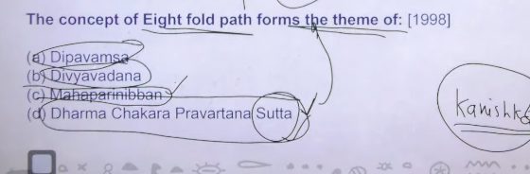
ANS : D

Gautam Buddha basically attain enlightment bodhi tree ke neeche gaya bodhygya me bihar me and once he attain enlightment toye sabse pahle aye sarnath me kuki unke pahle ke jo disciple shesya the wo sarnath me rah rahe the to sarnath me akar inhone path of enlightment sabse pahle apne un disciplie ko batya
Is batane ke prakreya ko bolte hai dharma chakra paravartana iska matlab wheels of the law or wheels of the religion turning yahah se Buddhism ka spread hona chalu ho gaya
To Buddha ataain englishbght unde bodhi tree bodhgyay
And sunhone apna sabse pahla cermon kaah dyia tha sarnath me
Aur sarnath me he dekhega apko dharma chakra prvarta mudra jisk ap india ke flag me bhe dekh skte ho ashoka chakra so this is nothing but wheel of law and is turing of wheel means gautam Buddha ka sabse pahla cermon usme he unhone sare cheese bate the that teher is 4 great sorrow
The world isfull of suffering , the cause of suffering is desire , suffering can be killed by killing desire, and in order to kill desire you must follow astakmarkg eight fold path , fir hare k asthakgmark me har component ke upar kuch discourse kyia hai

Ye sare cheese apko kahah milenge to dharma chakra parevartan sutta
Sutta means sutra surta means book

Deepavansha and deevadna ye dono Buddhist text shrilanka ke hai divyavadana jo hai wo 6th cenatury bc se 4th canary bc me likha gayay

Mahaparinibana = means death of gautam Buddha it is not book it is term is used I in vinay pitaka and suttpikat a

#.6
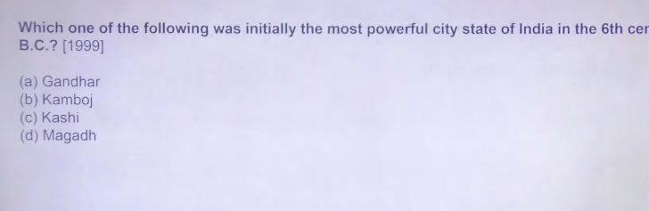
ANA: C kasha
16 mahahjanpaad was there and initial was strongest at that time is kasha,
Kasha ko hranae ka kaam kyia koshala ne then kasha and koshala ko combine alliance ko hrane ka kaam kyia magadh ke king ajatsatur ne
Ajastsatru is responsible for annexing kasha and koshal kingdom then madgha become succefull ultimately
In 16 mahdahjanpad madhag was successful but initial kasha is successful then after kasha is followed by koshala then after madha
Then after magadh ne entirernorth india ko apne under me kr kyoe

#.7
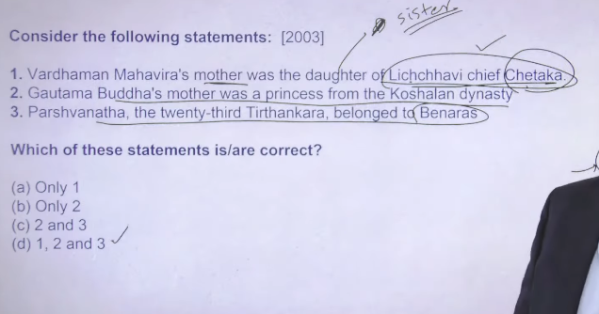

Ans: D
- kuch source me unko daughter and kuch me consider kyiahai sister hai
licchivi dynasty ruling from vaishali abhe ke bihar me hai iska one of the greatest king was chetak it iws one fothe greatest king fir chetak ke family linege ke baree me bahut sare information mahajanpad a me milte hai but it not queity significant

2 waise he buddhawi he is chatreya and belong to shakyam muni lumbni
3 and vardhamn mahver himself belong to jantrika clan

All there are hereaparent means chatreya the jo raja bane wale the but raja bane nahi they choose the path of the priet hodd

Most probable answer is 123 but bahut sare book me apko 2and 3 bhe milenga that is just because of that thingk lichivi is the sister of chetak ordaughter
Uske upar different different source are there but ultimately most probable I would tick 1 becausue the ultimate considering is sahe hai

#.8
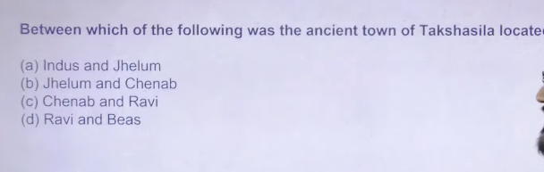
Ans: A Indus and Jhelum ke beech me located hai

Ans:
#.9
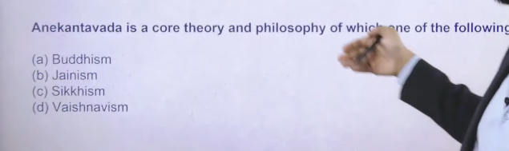
Ans: b
Anekantavad is the plain and simple Jainism philosophy hai
Anek means multicipility of the opinion inka aisa kahna hai ketruth can bee perceive from different different angle or different different view point no single view point itself is truth
Means apke ek cheez dehe to apke dekhne ka nazareya alag alag hai aur dusreo ke dekhne ka nazaryia alag hai
Apke samen ek truth hai to truth ke multiple interpretation can be there usme se ap koi bhe intrepretion sahe nahe man sakte hia because that is how the humanity works isko he bolt hai anekantvada anekantvad philosophy de he isske wajah se the becauae of the multiplicity of the interpretation
Aur kaun se interpretation ko apko sach manna hai to bhai apko jo lagta hai wo appp man skte ho iska matlab ye hai ke app dusre ke intrepreatation ko criticize karo this is the basic crux of the anekantvada because fo the multipliciatyy of the opinion or multiplicity fo the truth

#.10

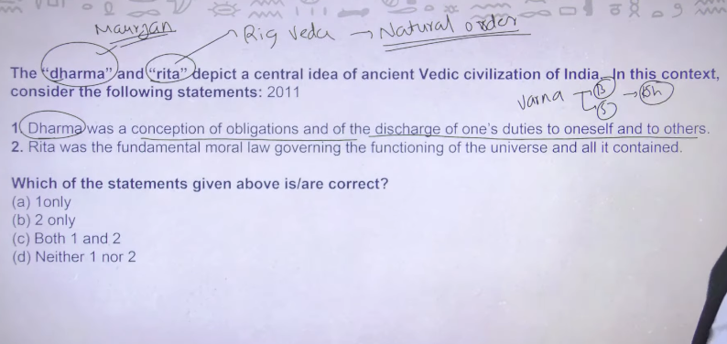
“धर्म और ऋत प्राचीन वैदिक भारतीय सभ्यता के केंद्रीय विचार (मुख्य सिद्धांत) को दर्शाते हैं।”
- Dharma = सही आचरण और कर्तव्य
- Rta = प्रकृति और ब्रह्मांड का नियम / व्यवस्था
“धर्म अपने कर्तव्यों और दायित्वों की अवधारणा है, जिसमें व्यक्ति का अपने प्रति और दूसरों के प्रति कर्तव्यों का पालन शामिल होता है।”
Dharma का मतलब है: अपने कर्तव्यों और जिम्मेदारियों को निभाना, अपने प्रति भी और समाज / दूसरों के प्रति भी। 📚
“ऋत ब्रह्मांड और उसमें मौजूद सभी चीज़ों के कार्य को नियंत्रित करने वाला मूल नैतिक नियम था। Rta का मतलब है: प्रकृति और पूरे ब्रह्मांड को चलाने वाला नियम या व्यवस्था। 📚

iscaharege of ones duty to oneself and to others ka kya matlab hai
“Discharge of one’s duty to oneself and to others” का मतलब है:
👉 अपने कर्तव्यों को निभाना — अपने प्रति भी और दूसरों के प्रति भी।
आसान उदाहरण
अगर हम Dharma की बात करें:
- अपने प्रति कर्तव्य → अपना ध्यान रखना, पढ़ाई करना, सही जीवन जीना।
- दूसरों के प्रति कर्तव्य → माता-पिता का सम्मान, समाज की मदद, नियमों का पालन।
एक लाइन में
Discharge of duty = अपने कर्तव्यों को सही तरीके से पूरा करना। 📚
discharge means
Discharge का मतलब होता है निभाना / पूरा करना / पूरा कर देना।
उदाहरण
“Discharge of duty”
👉 कर्तव्य निभाना
आसान उदाहरण
अगर कहा जाए:
“Discharge of one’s duty to oneself and to others”
तो इसका मतलब है:
👉 अपने और दूसरों के प्रति कर्तव्यों को निभाना।
✅ Short meaning:
Discharge = निभाना या पूरा करना। 📚
discharge means chodana bhe to ghoat ahi
हाँ, सही कहा 👍 “Discharge” का मतलब “छोड़ना / बाहर निकलना” भी हो सकता है, लेकिन इसका मतलब context (वाक्य) पर निर्भर करता है।
Discharge के अलग-अलग अर्थ
1️⃣ निभाना / पूरा करना
- Discharge duty → कर्तव्य निभाना
2️⃣ छोड़ना / बाहर निकालना
- Discharge water → पानी छोड़ना
3️⃣ अस्पताल से छुट्टी देना
- डॉक्टर ने मरीज को discharge कर दिया।
आपके वाक्य में
“Discharge of one’s duty”
यहाँ discharge का मतलब है → कर्तव्य निभाना,
न कि छोड़ना।
✅ Short:
Discharge = context के अनुसार “निभाना” या “छोड़ना” दोनों हो सकता है। 📚
कर्तव्य निभाना engilsh me kya bolte hai
“कर्तव्य निभाना” को अंग्रेज़ी में आम तौर पर “to perform one’s duty” या “to discharge one’s duty” कहा जाता है।
Examples
- He performs his duty honestly.
→ वह अपना कर्तव्य ईमानदारी से निभाता है।
- Everyone should discharge their duty.
→ हर व्यक्ति को अपना कर्तव्य निभाना चाहिए।
Simple translation
👉 कर्तव्य निभाना = perform duty / discharge duty 📚
obligation mane kya hota hai
Obligation का मतलब होता है कर्तव्य, जिम्मेदारी या दायित्व।
आसान भाषा में
जब आपको कोई काम करना ही चाहिए क्योंकि वह आपकी जिम्मेदारी है, तो उसे obligation कहते हैं।
उदाहरण
- माता-पिता की देखभाल करना → हमारा obligation है।
- नियमों का पालन करना → नागरिक का obligation है।
एक लाइन में
👉 Obligation = जिम्मेदारी / कर्तव्य। 📚

Ans:
Rita word humko rig veda me milta hai jiska meaning hia natural order
Means jo nature me chal rahah hai usko chalne do usmee interfere mat karo wahe saree cheese follow karo
Aur Ye jo dharma word hai by the time of mauryan bahut he elaborately assert hua hua dekhta hai means mauryan ke time per humko rita nahi pta tha mauryan ke time per humko dharma pata tha aur rigvedic time per humko dharma nahi pta tha humkoo rita pta tha
Rita is nothing buut a natural order us natural order ko follow karnee ka kaam humanity ko karna hai buty by the times of mauryan kya aya dharma aya dharma means religion nahi dharma means duty each and every person assign a duty and it was his duty to full fll that duty
Rigveda me intial phase me varna system nahi dekhne ko milega and jab varna system aya to each and every person divided into varna line jb app ek particular varn ke ho to apke kuch particular duty hai means apka kuch dharma hai apko us dharma ko follow karna hai
Like appp vashya ho to app khete bade karo trade karo tax paying bano
Agar app chatreya to to go to fight the war and rule the particular terriority
Ya fir carry out administrative work
Brahmin ho to priestly puja archana wale kaam karne hai
To regved time per rita the tb har people ko nature ke under rahna tha
But buy the time of maruyan dynasty dharma ne apne app ko assert kanra chalu kr dyai dharma is not your regliion it is your duty ]
This is the crux of rita and dharma
App jis position me ho usme apke kuch duty hai jinko appko follow karna hai

1 is correct means varna me app Brahman ho to apke kuch duty hai same agar app vaishya ho to apke kuch duty hai same…… it is correct

Dharma ka conceptural origin jo hai wo varna hai varna and dharma ye wole concept mauryan time per assert haona chalu ho gae
By the time of gupta ek oaru term hum logo ko milte hai wo hai varnasharam dharma means gutpa ke time per jo ye classification ttha ye bilkul rigid batna hua jaa rhah tha
But mauryan time per ye varna dharma bhale he ho but u can easly change your varna like Buddha mahaver parshwvan they are chatreya then change your varna aur dharma priest bane brahaman bane

To Correct Ans: Both A B right

#.11
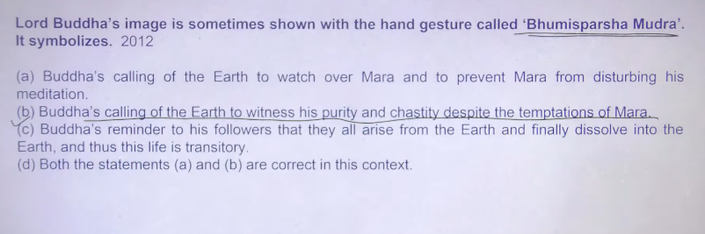

Correct answer is B
Bhumi shparash mudra wahe hai ke wo dharti ko awahsan krr rahe hai ki mara naam ke apsara dharti per mujhe physical pleasure dene k lyie aye buut I did not succum
Ths question is related to padmpanni means bhumi sparsh mudra me padmpani ko deekhaya gaya hai Ajanta caves me

#.12
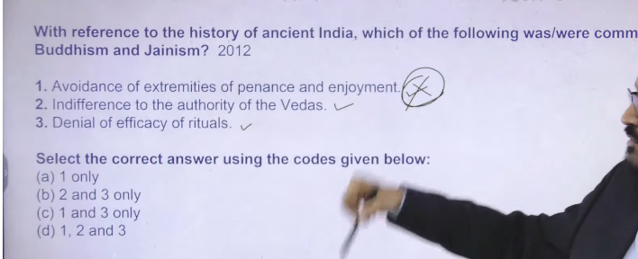

#.13
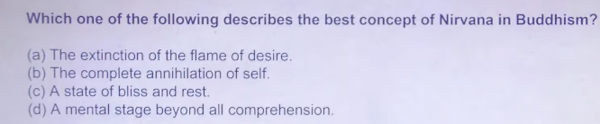

Nirvana means extinction of desire there are four great truth ,the world is full of sorrow the cuase of sorrow is desire, desire can be killed in order to kill the sorrow , and in order to kill the desire you must be follow eight fold path eight fold path ko follow karke apko nirvana milenge aur apka desire chala gay
Jb desire chala jata hai then apke soul ko earthly life se koi attachment nahi bachta hai aur jab sourl ko earthly life se koi attachment nahi bacha hai tb soul rebirth nahi lega tb soul ko nirvana moksha milega
Nirvana का मतलब क्या है?
👉 Nirvana का अर्थ है दुःख और जन्म-मरण के चक्र से मुक्ति
आसान समझ:
- मन की इच्छाएँ (desires) खत्म हो जाती हैं
- कर्म और rebirth रुक जाते हैं
- पूरी शांति (peace) मिलती है
Short में:
👉 Nirvana = दुःख से पूरी मुक्ति और शांति

S oo answerwill Be A
“The extinction of the flame of desire” 👉 “इच्छाओं की आग का बुझ जाना।”
- Extinction = समाप्त होना / बुझ जाना
- Flame = आग / ज्वाला
- Desire = इच्छा / तृष्णा

the complete annihilation of self in hindi
👉 “The complete annihilation of self” का हिंदी अर्थ:
👉 “स्व (अहं/आत्म-बोध) का पूर्ण नाश”
आसान भाषा:
👉 अपने ‘मैं’ (ego) का पूरी तरह खत्म हो जाना
Short में:
👉 अहंकार का पूरी तरह अंत
a state of bliss and rest hindi
👉 “a state of bliss and rest” का हिंदी अर्थ:
👉 “आनंद और शांति की अवस्था”
Short में:
👉 पूर्ण सुख और विश्राम की स्थिति
a mental stage beyond all comprehensions hidni
👉 “a mental stage beyond all comprehensions” का हिंदी अर्थ:
👉 “एक ऐसी मानसिक अवस्था जो सभी समझ से परे है”
Short में:
👉 समझ से परे मानसिक स्थिति

#.14

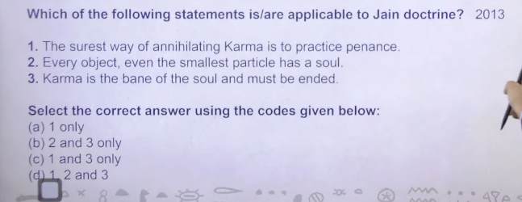

in jainis agar apko apke karmo se chutan hai tb apko extreme tapaschayra karne padege means extreme penance
every object jisme jaan nahi hai usme bhe soul hai ye bhe correct hai
3 karma he apke soul ke upar sabse bada bane abheeshap hai uske he apko end karna hai usko appp kaise end karoge to by practicesing the extreme penance to fir apk karma ahce karo apke karma he apko moksha dilayenge
Ans: 1,2,3 D

1
“कर्मों का नाश करने का सबसे निश्चित तरीका तपस्या करना है।”
शब्दों का अर्थ
- Surest way = सबसे निश्चित तरीका
- Annihilating karma = कर्मों का नाश करना
- Penance = तपस्या / प्रायश्चित
यह विचार खासकर Jainism की शिक्षा से जुड़ा है, जहाँ माना जाता है कि तपस्या से कर्म खत्म होते हैं। 📚
“Karma is the bane of soul and must be ended.” का हिंदी अर्थ:
👉 “कर्म आत्मा के लिए बाधा (कष्ट का कारण) है और इसे समाप्त करना चाहिए।”
शब्दों का अर्थ
- Karma = कर्म
- Bane = हानिकारक चीज / कष्ट का कारण
- Soul = आत्मा
- Must be ended = समाप्त किया जाना चाहिए
यह विचार मुख्य रूप से Jainism की शिक्षाओं से जुड़ा है, जहाँ माना जाता है कि कर्म आत्मा को बंधन में रखते हैं और मुक्ति के लिए उन्हें समाप्त करना जरूरी है। 📚

Jain Doctrine का हिंदी में मतलब होता है:
👉 जैन सिद्धांत या जैन धर्म की शिक्षाएँ।
यह Jainism के मुख्य सिद्धांतों और विचारों को दर्शाता है।
जैन धर्म के मुख्य सिद्धांत (Jain Doctrine)
1️⃣ Ahimsa – किसी भी जीव को हिंसा न करना।
2️⃣ Satya – हमेशा सत्य बोलना।
3️⃣ Asteya – चोरी न करना।
4️⃣ Brahmacharya – इंद्रियों पर नियंत्रण रखना।
5️⃣ Aparigraha – अधिक वस्तुएँ जमा न करना।
✅ Short meaning:
Jain Doctrine = जैन धर्म के मुख्य सिद्धांत या शिक्षाएँ। 📚

#.15
Ans: B
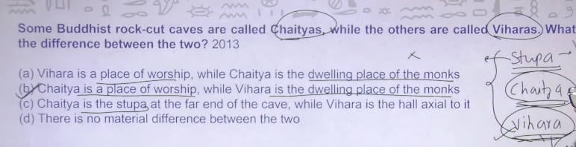

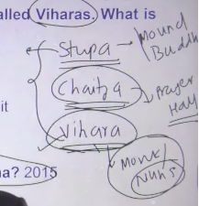

In buddhst architure there are three aspects ek hota hai stupa , ek hhota hai chaitya , ek hota hai vihara these are three essential architure element of Buddhism
Stupa = related to mound of Buddha means ek anda mileage us anda ke neeche and uparr harmikake neeche ke place milega Buddha se related kuch relexx apko milenge is is saying that jab Buddha died then Buddha ke body ke 80 diferent different part kaat lyie agaya and across india bheje gaye and uske uppar 80 different different stupa bana lyia gaey ye saying kitne true aur kitne false hai yee to nahi pta but buut jitney bhe stupa ke structure mele hai unme bhduah se related ya fir important buddhhist monk se related kuch na kuch relex mile hai

To stupa jo hai wo directly related to Buddha himself

Vihar = Buddha ne ek order of monks and nun banya tha aur ye monks and nun kaha rahenge to wo rahenge vihara me so vihara is nothing a place jah monks and nun rahha karte the to apko jitney bhe buddhst related caves dekhenge Ajanta hai bamiyana hai ,alora,thereafter bagh is in mp , ye jitney bhe cave hai ye ke time per Buddhist ka vihara hua krte the menas Buddhist monk live over there

Vihara = cave= where budhist monks levae over ther e
On the other hand
Chittya is = prayer hall to ye monks and nun kya karnege ek sath milkar prayer karnege so this is something quiet esseentais
Chaitya and vihara ye apko ke he jagha per milenge and stupa apko alag adekhne ko milenga
Ajanta me app jaoge alora me appp jaoge ,ya even app karelka stupa me jaoge ya fir elephant caves me jaoge ya fir bagh caves aya afganistan me jo bamiyana caves hai wahah jaoge yaha per you will find that Buddhist monk live overthere to ye cave architure vihara hai and vihara ke sath sath inke paaas prayer hall bhe hai that is chaitya

#.16
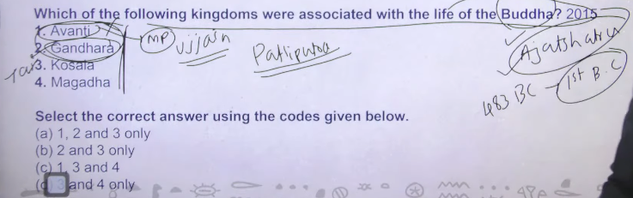

Ans: D 3 and 4
Gautam Buddha kab rahte the to aproxmatiley 483bc me dhaee hazar saal pahle
To sochoa jo basic administrative capital tha pure north india ka to agar apko patiluputra se udhkar Avanti jo mp me hai and gandhara taxshila itne dhoor jane ke koi sadhan nahi the so Buddha live in patiliputra to wo avanit and gandhar itne dhoor nhi gaey kuki janeka koi sadhan nahitha so Buddha never visit Avanti kingdom as well as gandhara kingdom
Buddha belong to magadh and there surrounding area and that tiem maggadha and Avanti has warfare with each other to agar ye dono ek dusre ke sath warfare me rahenge to magadh ke kise relgios person ka Avanti me ana to allow nahi hota haoga absolutely not same gandhara
And gandhara wala area magadh empire me kab aya to chandragutpa murya ke time per 305-320 bc ke around ye gandhara wala area magadh empire

ke under me ayay
remaing
kasha was initial strongest and thereafter it was captureby koshala then kasha and koshala dono ako ajastsatur ne capture kar lyia tha ajastsaturhe si very good friend of Buddha
then when 483bc Buddha died to us samay first buddhst council ko patronize karne ka kaam kyia tha ajastsatru ne patronize means ppaise dene ka kaam so basically it is related to terrriotry of mahjanpada

so basically Buddha se related kindggom is Magadha and kosala
so the answer has to be

Gautama Buddha ने अपने जीवन में कई महाजनपदों में यात्रा (visit) की थी 👇
मुख्य महाजनपद जहाँ Buddha गए:
- Magadha
👉 राजगृह (Rajgir) – राजा Bimbisara का राज्य
- Kosala
👉 श्रावस्ती (Shravasti) – यहाँ उन्होंने सबसे ज़्यादा समय बिताया
- Vajji
👉 वैशाली (Vaishali) – लिच्छवि गणराज्य
- Malla
👉 कुशीनगर – यहीं उनका महापरिनिर्वाण हुआ
- Kashi
👉 सारनाथ – पहला उपदेश (Dharmachakra Pravartan)

Short में:
👉 Buddha ने mainly Magadha, Kosala, Vajji, Malla, Kashi में यात्रा की 👍

👉 Pradyota (Avanti) और
Magadha के बीच संबंध:
👉 ज़्यादातर शत्रुता (enemy relation) थी ❌
क्यों?
👉 दोनों बड़े और शक्तिशाली राज्य थे
👉 इसलिए राजनीतिक rivalry (प्रतिस्पर्धा) रहती थी
लेकिन:
👉 कभी-कभी हालात के अनुसार temporary peace या normal relation भी हो सकता था

Short में:
👉 Pradyota (Avanti) vs Magadha = mainly दुश्मनी / rivalry
aur magadh ka king kaun tha
👉 Gautama Buddha के समय
Magadha का प्रमुख राजा था:
👉 Bimbisara
👉 बाद में उसका बेटा:
👉 Ajatashatru

Short में:
👉 Buddha के समय Magadha का राजा = Bimbisara (फिर Ajatashatru)

👉 Gautama Buddha के समय
Kosala का राजा था:
👉 Prasenajit
(जिसे Pasenadi भी कहते हैं)

Short में:
👉 Buddha के समय Kosala का राजा = Prasenajit (Pasenadi)
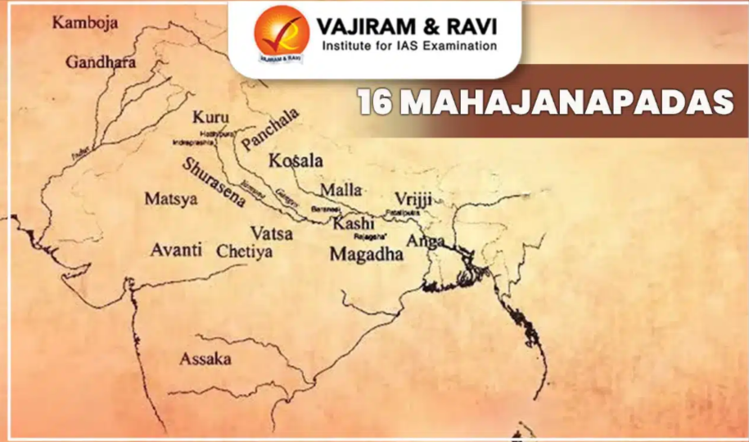
#.17
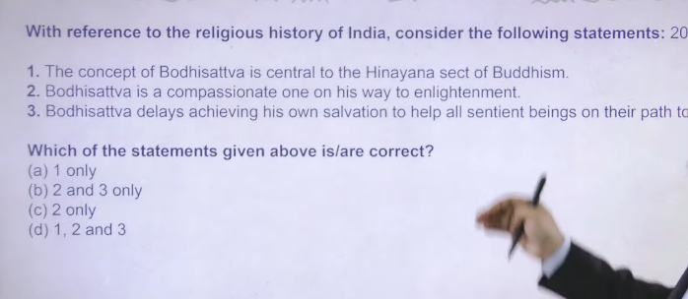

👉 Bodhisattva वह करुणामय (दया से भरा) व्यक्ति है, जो ज्ञान (enlightenment) प्राप्त करने के मार्ग पर है।
👉 दूसरों की मदद करते हुए ज्ञान पाने वाला व्यक्ति

Bodhisattva is the god god means Mahayana not heenyaans so the 1 has to be false
- there are different kind of bodhista and earlist three of them guid people to go to salvation path until maitrye has came
wo batayenge ke chalo nirvana ke taraf
3 bhagwan dyalu hota hai to inka bhe bhagwan dayalu hai to kudh ka salvation isley nahi kr rahah hai kuki that partiucal bhagwan has to b e guide each and evyer individual on the earth toward the salvation to ultimate god ayega maitreya to uska to kaam wahe hai to wo jab tk nahi ata tb tk ye jo different different god hai avlokteswara , Manjushree, vajrapani is there to ye kya karenge earth per logo ko salvation ke tarf jane ka rasta dkhyeange

So the answer is 2 and 3

“One on his way” का हिंदी मतलब होता है:
👉 “वह व्यक्ति जो किसी लक्ष्य की ओर जाने के रास्ते पर है।”
आसान उदाहरण
अगर कहा जाए:
“One on his way to enlightenment”
तो इसका मतलब होगा:
👉 “वह व्यक्ति जो ज्ञान प्राप्ति के मार्ग पर है।”
यह वाक्य अक्सर Bodhisattva के लिए प्रयोग होता है। 📚

Compassion का मतलब होता है दया और करुणा।
आसान भाषा में
👉 जब हमें किसी के दुख को देखकर उसके लिए दया महसूस होती है और उसकी मदद करने का मन होता है, उसे compassion कहते हैं।
Example
- Gautama Buddha ने सभी जीवों के प्रति compassion (करुणा) सिखाई।
✅ Short meaning:
Compassion = करुणा / दया। 📚
compassionate means
Compassionate का मतलब होता है दयालु / करुणामय।
आसान भाषा में
👉 जो व्यक्ति दूसरों के दुख को समझता है और उनकी मदद करना चाहता है, उसे compassionate कहते हैं।
Example
- Gautama Buddha को एक compassionate teacher माना जाता है क्योंकि उन्होंने सभी जीवों के प्रति करुणा सिखाई।
✅ Short meaning:
Compassionate = दयालु / करुणामय व्यक्ति। 📚

“Bodhisattva is a compassionate one on his way to enlightenment.” का हिंदी अर्थ:
👉 “बोधिसत्त्व वह दयालु व्यक्ति है जो ज्ञान (बोध) प्राप्त करने के मार्ग पर है।”
आसान भाषा में
- Bodhisattva = ऐसा व्यक्ति जो बुद्धत्व (ज्ञान) पाने के रास्ते पर है।
- Compassionate = दयालु / करुणामय
- Enlightenment = ज्ञान / बोध
यह विचार Buddhism में बहुत महत्वपूर्ण है। 📚

“Bodhisattva delays achieving his own salvation to help all sentient beings on their path to it.” का हिंदी अर्थ:
👉 “बोधिसत्त्व अपनी स्वयं की मुक्ति प्राप्त करने में विलंब करता है ताकि वह सभी जीवों को मुक्ति के मार्ग पर मदद कर सके।”
शब्दों का अर्थ
- Bodhisattva = वह जो ज्ञान प्राप्ति के मार्ग पर है और दूसरों की सहायता करता है।
- Salvation = मुक्ति
- Sentient beings = सभी जीवित प्राणी
यह विचार Buddhism की महायान परंपरा में बहुत महत्वपूर्ण है। 📚

Path to it
Ans: B

तुम्हारी line को सही और आसान तरीके से समझो 👇
Correct idea:
👉 बौद्ध धर्म का central concept (मुख्य विचार)
दोनों में common है:
- Hinayana
- Mahayana Buddhism

Central concept क्या है?
👉 दुःख (suffering), कर्म (karma), पुनर्जन्म (rebirth), और मुक्ति (nirvana)

आसान समझ:
👉 चाहे Hinayana हो या Mahayana
👉 दोनों का goal same है:
दुःख से मुक्ति (nirvana पाना)

Short में:
👉 Buddhism का main idea दोनों में same है — दुख से मुक्ति

#18
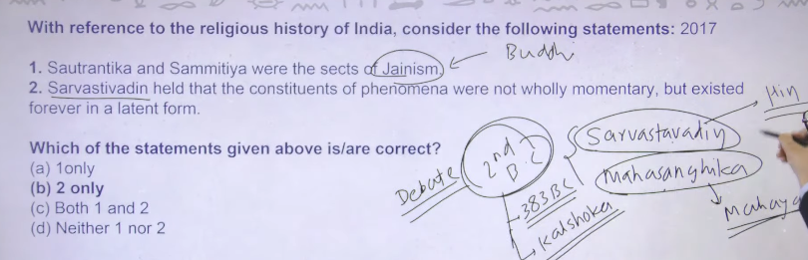

👉 Sthavādin के अनुसार, कर्म का असर छिपे रूप में बना रहता है (latent), इसलिए rebirth होता है — और जब ये असर खत्म हो जाता है, तब मुक्ति मिलती है।
- Sthavira (Sthavādin) → एक बौद्ध संप्रदाय held → मानते थे
- constituent → हिस्सा / भाग
- phenomenon → चीज़ें / घटनाएँ not wholly → पूरी तरह नहीं momentary → क्षणिक (एक पल का) existed → मौजूद थे forever → हमेशा latent → छिपा हुआ form → रूप

Ans:
Sautantika and sammityia both are related to Buddhist sects
Second Buddhist council me sarvastvadin and mahasanghika ye dono sect Buddhist ke decline ho gaye the later on sarvasavaadin jo hai ye merge ho gaya tha hinyaan Buddhism me and mahasanghika merge ho gaya mahyana Buddhism me earlisestt version of division jo hai uske bare me pucha tha but
Bahut he controvarseial type ka question ike wajah see hai kuki jo second Buddhist council hai jo 383 bc me hue the after 100 year nirvana of Buddha isko patronize kyia tha kalashoka ne jo king the patliputra ka at that time per to ye jo Buddhist council hai iske upar abhe bhe debat chal rahe hai ke ye Buddhist council hue the ke nahi but he different different history available hia ikse uppar

To ek cheez apko yaad rakhne hai ke sravastavadin and mahasangika hai ye sect hai of Buddhism hai aur sautantrika and sammitya ye do differtn sect further sect hai sarvastaadin ke

2- meaninghai ki koi bhe phenomenon hai uske jo constituents hote hai wo achanak se aye hue nahi hote hai momentary nahi hote hia wo basically latent hote hai abd wo latent form ko apko jagana padta hai
To jab bhe apko salvation chaye auur salvation apko bhale nahi chaye but apke body ke andar atma ke andar wo particual desiree hai abhe apko usko jagana hai jagane ke baad apko salvation ke tarf badna hai because that is the ultimate aim of your life

Ans: B 2

Sentence:
“Sthavādin held that the constituent of phenomenon were not wholly momentary but existed forever in a latent form”

1. Sthavira held
👉 held = मानते थे / believe करते थे

2. constituent
👉 constituent = छोटे-छोटे हिस्से / parts

3. phenomenon
👉 phenomenon = दुनिया की चीज़ें / घटनाएँ
(जैसे thoughts, feelings, objects)

4. not wholly momentary
👉 not wholly = पूरी तरह नहीं
👉 momentary = एक पल के लिए
✔️ मतलब: सिर्फ एक पल के लिए नहीं होते

5. but existed forever
👉 but = लेकिन
👉 existed forever = हमेशा किसी रूप में बने रहते हैं

6. latent form
👉 latent = छिपा हुआ
👉 form = रूप
✔️ मतलब: छिपे हुए रूप में

अब पूरा आसान मतलब:
👉 Sthavira मानते थे कि दुनिया की चीज़ें पूरी तरह एक पल में खत्म नहीं होतीं, बल्कि वे छिपे हुए रूप में हमेशा बनी रहती हैं।

सबसे छोटा मतलब:
👉 चीज़ खत्म होती है, लेकिन उसका असर छिपकर रहता है
buddhism context me is line ko define karo
ठीक है 👍 अब इस line को बौद्ध धर्म के context में simple तरीके से समझो 👇

किसकी सोच है?
👉 Sthavira (Sthavādin)

Buddhism में इसका मतलब:
👉 बौद्ध धर्म में कहा जाता है कि
सब कुछ क्षणिक (momentary) है (हर चीज़ बदलती रहती है)
लेकिन Sthavādin ने कहा 👇
👉 चीज़ें सिर्फ एक पल में खत्म नहीं हो जातीं ❌
👉 उनका कुछ असर (karma / impression) बचा रहता है ✔️

इसका relation किससे है?
👉 कर्म (karma) और rebirth (पुनर्जन्म) से
👉 अगर असर नहीं बचेगा:
- तो कर्म का फल कैसे मिलेगा?
- पुनर्जन्म कैसे होगा?
इसलिए उन्होंने कहा:
👉 चीज़ें latent (छिपे हुए रूप) में बनी रहती हैं

Example:
👉 तुमने कोई कर्म किया
- काम खत्म हो गया ✔️
- लेकिन उसका effect बचा रहता है ✔️
- बाद में उसका फल मिलता है

Final simple meaning:
👉 Sthavādin के अनुसार, चीज़ें खत्म हो जाती हैं लेकिन उनका असर (karma) छिपकर बना रहता है, इसलिए future में उसका फल मिलता है
acha to fir karma rebirth se mukti ke cocept me ye line exaplain karo
ठीक है 👍 अब इस line को karma, rebirth और mukti (moksha/nirvana) के concept से जोड़कर समझो 👇

किसकी सोच?
👉 Sthavira

1. Karma (कर्म)
👉 तुम जो भी कर्म करते हो (good/bad)
- काम खत्म हो जाता है ✔️
- लेकिन उसका असर (latent form) बचा रहता है ✔️
👉 यही “latent form” = कर्म का बीज (seed)

2. Rebirth (पुनर्जन्म)
👉 ये जो कर्म का बीज है
- वो तुरंत खत्म नहीं होता
- वो आगे जाकर फल देता है
👉 इसी कारण:
- अगला जन्म (rebirth) होता है
- जीवन की situation बनती है

3. Mukti / Nirvana (मुक्ति)
👉 जब:
- कोई नया कर्म नहीं बनता
- पुराने कर्म के बीज भी खत्म हो जाते हैं
👉 तब:
- कोई “latent effect” नहीं बचता
- इसलिए rebirth रुक जाता है

Final linking (पूरी line का मतलब):
👉 Sthavādin के अनुसार, कर्म का असर छिपे रूप में बना रहता है (latent), इसलिए rebirth होता है — और जब ये असर खत्म हो जाता है, तब मुक्ति मिलती है।

Short में:
👉 Latent karma → rebirth का कारण
👉 No karma → no rebirth = मुक्ति

- constituent का मतलब:👉 हिस्सा / घटक (part of something) 👉 जो मिलकर किसी चीज़ को बनाते हैं
Example 1:
👉 एक car
- engine
- wheels
- body
✔️ ये सब उसके constituents (हिस्से) हैं

Example 2:
👉 एक mobile phone
- battery
- screen
- processor
✔️ ये सब उसके constituents हैं

Short में:
👉 constituents = वो parts जो मिलकर कोई चीज़ बनाते हैं
sentence
ठीक है 👍 “constituent of phenomenon” के लिए 2 simple sentences:
- 👉 Every object is made up of many constituents of phenomenon.
(हर चीज़ कई छोटे-छोटे हिस्सों से बनी होती है)
- 👉 Body and mind are constituents of human phenomenon.
(शरीर और मन इंसान के हिस्से हैं)
Short में:
👉 Constituent of phenomenon = किसी चीज़ के छोटे-छोटे parts

- A constituent is a component part of a whole (e.g., ingredients, elements of a mixture) or a person represented by an elected official. It refers to parts that create a unit, such as chemical constituents, or people in a voting district. Synonyms include component, ingredient, element, voter, and elector.
- Usage Examples of Constituents
- As a Part/Component:
- "Oxygen is a constituent of air".
- "Vitamins are essential constituents of a good diet".
- "Methane is the main constituent of natural gas".
- "The engine has three moving constituent parts".
- As a Person/Voter (Political):
- "The senator mails a newsletter to his constituents every two months".
- "She's pledged to help her elderly constituents".
- "Elected officials should stay in touch with the needs of their constituents".
- As an Adjective:
- "The constituent assembly met to draft the new constitution".
- Synonyms of Constituents
- For Component/Part: Ingredient, element, factor, component, item, segment, piece, fragment, section, portion, unit.

#19


Ans: B
Ek minor sect ke bare meupsce ne pucha ‘
Sthanakvasi sect क्या है?
👉 Sthanakvasi जैन धर्म की एक उप-शाखा (sub-sect) है
👉 यह Svetambara से निकली है
इसकी खास बातें:
- मूर्ति पूजा (idol worship) नहीं करते
- सादगी और ध्यान (meditation) पर ज़ोर देते हैं
- मंदिर की जगह स्थानक (hall) में पूजा करते हैं
Short में:
👉 Sthanakvasi = Svetambara की non-idol worship sect

जैन धर्म में:
👉 Mahavira को “God” (creator भगवान) नहीं माना जाता
क्या माना जाता है?
👉 उन्हें Tirthankara / महान गुरु माना जाता है
👉 जिन्होंने मोक्ष (liberation) प्राप्त किया
अलग-अलग sect में:
- Digambara → पूजा करते हैं
- Svetambara → पूजा करते हैं
- Sthanakvasi → मूर्ति पूजा नहीं, पर सम्मान करते हैं
Short में:
👉 Mahavir = God नहीं, बल्कि enlightened guru (पूजनीय)

#.20
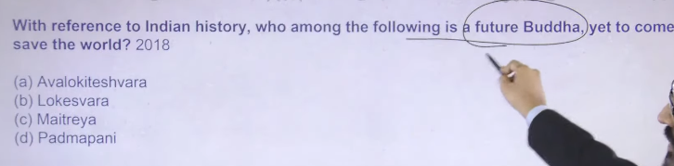

Ans: C
Avalokiteshvara ke do different name hai – lokesvara, and padmpani he is not the future Buddha he is there he is guiding people toward the salvation
Ek baar jab maitreya ayega tb apko manjushre, vajrapani, avalokeswavara apko nahi dekhenge

Avalokiteshvara कौन हैं?
👉 Avalokiteshvara एक Bodhisattva हैं (करुणा के प्रतीक)
👉 ये खास तौर पर Mahayana Buddhism में बहुत महत्वपूर्ण हैं
आसान समझ:
- इन्हें दया और करुणा (compassion) का भगवान माना जाता है
- माना जाता है कि ये सभी दुखी लोगों की मदद करते हैं
Short में:
👉 Avalokiteshvara = करुणा के Bodhisattva
lokeswara
Lokesvara क्या है?
👉 Lokesvara actually Avalokiteshvara का ही दूसरा नाम है
मतलब:
- Loka = दुनिया (world)
- Ishvara = स्वामी/भगवान (lord)
👉 इसलिए Lokesvara = “दुनिया के स्वामी” / Lord of the World
Short में:
👉 Lokesvara = Avalokiteshvara (same)
padmpani
Padmapani क्या है?
👉 Padmapani वास्तव में
Avalokiteshvara का ही एक रूप (form) है
मतलब:
- Padma = कमल (lotus)
- Pani = हाथ (hand)
👉 Padmapani = हाथ में कमल रखने वाला
आसान समझ:
👉 यह करुणा के Bodhisattva Avalokiteshvara का एक प्रसिद्ध रूप है
Short में:
👉 Padmapani = Avalokiteshvara का lotus वाला रूप
avloketswara ek bodhisatva hai ika kaya matlba hai ke wo budha hai
नहीं ❌, Bodhisattva = Buddha नहीं होता
समझो आसान भाषा में 👇
Avalokiteshvara क्या हैं?
👉 ये एक Bodhisattva हैं, Buddha नहीं
Bodhisattva का मतलब:
👉 ऐसा व्यक्ति जिसने ज्ञान (enlightenment) पा लिया है
👉 लेकिन दूसरों की मदद के लिए अभी Buddha नहीं बना / nirvana में नहीं गया
Buddha क्या होता है?
👉 पूरी तरह से enlightened और nirvana प्राप्त कर चुका

Simple difference:
👉 Bodhisattva = almost Buddha (helping others)
👉 Buddha = fully enlightened

Short में:
👉 Avalokiteshvara Buddha नहीं, बल्कि Bodhisattva हैं

21
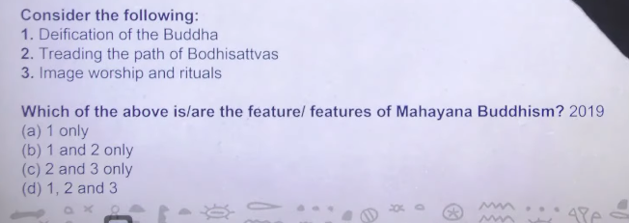

Ans: D

Deification of Buddha का हिंदी अर्थ
👉 “बुद्ध का देवता के रूप में पूजन करना”
या
👉 “बुद्ध का देवत्वकरण”
आसान भाषा में
शुरुआत में Gautama Buddha को सिर्फ महान गुरु और शिक्षक माना जाता था।
लेकिन बाद में कुछ परंपराओं में उन्हें देवता जैसा मानकर पूजा जाने लगा, इसे Deification of Buddha कहते हैं।
यह खासकर Buddhism की बाद की परंपराओं (जैसे Mahayana Buddhism) में ज्यादा दिखाई देता है। 📚
defication means
Deification का मतलब होता है किसी इंसान को देवता बना देना या देवता की तरह मानना।
आसान भाषा में
👉 जब किसी महान व्यक्ति को भगवान जैसा मानकर पूजा जाने लगे, तो उसे deification कहते हैं।
Example
- बाद में Gautama Buddha को कुछ परंपराओं में देवता की तरह पूजा जाने लगा, इसे deification of Buddha कहा जाता है।
✅ Short meaning:
Deification = किसी को देवता बनाना या देवता की तरह मानना। 📚
treading the path of bodhisattva hindi
“Treading the path of Bodhisattva” का हिंदी अर्थ है:
👉 “बोधिसत्त्व के मार्ग पर चलना।”
आसान भाषा में
- Treading the path = मार्ग पर चलना
- Bodhisattva = ऐसा व्यक्ति जो ज्ञान प्राप्ति की ओर बढ़ते हुए सभी जीवों की मदद करना चाहता है।
इसका मतलब है:
👉 दूसरों की मदद करते हुए ज्ञान (बोध) प्राप्त करने के रास्ते पर चलना।
यह विचार Buddhism की महायान परंपरा में बहुत महत्वपूर्ण है। 📚

All of the are the feature fo mahyanaa Buddhism
Mahayana Buddhism ka janam he concept of god ke uppar huea hai
Deficiation means bhgwan karan karna kise insaan ka kise jamane me wok e man tha uske marne ke baad wo bhagwan baan gaya
Mahayan me ye teeno milenge
Heenyana iin teeno ko oppose karta hai ki aisa kuch nahi hai
That is verya plain and simple thing

#.22
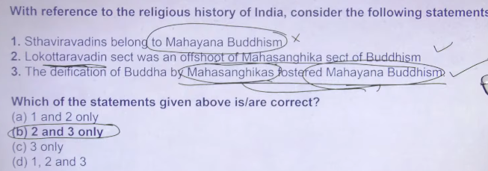

- Sthavira / Sthavādin → Theravada Buddhism से संबंधित है
- Sthavādin = Theravada परंपरा (पुरानी शाखा)
- Mahayana = अलग और बाद में विकसित शाखा
Mahasanghika क्या है?
👉 Mahasanghika बौद्ध धर्म की प्राचीन (early) शाखा थी
👉 इसका मतलब है “बड़ा समूह” (Great Community)
इसकी खास बातें:
- नियमों में थोड़ा लचीलापन (less strict) रखते थे
- Gautama Buddha को अधिक दिव्य/अलौकिक (superhuman) मानते थे
आसान समझ:
👉 Mahasanghika = liberal group + Buddha को divine मान

Mahasanghika ने Gautama Buddha को सिर्फ मानव नहीं, बल्कि दिव्य (superhuman) रूप में देखना शुरू किया। इसे ही “deification” (देवत्व देना) कहते हैं।
इससे क्या हुआ?
- महasanghika ने कहा कि बुद्ध अलौकिक शक्तियों वाले, सर्वज्ञ और लगभग ईश्वरीय हैं
- इससे लोगों में भक्ति (devotion) बढ़ी
- बुद्ध को पूजने और आदर्श रूप में मानने की परंपरा मजबूत हुई
- यही सोच आगे चलकर Mahayana Buddhism में विकसित हुई
- महायान में:
  - बुद्ध को देव-जैसा (transcendent) माना गया
  - Bodhisattva की पूजा और आदर्श भी आया
  - भक्ति और करुणा (compassion) पर ज्यादा जोर पड़ा

👉 Mahasanghika ने बुद्ध को divine बनाया → इससे भक्ति बढ़ी → इसी आधार पर Mahayana Buddhism विकसित हुआ

Deification (देवत्व देना) 👉 किसी इंसान को भगवान या दिव्य रूप में मान लेना
Gautama Buddha को साधारण इंसान से बढ़ाकर दिव्य/ईश्वरीय मानना = deification
Fostered 👉 बढ़ावा देना / विकसित करना / प्रोत्साहित करना 👉 किसी चीज़ को आगे बढ़ाना
शुरुआत में कौन से branches थे?
👉 सबसे पहले सिर्फ 2 groups बने थे:
- Sthavira
- Mahasanghika
ध्यान देने वाली बात:
👉 उस समय Mahayana Buddhism नहीं था
👉 Mahayana बाद में develop हुआ
आसान timeline:
- पहले: Sthavira + Mahasanghika
- बाद में: Mahayana, Theravada, Vajrayana बने
Short में:
👉 Starting branches = Sthavira & Mahasanghika (NOT Mahayana)

बौद्ध धर्म मुख्यतः 3 भागों (शाखाओं) में बाँटा जाता है:
- Theravada Buddhism
- Mahayana Buddhism
- Vajrayana Buddhism
Short में:
👉 Buddhism = 3 main parts
inke bhe sub part the kya
हाँ 👍, इन मुख्य शाखाओं के भी sub-parts (उप-शाखाएँ) थे/हैं।
1. Theravada Buddhism
- आज ज़्यादा sub-sects नहीं, पर पहले अलग-अलग निकाय थे
- अब mainly एक ही tradition बचा है
2. Mahayana Buddhism
इसके कई sub-parts बने:
- Zen Buddhism
- Pure Land Buddhism
- Nichiren Buddhism
3. Vajrayana Buddhism
इसके भी sub-parts:
- Tibetan Buddhism
- (इसके अंदर भी अलग schools हैं जैसे Gelug, Kagyu आदि)
छोटा निष्कर्ष:
👉 हाँ, हर मुख्य शाखा के अंदर भी कई sub-branches बनीं।
main category of buddhism is
बौद्ध धर्म की main categories (मुख्य शाखाएँ) ये हैं:
- Theravada Buddhism
- Mahayana Buddhism
- Vajrayana Buddhism
Short में:
👉 Buddhism = 3 main categories
2 line give for eahc what is
1. Theravada Buddhism
👉 सबसे पुरानी शाखा, बुद्ध की मूल शिक्षाओं पर आधारित
👉 व्यक्तिगत मुक्ति (nirvana) और साधना पर ज़ोर
2. Mahayana Buddhism
👉 सभी जीवों की मुक्ति (universal salvation) पर ज़ोर
👉 बुद्ध को दिव्य मानकर भक्ति और Bodhisattva आदर्श को मानता है
3. Vajrayana Buddhism
👉 Mahayana का ही एक विकसित रूप, जिसमें तंत्र और मंत्र का उपयोग होता है
👉 तेज़ मार्ग (fast path) से enlightenment पाने पर ज़ोर
thervada consider and vajrayan consider buddha as god
संक्षेप में 👇
Theravada Buddhism
👉 बुद्ध को भगवान (God) नहीं मानता
👉 उन्हें एक महान शिक्षक (enlightened human) मानता है
Vajrayana Buddhism
👉 बुद्ध को दिव्य/देव-जैसा (divine) रूप में मानता है
👉 कई देवता और रूप (deities, tantric forms) की पूजा भी होती है
Short निष्कर्ष:
👉 Theravada = बुद्ध God नहीं
👉 Vajrayana = बुद्ध को divine रूप में मानते हैं
buddhsim ka dividtion kb hua tha kya reason the
बौद्ध धर्म का पहला बड़ा विभाजन लगभग 4th–3rd century BCE में हुआ, खासकर Second Buddhist Council के समय।
मुख्य विभाजन:
👉 Sthavira vs Mahasanghika
कारण (Reasons):
- नियमों (Vinaya) पर विवाद
👉 कुछ भिक्षु नियमों को ढीला करना चाहते थे, कुछ सख्त रखना चाहते थे
- बुद्ध की प्रकृति पर मतभेद
👉 Sthavira: बुद्ध = मानव गुरु
👉 Mahasanghika: बुद्ध = अधिक दिव्य/अलौकिक
- जीवन शैली में अंतर
👉 सख्त अनुशासन vs थोड़ा उदार दृष्टिकोण
छोटा निष्कर्ष:
👉 अनुशासन और विचारों के मतभेद के कारण बौद्ध धर्म का विभाजन हुआ
noth udnerstood and sthavira kya hai
चलो आसान भाषा में समझते हैं 👇
Sthavira क्या है?
👉 “Sthavira” का मतलब होता है पुराने/वरिष्ठ भिक्षु (elders)
👉 यह बौद्ध धर्म की पहली शाखाओं में से एक थी
आसान समझ:
👉 Sthavira वाले लोग कहते थे:
- नियम (discipline) सख्त होने चाहिए
- Gautama Buddha को एक महान इंसान/teacher मानो, God नहीं
क्यों बना?
👉 कुछ भिक्षु नियम ढीले करना चाहते थे
👉 Sthavira group बोला: नहीं, नियम strict ही रहेंगे
Short में:
👉 Sthavira = strict rules + Buddha as teacher (not God)
sthavira and thervaada both are same
पूरी तरह same नहीं हैं, लेकिन जुड़े हुए हैं 👇
Sthavira
👉 बौद्ध धर्म की प्राचीन (early) शाखा थी
👉 यह original group था जो strict rules follow करता था
Theravada Buddhism
👉 Sthavira से ही बाद में विकसित (develop) हुई
👉 आज की modern surviving tradition है
Short में:
👉 Sthavira = पुरानी जड़ (origin)
👉 Theravada = उसी से निकली हुई शाखा
✔️ मतलब: Same नहीं, लेकिन Theravada = Sthavira की descendant है
kigve me buddhaism ke pahle starting ke kaise aur kitneparts me divide hua tha
शुरुआत में बौद्ध धर्म ऐसे divide हुआ था 👇
पहला विभाजन (First division)
👉 2 भागों में बँटा:
- Sthavira (Elders)
- Mahasanghika (Major group)
कैसे हुआ?
👉 भिक्षुओं में नियम (Vinaya) और सोच को लेकर विवाद हुआ
👉 इसी वजह से 2 groups बन गए
बाद में क्या हुआ?
👉 इन दोनों से आगे चलकर:
- Theravada Buddhism
- Mahayana Buddhism
- Vajrayana Buddhism
जैसी बड़ी शाखाएँ विकसित हुईं
Short में:
👉 Starting: 2 parts (Sthavira + Mahasanghika)
👉 Later: 3 main traditions बने
division ka ek image do pura

Edit
buddhism kitne sects me divide tha
शुरुआत में बौद्ध धर्म 2 sects (शाखाओं) में divide हुआ था 👇
👉 2 मुख्य sects:
- Sthavira
- Mahasanghika
बाद में:
👉 इनसे आगे चलकर कई (लगभग 18+) छोटी-छोटी शाखाएँ बनीं
Short में:
👉 पहले = 2 sects
👉 बाद में = कई (18 के आसपास)
lokotarvadin sect was an offshott of mahsanghika sect
हाँ ✅, यह statement सही है।
👉 Lokottaravada sect वास्तव में
Mahasanghika की एक offshoot (उप-शाखा) थी।
आसान समझ:
- Mahasanghika → main group
- Lokottaravada → उसी से निकली sub-branch
खास बात:
👉 Lokottaravadin लोग Gautama Buddha को
पूरी तरह अलौकिक (lokottara = worldly से ऊपर) मानते थे
Short में:
👉 Lokottaravada = Mahasanghika की branch

बौद्ध धर्म मुख्यतः 3 भागों (शाखाओं) में बाँटा जाता है:
- Theravada Buddhism
- Mahayana Buddhism
- Vajrayana Buddhism
Short में:
👉 Buddhism = 3 main parts
inke bhe sub part the kya
हाँ 👍, इन मुख्य शाखाओं के भी sub-parts (उप-शाखाएँ) थे/हैं।
1. Theravada Buddhism
- आज ज़्यादा sub-sects नहीं, पर पहले अलग-अलग निकाय थे
- अब mainly एक ही tradition बचा है
2. Mahayana Buddhism
इसके कई sub-parts बने:
- Zen Buddhism
- Pure Land Buddhism
- Nichiren Buddhism
3. Vajrayana Buddhism
इसके भी sub-parts:
- Tibetan Buddhism
- (इसके अंदर भी अलग schools हैं जैसे Gelug, Kagyu आदि)
छोटा निष्कर्ष:
👉 हाँ, हर मुख्य शाखा के अंदर भी कई sub-branches बनीं।
main category of buddhism is
बौद्ध धर्म की main categories (मुख्य शाखाएँ) ये हैं:
- Theravada Buddhism
- Mahayana Buddhism
- Vajrayana Buddhism
Short में:
👉 Buddhism = 3 main categories
2 line give for eahc what is
1. Theravada Buddhism
👉 सबसे पुरानी शाखा, बुद्ध की मूल शिक्षाओं पर आधारित
👉 व्यक्तिगत मुक्ति (nirvana) और साधना पर ज़ोर
2. Mahayana Buddhism
👉 सभी जीवों की मुक्ति (universal salvation) पर ज़ोर
👉 बुद्ध को दिव्य मानकर भक्ति और Bodhisattva आदर्श को मानता है
3. Vajrayana Buddhism
👉 Mahayana का ही एक विकसित रूप, जिसमें तंत्र और मंत्र का उपयोग होता है
👉 तेज़ मार्ग (fast path) से enlightenment पाने पर ज़ोर
thervada consider and vajrayan consider buddha as god
संक्षेप में 👇
Theravada Buddhism
👉 बुद्ध को भगवान (God) नहीं मानता
👉 उन्हें एक महान शिक्षक (enlightened human) मानता है
Vajrayana Buddhism
👉 बुद्ध को दिव्य/देव-जैसा (divine) रूप में मानता है
👉 कई देवता और रूप (deities, tantric forms) की पूजा भी होती है
Short निष्कर्ष:
👉 Theravada = बुद्ध God नहीं
👉 Vajrayana = बुद्ध को divine रूप में मानते हैं
buddhsim ka dividtion kb hua tha kya reason the
बौद्ध धर्म का पहला बड़ा विभाजन लगभग 4th–3rd century BCE में हुआ, खासकर Second Buddhist Council के समय।
मुख्य विभाजन:
👉 Sthavira vs Mahasanghika
कारण (Reasons):
- नियमों (Vinaya) पर विवाद
👉 कुछ भिक्षु नियमों को ढीला करना चाहते थे, कुछ सख्त रखना चाहते थे
- बुद्ध की प्रकृति पर मतभेद
👉 Sthavira: बुद्ध = मानव गुरु
👉 Mahasanghika: बुद्ध = अधिक दिव्य/अलौकिक
- जीवन शैली में अंतर
👉 सख्त अनुशासन vs थोड़ा उदार दृष्टिकोण
छोटा निष्कर्ष:
👉 अनुशासन और विचारों के मतभेद के कारण बौद्ध धर्म का विभाजन हुआ
noth udnerstood and sthavira kya hai
चलो आसान भाषा में समझते हैं 👇
Sthavira क्या है?
👉 “Sthavira” का मतलब होता है पुराने/वरिष्ठ भिक्षु (elders)
👉 यह बौद्ध धर्म की पहली शाखाओं में से एक थी
आसान समझ:
👉 Sthavira वाले लोग कहते थे:
- नियम (discipline) सख्त होने चाहिए
- Gautama Buddha को एक महान इंसान/teacher मानो, God नहीं
क्यों बना?
👉 कुछ भिक्षु नियम ढीले करना चाहते थे
👉 Sthavira group बोला: नहीं, नियम strict ही रहेंगे
Short में:
👉 Sthavira = strict rules + Buddha as teacher (not God)
sthavira and thervaada both are same
पूरी तरह same नहीं हैं, लेकिन जुड़े हुए हैं 👇
Sthavira
👉 बौद्ध धर्म की प्राचीन (early) शाखा थी
👉 यह original group था जो strict rules follow करता था
Theravada Buddhism
👉 Sthavira से ही बाद में विकसित (develop) हुई
👉 आज की modern surviving tradition है
Short में:
👉 Sthavira = पुरानी जड़ (origin)
👉 Theravada = उसी से निकली हुई शाखा
✔️ मतलब: Same नहीं, लेकिन Theravada = Sthavira की descendant है
kigve me buddhaism ke pahle starting ke kaise aur kitneparts me divide hua tha
शुरुआत में बौद्ध धर्म ऐसे divide हुआ था 👇
पहला विभाजन (First division)
👉 2 भागों में बँटा:
- Sthavira (Elders)
- Mahasanghika (Major group)
कैसे हुआ?
👉 भिक्षुओं में नियम (Vinaya) और सोच को लेकर विवाद हुआ
👉 इसी वजह से 2 groups बन गए
बाद में क्या हुआ?
👉 इन दोनों से आगे चलकर:
- Theravada Buddhism
- Mahayana Buddhism
- Vajrayana Buddhism
जैसी बड़ी शाखाएँ विकसित हुईं
Short में:
👉 Starting: 2 parts (Sthavira + Mahasanghika)
👉 Later: 3 main traditions बने
division ka ek image do pura
Edit
buddhism kitne sects me divide tha
शुरुआत में बौद्ध धर्म 2 sects (शाखाओं) में divide हुआ था 👇
👉 2 मुख्य sects:
- Sthavira
- Mahasanghika
बाद में:
👉 इनसे आगे चलकर कई (लगभग 18+) छोटी-छोटी शाखाएँ बनीं
Short में:
👉 पहले = 2 sects
👉 बाद में = कई (18 के आसपास)
lokotarvadin sect was an offshott of mahsanghika sect
हाँ ✅, यह statement सही है।
👉 Lokottaravada sect वास्तव में
Mahasanghika की एक offshoot (उप-शाखा) थी।
आसान समझ:
- Mahasanghika → main group
- Lokottaravada → उसी से निकली sub-branch
खास बात:
👉 Lokottaravadin लोग Gautama Buddha को
पूरी तरह अलौकिक (lokottara = worldly से ऊपर) मानते थे
Short में:
👉 Lokottaravada = Mahasanghika की branch

Buddhist sects are generally divided into three main branches or traditions: Theravada, Mahayana, and Vajrayana. These branches represent different approaches to the Buddha's teachings, ranging from conservative monastic practices to broader, esoteric interpretations, with many sub-schools within each.
- Theravada ("Teaching of the Elders"): Known as the most conservative or orthodox branch, it focuses on original teachings, personal enlightenment, and monastic discipline. It is dominant in Sri Lanka, Thailand, Cambodia, Laos, and Myanmar.
- Mahayana ("Great Vehicle"): The largest branch, which emphasizes the Bodhisattva ideal (helping all beings reach enlightenment). It is prevalent in China, Japan, Korea, Vietnam, and Taiwan, and includes traditions like Zen and Pure Land.
- Vajrayana ("Diamond Vehicle"): Often considered part of or an offshoot of Mahayana, it is known as Tantric Buddhism and emphasizes rapid enlightenment through specialized rituals and meditation. It is primarily practiced in Tibet, Nepal, Bhutan, and Mongolia.
Key Historical Split:
The original, early division occurred following the Second Buddhist Council (~383 BCE), splitting into the Sthaviravada (ancestors of Theravada) and Mahasanghika (a more liberal group), which laid the foundation for the later, more distinct traditions.
Vision IAS +1

#.23
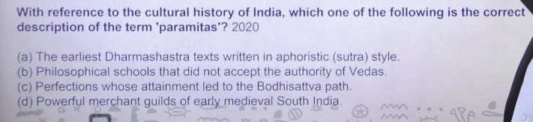
Ans: c
👉 “Perfections whose attainment led to the Bodhisattva path” का हिंदी मतलब है:
“वे पारमिताएँ (श्रेष्ठ गुण) जिनकी प्राप्ति से बोधिसत्त्व मार्ग पर चला जाता है।”
Paramitas (पारमिताएँ)— ऐसी श्रेष्ठ गुण/virtues जिन्हें अपनाकर व्यक्ति बोधि (ज्ञान) प्राप्त करता है।
Bodhisattva (in बौद्ध धर्म) = वह व्यक्ति जो बुद्ध बनने की राह पर है और दूसरों की मुक्ति के लिए काम करता है।
वे श्रेष्ठ गुण जिन्हें प्राप्त करने से व्यक्ति बोधिसत्त्व के मार्ग पर चल सकता है। 📚
- Paramita = श्रेष्ठ गुण / पूर्णताएँ
- Bodhisattva = वह जो ज्ञान (बोध) प्राप्ति के मार्ग पर है और दूसरों की मदद करता है
पारमिताएँ ऐसे श्रेष्ठ गुण हैं जिन्हें प्राप्त करने से व्यक्ति बोधिसत्त्व के मार्ग पर चल सकता है।
Manjushree jo hai wo hato me books lyie hai aur ye book ka name hai pareemeta Manjushree is basically the god of wisdom
Manjushri is an important Bodhisattva in Buddhism.
He represents wisdom and insight.
He is often shown holding a sword that cuts ignorance.
manjsudhsre in buddah ke bare me bato
मंजुश्री बौद्ध धर्म के एक प्रमुख बोधिसत्त्व हैं।
👉 ये ज्ञान (wisdom) के प्रतीक माने जाते हैं।
👉 इनके हाथ में तलवार होती है, जो अज्ञान (ignorance) को काटने का प्रतीक है।
👉 ये साधकों को सही समझ और बुद्धि प्राप्त करने में मदद करते हैं।

Aphoristic sutra style = छोटे, संक्षिप्त और सूत्र जैसे वाक्यों में लिखी गई शैली, जिनमें गहरा अर्थ होता है और जिन्हें समझने के लिए व्याख्या (explanation) की जरूरत होती है।
not understod
कोई बात नहीं, आसान में समझो 👇
Aphoristic sutra style =
👉 बहुत छोटे-छोटे वाक्य
👉 लेकिन उनमें गहरा मतलब छुपा होता है
📌 Example:
जैसे “अहिंसा परमो धर्मः” – छोटा वाक्य, पर बड़ा अर्थ
👉 Simple line:
Short line + deep meaning = aphoristic sutra style 👍
gie me ine ingleihs
Aphoristic sutra style =
👉 very short sentences
👉 but with deep meaning
📌 Example:
“Ahimsa is the highest duty”
👉 Simple line:
Short sentence + deep meaning = aphoristic sutra style 👍

Philosophical schools = different systems of thought or ideas that explain life, reality, and truth.
👉 In Indian context:
- Nyaya – logic
- Samkhya – dualism (purusha & prakriti)
- Vedanta – Brahman/ultimate reality
- Buddhist philosophy – impermanence & suffering
- Jain philosophy – non-violence & many-sided truth
👉 Simple line:
Philosophical schools = different ways of thinking about truth and life.
Philosophical schools = जीवन, सत्य और वास्तविकता को समझाने वाले अलग-अलग विचारधाराओं के समूह।
isko english me do
Philosophical schools = groups of different systems of thought that explain life, truth, and reality.

#.24
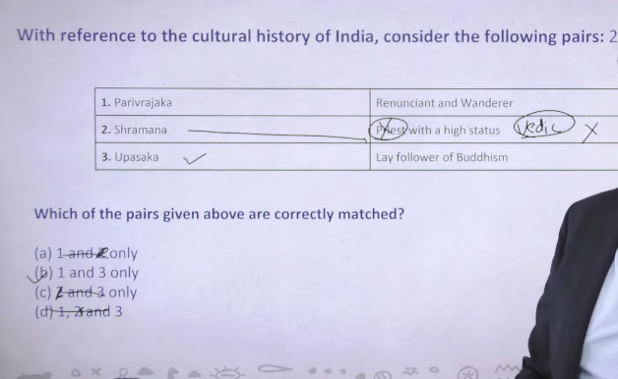
प्रवर्जक (Pravarjaka) वह व्यक्ति जो संसार छोड़कर संन्यास (त्याग का जीवन) अपनाता है।
Shramanic religions have monks who practice and spread dharma, not perform priestly rituals.
Shramana: monks (भिक्षु) who follow renunciation, meditation, and dharma.
Pravrajaka: an individual who leaves home to become a monk.

- Shramana = category (group)
- Pravrajaka = individual (person in that group)
- Shramanic religions (जैसे Buddhism और Jainism) में monks होते हैं, लेकिन:
- Monk = priest (पूजा कराने वाला) नहीं होता
- Monk क्या होता है?
वह व्यक्ति जो धर्म का पालन करता है, ध्यान करता है, और लोगों को मार्ग दिखाता है
वह खुद पूजा कराने वाला पुजारी नहीं होता
- Pravrajaka:
जो घर छोड़कर monk बनता है
- Shramana:
ऐसे सभी monks का समूह/परंपरा

Renunciant = जो व्यक्ति दुनिया (माया, परिवार, सुख-सुविधा) का त्याग कर दे
Wanderer = जो व्यक्ति इधर-उधर भटकते हुए जीवन बिताए
Renunciant and wanderer = वह व्यक्ति जिसने सब कुछ छोड़ दिया और घूम-घूमकर जीवन जीता है (जैसे साधु/संन्यासी)।
“प्रवर्जक (Pravarjaka)” शब्द मुख्यतः हिंदू धर्म से जुड़ा है (संन्यास लेने वाले के लिए),
लेकिन इसका उपयोग बौद्ध धर्म में भी मिलता है (गृह त्याग करने वाले भिक्षु के लिए)। यह शब्द दोनों परंपराओं में इस्तेमाल हुआ है।

To priest apko vedic literature me milenge not in the shramaini k relgion
Upasak means lay follower of particular religion or sects
Heterodox sect ka jo sanskrti name hai wo hai shramana
Vidic religion me apko priest milenge
And shramanik relgion me apko monk milenge
monk are basically dharma pracharak priest means dharma ke puja karne wala

1. Vedic vs Shramanic traditions
- वैदिक धर्म (Vedic religion)
👉 यहाँ priest (पुरोहित) मिलते हैं
👉 इनका काम होता है यज्ञ, पूजा, मंत्र आदि करना
- श्रमण परंपरा (Shramanic / Heterodox sects)
👉 इसमें बौद्ध धर्म, जैन धर्म आते हैं
👉 यहाँ monk (भिक्षु / साधु) होते हैं
👉 ये पूजा कराने वाले नहीं, बल्कि धर्म का पालन और प्रचार करते हैं
✔️ Difference:
- Priest = पूजा/यज्ञ कराने वाला
- Monk = त्यागी जीवन जीने वाला, धर्म सिखाने वाला

2. Upasak (उपासक)
किसी धर्म या संप्रदाय का सामान्य (lay) follower
✔️ ये गृहस्थ होता है (घर-परिवार वाला), monk नहीं

3. Pravrajaka (प्रवर्जक)
👉 Pravrajaka का मतलब है:
वह व्यक्ति जिसने संसार छोड़ दिया (renunciation) और भटकते हुए जीवन जीता है
✔️ जैसे:
- साधु
- संन्यासी
- घूम-घूम कर ज्ञान खोजने वाला

4. Shramana (श्रमण)
👉 यह heterodox traditions (non-vedic) का संस्कृत नाम है
👉 इसमें वे लोग आते हैं जो:
- त्याग करते हैं तपस्या करते हैं
- वैदिक परंपरा को follow नहीं करते

Final simple summary 👇
- Vedic religion → Priest (पुरोहित)
- Shramanic religion → Monk (भिक्षु/साधु)
- Upasak → साधारण follower (गृहस्थ)
- Pravrajaka → संसार त्याग कर भटकने वाला संन्यासी

Heterodox sect (UPSC – 4 lines):
- Heterodox (नास्तिक) संप्रदाय वे हैं जो वेद की authority और वैदिक कर्मकांड को नहीं मानते।
- इन्हें सामूहिक रूप से श्रमण परंपरा कहा जाता है, जो 6th century BCE में उभरी।
- ये यज्ञ-कर्मकांड के बजाय तप, नैतिक जीवन, अहिंसा और ज्ञान पर जोर देते हैं।
- इन परंपराओं में monks (भिक्षु/साधु) का महत्व होता है, न कि priests का।
- ये जाति व्यवस्था और ब्राह्मण वर्चस्व को चुनौती देती हैं।
- प्रमुख उदाहरण: बौद्ध धर्म, जैन धर्म।
- Heterodox sects वे धार्मिक परंपराएँ हैं जो वेद की authority को स्वीकार नहीं करतीं।
- इन्हें श्रमण परंपरा भी कहा जाता है।
- ये कर्मकांड (rituals) की जगह नैतिकता, तप और ज्ञान पर जोर देती हैं।
- प्रमुख उदाहरण हैं बौद्ध धर्म और जैन धर्म।
- इनका उदय सामाजिक-धार्मिक सुधार आंदोलन के रूप में हुआ, जिसने भारतीय दर्शन को नई दिशा दी।

🟡 Buddhism (बौद्ध धर्म)
- बौद्ध धर्म – founded by गौतम बुद्ध
- Four Noble Truths – दुःख और उसके कारण का सिद्धांत
- Eightfold Path – सही जीवन का मार्ग
- Nirvana – मोक्ष (दुःख से मुक्ति)
- Sangha – भिक्षुओं का समूह
- Tripitaka – बौद्ध ग्रंथ

🟢 Jainism (जैन धर्म)
- जैन धर्म – 24th Tirthankara महावीर
- Ahimsa – अहिंसा सर्वोपरि
- Triratna (3 jewels) – सम्यक दर्शन, ज्ञान, आचरण
- Kevalya – मोक्ष (पूर्ण ज्ञान)
- Tirthankara – आध्यात्मिक गुरु
- Anekantavada – सत्य के अनेक पहलू

🔵 Common / Mixed Terms
- श्रमण परंपरा – दोनों का आधार
- Upasaka – सामान्य अनुयायी (lay follower)
- Pravrajaka – संन्यासी/त्यागी
- Karma & Rebirth – कर्म और पुनर्जन्म

????Magdha Empire

1
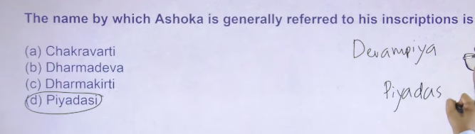
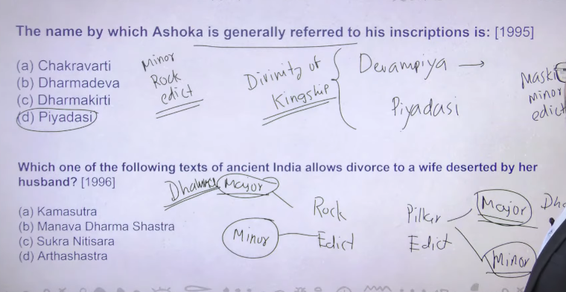
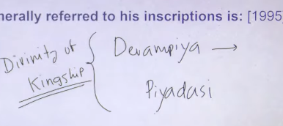
Peeprahava is the oldest stupa but isme bhe debate hai ke oldest peeprahva ka hai ya fir sanchi ka hai
Jainism and Buddhism dono ke school and subschool important hai
Agar koi doubt rahe tomeanwhile you can ask me

Devam pyia means beloved of god
Piyadashi means jo dikhhne me badhiya hai jsika appearance acha hai
To ye common name ashoka apne lyie use kyia karta tha because there is the earliest evidence of divinity in kingship ka jo earliest concept hai ke raja bhagwa hota hai divnity fo kingship kafi common term hia so divinity of kingship ka earliest concept hai that we can trace from the ashonkan period onward then later on period me ye strengthn hota gya
And even when Islamic invaders rule in india islam me khud ko allah se compare karna bahle he gunah ho but Islamic invader jo india me rule kr rahe the unhone kingship wala concept apan lyia akbar and balaban is used to called himsslef jil-e-illahe means shadow of god of earth
Divinity fo kingship wala concept hai that is always coming from handy rulling class kuki raja bhagwan baan jayega to bagawat kaam hoge aur log usko sunna chalu karenge
So divinity of kingshipke lyei ashowka always used to called himself devampyia piyadashi

Ashoka ke kuch minor rock edict hai
Ashoka ke kuch inscription hai jo humko rock ke uppar mile hai aur kuch pillar ke uppar mile hai then fir again dono me classification hai major and minor ka
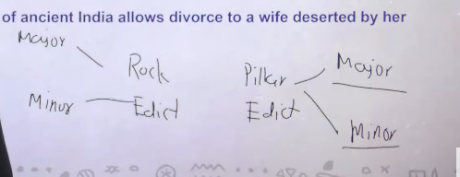
Major and minor ka concept isley hai kuki ashoka n
Majaor pillar and major rock ke uppar ashoka ne dhamma policy likh rakha hai ashoka dhaam is nothing related to religion but it is a social code and conduct hai ki logo ko kaise behave karna hai in the society
Kuki in india at that time different religion and different kind of people live in and aisse me agar apke pass secularism ka concept nahi hai to apke paas kaun sa concept hai dhamma wala it was nothing it is just indirect threat to people ki apko kaise rahna hai fir usne ye bhe batya ke agar app aise nahi rahoge to uske lyie officer appoint krke rakhe hai that is dhamma mahamatra they offieerce are punished those who are nothe followed policy of dhamma
Major rock and major pillar ke uppar ashoka ka name devampyiapyiadashi khe milega
But minor rock and minor pillar edict me ashoka ne apna naam ashoka batya hai measn devampyia dashiki ke sath brachet me ashoka hai ye wale inscription hum logo ko kahah mile hai to sirf south india me mile hai north idnia me aisa koi bhe inscription nahi mila hai jaash ashoka ne apna naam likhkar rakha hai

To fir ashhoka agar apne ko devam pyiadpyiadashi bol rahah to hame kaise pata chalk e wo ashoka hai because maski minor rock edict me uske uppar ashoka ne apna naamee ashoka likh kar rakha hai jisse paatachala ke wo ashoka hai devampiyiyadashi jb tk ye patanhai that b tk ho do different log and ashoka ko srilandka (seelon) ka king mante the
This is something that devamapyia dashiki ka major roeck and minor pillar minor pillar and rock edict se kya lena dena hai thereafter next one

Ans:D

2

Divorce sabsee pahle india me kine ne allow kyia wo none other than achayra chnkya arhtshastra me instance sabse pahle dekhne ko milega where divorce kind of thing can be there
Ans: d

3
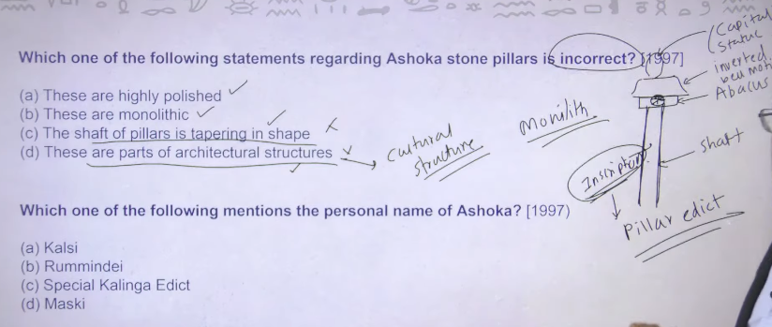
To ashoka ka jo pillar hai wo bahut he plane and simple hua krta tha pillar uske upara abacus useupar inverted well motive ya inverted lotus fir uske upar capital capital is nothing it is just a stone statue aur jo neeche pilar hai useko shaft bottle the to ye bahut he plain and common structure hai
Ashoka ke jo pillar hote the wo monolith hote the monolith means ek he structure ko carve out krkeupar stricter bante the
Shaft jo hai uske upar ashoka apne inscription likhta tha to jab ye inscritpon humiko mile to hamne inko bola chalu kyia pillar edict
Edict means inscription
Abhe india ka jo royal insigniya hai royal insigniya kya hai basically four lion royal insigniya ko ashoka ke sarnath ke pillar ke upar se uthaya hai and waise he inida ke flag me jo dharma chakra parevartan ka mudra hai wo bhe one of the ashoka ke sarnath ke pillar ke abacus me tha
1 and 2 monolith hai to usko app carve out krke struuctuure me laa rahe ho jisko polished bhe bolte hai
3- means shaft hai uske upar koi tapering nahi hai trekon shape nahi hai pillar 4- ye architectural structure se jayda cultural structure hai to both are incorrect these are controversial statemet cultural structure iske lyie kuki in pillar ke uppar hum logo ko inscription mile hai
So by puttingthe inscription on pillar ashoka made those a cultural marvel in his perioid

4
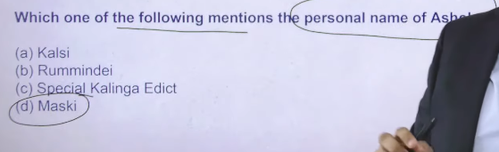
Ans:D
Maski pillar eedict me ahsoka ne apna name likha hai dvampiyayadaashi that is ashoka his personal name

Maski ke alawa ek aur inscription hai that is kanganhalli

5

Ans: a
Sohagaura copper inscriition jo hai wo Chandragupta maurya ka hai usme usne mention karke rakha hai ke koshthgara a place where grains are stored
Mehrauli pillar insccition chdragutpat second ke prashti hai jisme uske prashansh ke gae hai
Prayag prashit is – samdurda gutpat samudarapgut ka praise isme milega isko Allahabad pillar inscription bhe bola jata hai

Then after
Rummendaie pillar edict of ashoka and iske sath he lumbini pillar edict of ashoka ye iske lyie important hai kuuki iske upar ashoka ne khud likh kr rakha hai ke mai Buddha ke gaon ko visit kyia hu because Buddha isborn in lumbini and ye bhe lkha hai ke fir ushne tax ko reduce kyia tha
Jisse ye ptaa chala ki king has the power to reduce taxes

6
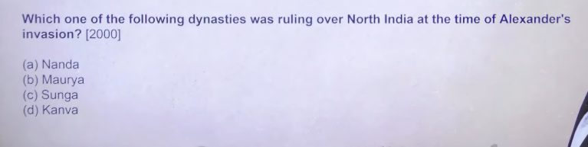
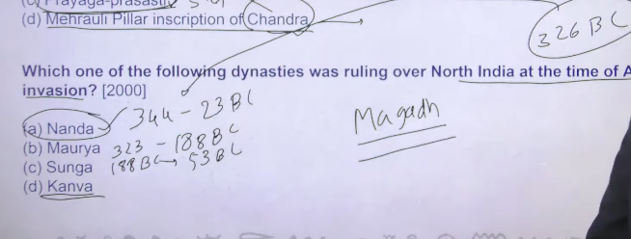
Ans: A
The Nanda dynasty ruled the Magadha region in northern India for a relatively brief period, commonly identified as c. 345–321 BCE. Founded by Mahapadma Nanda after overthrowing the Shishunaga dynasty, the empire was characterized by massive military power and centralised administration, ultimately falling to Chandragupta Maurya.
Key Details of the Nanda Dynasty Period:
- Duration: Approximately 345–321 BCE.
- Founder: Mahapadma Nanda (ruled c. 345–337 BCE), sometimes known as the destroyer of Kshatriyas.
- Dhana Nanda, the last ruler of the Nanda dynasty in ancient India, reigned approximately from c. 329–321 BCE.

Alexandar ke invasion ke time per north india me kauun rule kar rahah tha to answer is nanda dyanasty dhananda
Haryank dynasty
sishunaga
Nanda dynasty ruling over maghad 344bc to 323bc
Mauryans- roght time period is 323bc- 188bc
Thereafter sunga188bc to 53bc therafter
Kanvas ate hai these are rought time period
Kanvas is the last dynasty to rule madgdh empire

These are thebasically dynasty that ruled magadh empiore
To jab alexdanr ka invasion hua 326bc me who are the ruler then nanda was the ruler

Ans: A

7
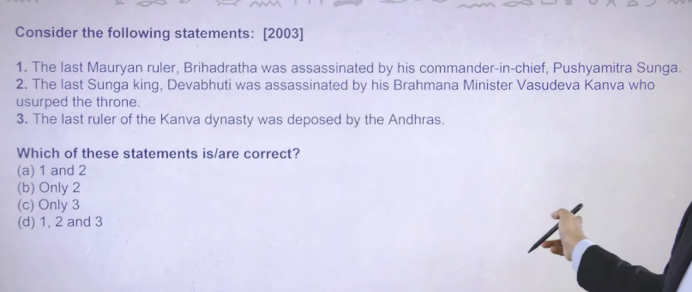
Ans:
Shunga kaise aye mauryan ruler bridharahta ko maar kar he killed last mauryan king bridharatha
Then after second is also true
Then after third is also true andhara is satvahanas kanva dynasty was defeated by satvahana dynasty
But satvahah never ruled from patliputra because there capital is prathesthan prathesthan is modern day paithan Aurangabad ke around wala area hai in maharastra me
Ans:D
Thhisis the basically dynastic succession of magadh

8 Ans: C
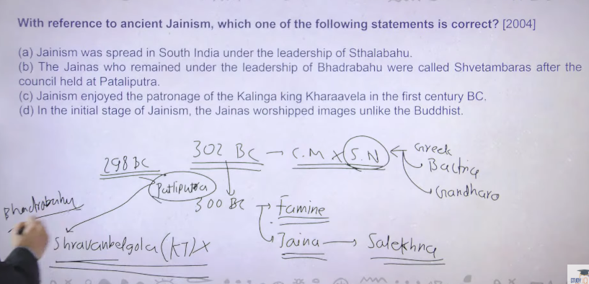
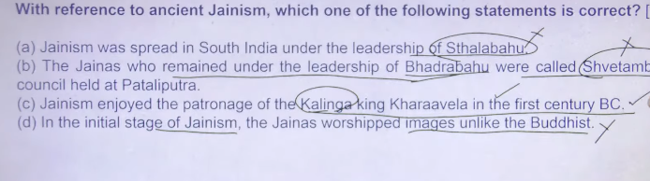

Ans:C wwill bee c overhere since the corrct statement asked here
Since correct statement has been asked to be indentify

“Jainism enjoyed the patronage of the Kalinga king Kharavela in the 1st century BCE” ka matlab hai:
👉 1st century BCE me Kharavela (Kalinga ka raja) ne Jain dharm ko support aur protection diya.
Patronage ka matlab hota hai:
- Raja ka support dena
- Dharm ko badhava dena
- Monks (sadhus) ko help karna
- Mandir/guha banwana ya daan dena
👉 Simple line:
“Kalinga ke raja Kharavela ne 1st century BCE me Jain dharm ko support kiya aur use badhava diya.”

In 302bc chandgupta maurya defaeated selucus necater , seleucus necater is the greek commander of great Alexander who is ruling from bacteria bacteria is in today modern day afganistan aur isko he harakar unhone gandhar wala pura area apne under me le lyia tha Chandragupta maurya ne
But the problem is war excel ke itne dur daraj area me jakar agar war khelna hai to uske lyie resources lagega and that exactly what happen with that this fellow
Ajj bhe agar app dekhoge to aaj jo Ukraine and putin ka saga chal rahah hai usme ultimate loss putin ka ho raha hai wo Russia ka ho rahah hai kuki because huge drain of resource going towards Ukraine to inke sath bhe wahe hua
302 BC me jb ye war khtam hua to somewhere around 300BCme mauryan empire me ek large famine aa gaya to chandgupta muarya ne ek stategey play ke that he is adopted jainisme he is not jain from beginning of his life he became jain to end of his life and once he became jain usne ek ceremony perform kanre ke soche jisko bolte hai salekhna modern day porution name hai iska and porution me you will starve yourself to death means app fast rakhoge waur wo fast kya hoga extreme penance hoga extreme level ka fast hoga jab tk app mar nahi jate
To basically killing yourself via fasting is called pollution in today ancient time me ikso salekhna bolte the
So basically this is the concept of chandraputa maurya Jainism adpopt kya aur janism adopt kern eke baad somewhere around 298 BC he decided ke patliputra aur madhag dynasty ke upar ka load thoda kaam karte hai he decided travel from patliputra to shrvanbelgoa (Karnataka) aur shravanbelgoal me jakar he will commit parution and he killed himself and that is exactly what he has he did
Patliputra bhirar area modern day patna
Idea is that wo jayenge to akele nahi jayenge there was huge number of people hai jo unke sath jayenge to teriotry ke upar jo logo ka bhaar hai wo kaam ho jayega aur is famine ko exactly taclkle kyia jaa sakega
Now he was king to koi na koi bada jain monk to unke sath jayega to inke sath shrvanbelgala me jo aya uska name tha bhadrbahu so bhadrabahu went along with him in shravanbelgea aur palitputr ame jo bahca hua tha monk leader wo tha sthulbahu so sthulbahu was there only in paltiputra and bhadrabahu went to shravanbelgola
And when chandragutpa mauurya died in shravenglagoa after that badhrabahu came back to patliputra to usne yaaha dekha ke sthulbahu and uske jo follower hai unhone to kapde pahna chalu kyia jbki mahveer ne clearly bola tha that we shall not wear the cloth apko naked rahan ahai
But sthulbahu ne bola ek empire me sabhe logo naked hai famine ke wajah se jised ye dertermine karna mushkeel ho rahah tha ki kaun jain follower hai aur kaun commn people hai to it is very difficult to segregate people from jain monk that’s why I allowedpeople to wear the cloth to inke folowerr ko bolenge shewtambar mean jinhone shewat white cloths pahne ho safed kapde ya fir white clad
Jbke bhadrbahue hee always remain naked to inke follower ko bolengee degambar degambar means dega ambar sky clad to jo asmaan haiusko he kapda manee walee log
To jo ye shewtambar and degambar wala story hai it is related to famine aur isee famine me hum logo ko sahugaura copper plate inscription bhe mila hai jismee maurya king chadrna ne clear directive dyia hai local officials ko that you need to create koshthgara
This is the brief story toward the end of chandraguptrya murya ke reign me hua

First and second is wrong
Third- kalinga modern day odhissa wala area it was ruled by kahravela kharahela is the good kign and best king of ancient india inka ek inscription bhe hai hatigumfa inscription odhissa me he hai kharavela is also jain flower it is true
Fourth is wrong both buddhsima and janinsm me initial period me image worship nahi hote the image wordship in dono me bhee chalu kab hue gupta period onward
Buuddhism me humne dekha tha ke jo first centurya and second centary ad ke onward bodhiatva ka concept ayay and with bodhhisatva inme image worship chalu ho gae same jain me bhe gupta period onward inmee image worsip chalu ho gae

9 Ans: C 2and3

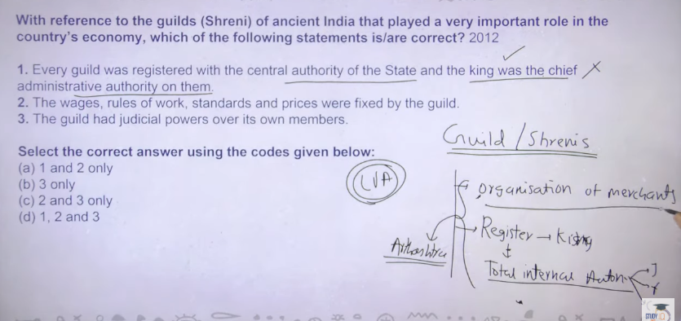
👉 Guild = an association of people of the same trade or profession who work together and regulate their activities. 👍

👉 “Over its own members” ka matlab:
“Apne hi members par (unka control / authority hona)”
श्रेणी (या श्रेणी) व्यापारियों, सौदागरों और कारीगरों का एक प्राचीन भारतीय संघथा। इसे अक्सर "गिल्ड" के रूप में जाना जाता है और इसनेप्राचीन भारत के सामाजिक-आर्थिक जीवन में, विशेष रूप से 500 ईसा पूर्व और 300 ईस्वी के बीच, महत्वपूर्ण भूमिका निभाई।
A guild (or “shreni” / श्रेणी) was an important type of organization in ancient India.
📌 Meaning of Shreni / Guild
A shreni (guild) was an association of people who had the same profession or trade.
🏺 In Ancient India
- During the time of Mahajanapada period and later, craftsmen and traders formed guilds.
- Examples of members:
  - Potters
  - Weavers
  - Goldsmiths
  - Merchants
🔑 Main Features
- Professional group → Same occupation people worked together
- Rules & regulations → Each guild had its own laws
- Training system → Skills were passed from master to apprentice
- Economic role → Controlled production, prices, and trade
- Social role → Helped members in times of need
📖 Simple Definition
👉 A shreni (guild) is a group of traders or craftsmen who unite to protect their interests and regulate their work.
If you want, I can also give you MCQs or a short note for exams 👍
the guild had judicial power over its own member kay matla bhai
Simple language me samajh lo 👇
📌 “The guild had judicial power over its own members” ka matlab:
👉 Guild (shreni) ke paas apne members par faisla lene ki power hoti thi.
🔍 Easy Explanation:
- Agar guild ke kisi member ne:
  - rule tod diya
  - cheating ki
  - ya koi galat kaam kiya
👉 To guild khud uska judgement (nyay) karti thi — court jane ki zarurat nahi padti thi.
⚖️ Guild kya kar sakti thi?
- Warning dena
- Fine (jurmana) lagana
- Member ko punish karna
- Ya guild se bahar nikal dena
📖 One-line me:
👉 Guild apne members ke disputes aur galtiyon ka faisla khud karti thi.
Agar chaho to is topic pe ekdum exam-ready short note bhi bana deta hoon 👍

📌 Guild (Shreni) ka head kaun hota tha?
👉 Guild ka leader “Jetthaka” (Jyeshtha / Pramukh) kehlata tha
👉 Kabhi-kabhi use Shreshthi bhi bola jata tha (especially merchants ke case me)

📌 Head ko kaun decide karta tha?
👉 Guild ke members khud milkar choose karte the
🔍 Kaise choose hota tha?
- Senior aur experienced log ko preference milta tha
- Kabhi election jaisa system
- Kabhi sabki sahmati (consensus) se
- Kabhi post hereditary (parivar me) bhi ho sakti thi

📖 Short me:
👉 Guild ka head Jetthaka hota tha aur usse guild ke members hi select karte the.
Agar chaho to main iska ek short note + MCQ bhi bana deta hoon exam ke liye 👍
craftsman means short me
👉 Craftsman ka short matlab:
“Skilled worker jo haath se cheezein banata hai.”
🔧 Examples:
- Carpenter (badhaai)
- Potter (kumhar)
- Goldsmith (sonar)
📖 One-line:
👉 Craftsman = hunar se kaam karne wala vyakti (kala-kari karne wala) 👍

A Shreni (Sanskrit: श्रेणि, sometimes spelled Sreni or Sherni) is a historical association of traders, merchants, and artisans in ancient India. Often compared to medieval European guilds, shrenis were autonomous professional bodies that played a vital role in India's economy from as early as the 5th century BC, lasting through the Mauryan and Gupta periods.
Key Aspects of a Shreni (Guild)
- Professional Organization: A shreni was generally formed by persons engaged in the same vocation, such as ivory carvers, weavers, jewelers, or oil-millers.
- Self-Regulation: Shrenis acted as self-governing bodies. They had their own rules, known as shreni-dharma, which governed wages, work standards, and prices for goods, ensuring quality and fairness.
- Structure: Each guild had a chief—often called a Sreshthin (origin of the modern surname 'Seth') or Jetthaka—assisted by an elected council, with a general assembly of members that held authority.
- Financial and Judicial Role: They functioned as bankers, accepting deposits and lending money. They also had judicial powers over their members to settle disputes and enforce discipline.
- Social and Cultural Impact: Many shrenis became very wealthy and sponsored public projects, such as building temples, supporting monasteries, or constructing infrastructure.
A well-known example is the shreni of ivory carvers of Vidisha, who supported the construction of the southern gateway of the Sanchi Stupa.
In some contexts, a joint organization of multiple shrenis was called a nigama, which acted as a chamber of commerce and industry.

Guild ya shrene it is nothing it is organization of the merchant
These org used to must register himself to the king after registration you can have total internall autonomy
Total internall autonomy means judicial, financial, criminal ye teeno right guild ke paas ho jate hia
Apke pass ek organization hai to obious usme apke paas ek chief rahega ek committee rahege committee kya karege apne app ko register karege kise pass king ke pas jb appne apne apko register kr lyie to wo org apne app ko bolege guild ya shrene uske baad us org kya kaya mila total internal autonomy aur king ko kya mila ek organization mila us organization ke wajah se revenue source mila
Guild ka earliest reference humko later vedic age me milta hai
Aur guild related information hum logo ko milte hai arthshastra se arshsahata me clearly liha hai ke guild hote kya hai iske function kaise chalet hai kya hota hai kya nahi hota hai
Later vedic age aur mahajanpada me bhe inka existence hai but elaborate information to hum logog ko arhtshastra se he milte hai
1= controversial type of question hia primafacy ye barabar hai aur ye statement barabar he hona chaye but ultimately upsc ne is statement ko wrong kr dyia hai so the only logic is here is now coming because jo adminstative head hai wo king nahi tha adminstative head means guild ke comitee ka chief
Even thou they used to register themselves with king and the king was the ultimate adminstartvie of the authority but yaha per ye statement upsc ne galat mark kyia hai but the primafacy ye statement shae hai
To again controversial type of statement hai

2 is true because total internal autonomy hai to sare ke sare cheze guild he karta tha 3 is also true
But it is controversial question it is subject tointrepretaion ke app iska intrepreataion kaise karoge

What did it mean when a guild had “judicial power over its own members”?
Options:
A) The guild controlled its own members’ disputes and punishments
B) The guild built courts for the entire city
C) The guild provided training to outsiders
D) The guild collected taxes for the king
✅ Correct Answer:
👉 A) The guild controlled its own members’ disputes and punishments 👍

10 Only 3 is correct

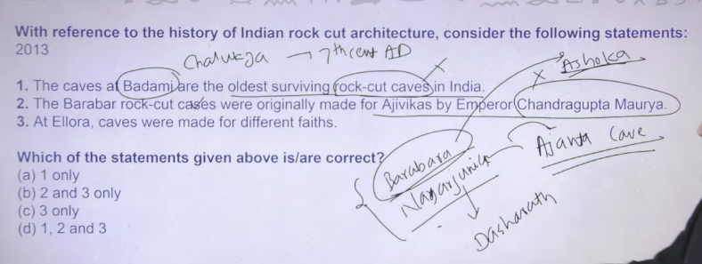
👉 Ellora Caves were made for different religions (faiths):
- 🕉️ Hinduism
- ☸️ Buddhism
- ✡️ Jainism
👉 Ellora Caves were built for multiple faiths—Hindu, Buddhist, and Jain. 👍

👉 Barabar Caves belong mainly to the Ajivika sect
- These caves were dedicated by Ashoka to the Ajivika sect
- Ajivikas were a religious sect similar to Buddhism and Jainism
👉 Barabar Caves were mainly associated with the Ajivika sect. 👍

First statemest is wrong becuaae ye jo badami chalku haiwo 7th centary Ad se hai jbke Ajanta cave rock cut arcitrher to pahle se he hai Ajanta se pahel ke cave hai barabara , nagarjuniyia both are considere as oldest one in bihar
Oldest rock cut cave agar india me koi hai to wo hai rock cut cave aur ye barabara cave ashoka ne bane the in order to give a donation to ajeeveka sect because ajjeeveka is the religion of his father bindusara bindusara ke manre ke baad ashoka ne cave bana kar adjevka ko donate kr de
And ashoka ke marne ke baad uske putra dashrath ne nagartjun cave bane aur usene bhe ikso ajeeveka sect ko de de
To both are the oldest rock cut cave in the country iske bad humee example milta hai Ajanta ka dashrath is the son and succuuer of ashoka

3 is correct because ellora me apko Buddhism ,janism and brahnimins teeno ke paintin agn teeno ke sculpture milenge
On the other hand agar aap Ajanta me dekhogee to cavee structure me Buddhist related painting he dekhne ko milenge
So this is the basic differenece between the
oldest surviviing rock cut archituecuter is
👉 Oldest surviving rock-cut architecture = Barabar Caves 👍
📖 One-line:
👉 The oldest surviving rock-cut architecture in India is the Barabar Caves (Mauryan period).
ellora and ajanta is not
Good question 👍 — but no, they are not the oldest.
📌 Correct understanding:
- 👉 Oldest rock-cut architecture = Barabar Caves (Mauryan period, 3rd century BCE)

📌 What about Ajanta & Ellora?
- Ajanta Caves → around 2nd century BCE to 6th century CE
- Ellora Caves → around 6th to 10th century CE
👉 So these are later developments, not the earliest.

📖 One-line for exam:
👉 Barabar Caves are the oldest rock-cut caves, while Ajanta and Ellora came later. 👍
barabara cave kisne banwal and locaiton kya the
📌 Barabar Caves – kisne banwaya aur location
👉 Kisne banwaya?
- Ashoka (Mauryan Samrat)
- Kuch caves uske bete Dasharatha Maurya ne bhi banwayi

👉 Location kya hai?
- Barabar Caves
- Near Gaya district, Bihar

📖 One-line:
👉 Barabar Caves were built by Ashoka and are located near Gaya in Bihar. 👍

The Barabar Caves, located in the Makhdumpur region of Jehanabad district in Bihar, India, are the oldest surviving rock-cut architecture, dating back to the 3rd century BCE (roughly 322–185 BCE) during the Mauryan Empire. These caves are carved out of granite, known for their polished interiors, and were primarily used by the Ajivika sect.
Key details regarding the Barabar Caves include:
- Significance: They represent the earliest examples of rock-cut architecture in India.
- Location: Situated in the twin hills of Barabar (four caves) and Nagarjuni (three caves).
- Origin: Most date to the reign of Emperor Ashoka and his grandson Dasharatha.
- Features: Famous for their highly polished granite surfaces, which create an echo effect, and for having intricate carvings like the Lomas Rishi cave entrance.
- Purpose: Served as monastic retreats for the Ajivika ascetics.
dedicated to one faith: Buddhism. The 30 rock-cut caves, built between the 2nd century BCE and the 6th century CE, served as monasteries and worship halls (chaityas) for Buddhist monks and nuns, featuring art focused entirely on the life of the Buddha and Jataka tales.
Facebook +4
Key details regarding the faith at Ajanta:
- Exclusively Buddhist: Unlike the nearby Ellora Caves (which feature Hindu, Buddhist, and Jain monuments), Ajanta is solely a Buddhist site.
- Two Phases/Traditions: The caves represent two distinct phases of Buddhist thought: the early Hinayana (Theravada) phase (using symbols like wheels/stupas) and the later Mahayana phase (introducing images of the Buddha).
- Purpose: These caves served as residential, educational, and meditative spaces for Buddhist monks.
Wikipedia +5
Note: While Ajanta is purely Buddhist, the Ellora Caves (located nearby) contain temples dedicated to three faiths (Hinduism, Buddhism, and Jainism

11 Ans: b
Ahoka ke pillar edict and rock edict dono he important hai
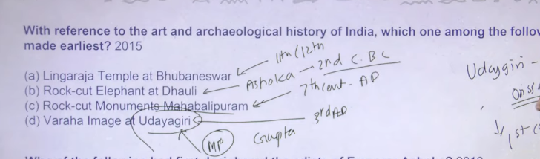
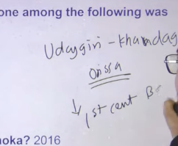

Based on the art and archaeological history of India, the Rock-cut Elephant at Dhauli (Odisha) was made earliest among common archaeological options, dating to the 3rd century BCE during the Mauryan period. Created under Ashoka, this sculpture represents the earliest Buddhist art in the region, pre-dating Gupta-era and Pallava-era monuments.
Earliest Archaeological Sites/Art (Chronological Order):
- Rock-cut Elephant at Dhauli (c. 3rd Century BCE): Mauryan-era, considered the earliest significant rock-cut sculpture on this list.
- Varaha Image at Udayagiri (c. 5th Century CE): Early Gupta period Hindu sculpture.
- Rock-cut Monuments at Mahabalipuram (c. 7th-8th Centuries CE): Pallava dynasty structural work.
- Lingaraja Temple at Bhubaneswar (c. 11th Century CE): Somavamsi dynasty.

👉 Monument = a building or structure of historical importance
📖 One-line:
👉 Monument = ऐतिहासिक इमारत / स्मारक 👍
nahi samjhe
Chalo aur simple bana dete hain 👇
👉 Monument = koi purani ya important imarat
🔍 Example:
- Taj Mahal
- Qutub Minar
👉 Ye sab monuments hain kyunki ye history se judi hui hain.
📖 Sabse simple:
👉 Monument = purani important building 👍

👉 “With reference to art and archaeological history of India” ka simple matlab:
👉 “India ki kala (art) aur puratatva (archaeology) ke context me”

🔍 Easy samajh:
- Art = paintings, sculptures, architecture (mandir, caves, etc.)
- Archaeological history = purane remains (jaise coins, tools, caves, inscriptions)

📖 One-line:
👉 Iska matlab hai ki question India ki kala aur purane avasheshon ke base par poocha gaya hai. 👍
archalegocial means short in hindi
👉 Archaeological (archaeological) ka short Hindi matlab:
👉 “पुरातात्विक”
📖 One-line:
👉 Archaeological = पुराने अवशेषों से जुड़ा हुआ 👍
like wahta example
Samajhne ke liye examples dekh lo 👇
📌 Archaeological (पुरातात्विक) examples:
- 🏺 Coins (sikke)
- 🏛️ Caves & monuments → jaise Ajanta Caves
- 🗿 Statues / sculptures (murtiyan)
- 🪨 Inscriptions (shilalekh)
- 🏺 Pottery (mitti ke bartan)

📖 One-line:
👉 Archaeological things = purane zamane ki vastuayen jo history batati hain. 👍

There are two udaygirei ek udaygiri madhyapradesh wala hai aur ek udyagirif khandgiri caves hai jo ke hai odhissa me
Varah image wala udaygirie hai varah means bore boore means shuaar type of the image to jo ye uadygirie wala image hai thapt belong to madhyapradesh wala udyagiri cave jo ke guptas ka madhyapradesh me jo udyagirif hai usme varah image hai aur wo guptas ka hai guptas time per 3rd cenatry ad ke around

On the other hand udaygiri khandagiri caves ye apke hai odhissa me ye wale belong krte hai 1 cenatry BC

C- mahabalipuram jo city hai usko basane ka kaam kisne kyia tha to wo kyia tha narshimavarman ne kyia tha after defeating chalukyas of badami this can be traced around 7th cenatry ad

b- dhauli rock cut cave pillar banya tha ashoka ne 2nd cenatry bc
a= 11-12th cenatry ad ke around

Ajanta Caves (29/30 Buddhist caves) were built roughly between the 2nd century BCE and 6th century CE by the Satavahana dynasty (early) and Vakataka dynasty (later), particularly under Harishena. Ellora Caves (34 Hindu, Buddhist, Jain caves) were built between 600 CE and 1000 CE by dynasties including the Rashtrakutas and Kalachuri.
Wikipedia +5
Key Details:
- Ajanta Caves: Located in Maharashtra, these caves are predominantly Buddhist monasteries (Viharas) and shrines (Chaityas) focused on paintings of Jataka tales and Buddha's life. Construction occurred in two phases: 2nd Century BCE - 1st Century CE (Satavahana), and 4th/5th Century CE - 6th Century CE (Vakataka/Gupta period).
- Ellora Caves: Also in Maharashtra, they represent Hindu, Buddhist, and Jain faiths. The famous Kailasa Temple (Cave 16) was built in the 8th century by the Rashtrakuta King Krishna I.
- Significance: Both sites are UNESCO World Heritage Sites, showcasing supreme rock-cut architecture in India

Based on Indian art and archaeological history, Ajanta Caves were created earlier than Ellora. The earliest caves at Ajanta (nos. 9 & 10) date back to the 2nd century B.C., while the oldest structures at Ellora date to around A.D. 600–1000, making Ajanta significantly earlier.

12
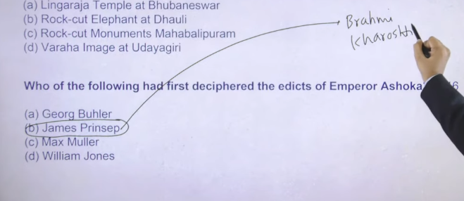

Because james principe was the responsible of deschiper of brahmi and kharoshid in 1838
Since he was the first person to dischiper the script to
Sabse pahle ye rock edict and pillar edict ko padne ka kaam kisne kyia to james prince ne

13

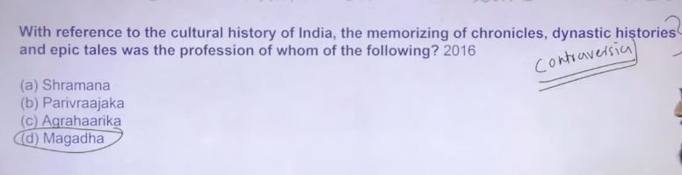
Ans: D
I would have marks shramans but this is not answer shrmanas jo hote the wo wanderer hote the to ye places to places jakarr ko chronology raat lete the then after tell this to their boss then after ye sab kise na kise buddhsit literature me reflect hota tha that controversy that hw kise region ka profession ho sakta hai but upsc ne answer me Magadha de kar rakha hai

Again controversial question agar apne kisi ka profesion pucha hao to wo kise bande ka ho skata hai kise region ka nahi

👉 “भारत के सांस्कृतिक इतिहास के संदर्भ में, इतिहास (chronicles), वंशों की कथाएँ (dynastic histories) और महाकाव्य कथाओं को याद रखना और सुनाना किसका पेशा था?”

📌 Iska matlab (simple me):
👉 Yeh question pooch raha hai ki
purane time me kaun log history, rajaon ki kahaniyan aur Mahabharat/Ramayan jaisi kahaniyan yaad rakhte aur sunate the?

📖 One-line:
👉 Yeh question un logon ke baare me hai jinka kaam kahaniyan aur itihaas yaad karke sunana tha. 👍
Agar chaho to iska answer bhi bata deta hoon 😉
✅ Correct Answer:
👉 Sutas / Magadhas (bards)
- Ye log kahaniyan, vansh ki history aur epics yaad rakhte aur sunate the

📖 One-line:
👉 Answer: Sutas/Magadhas (jo kahaniyan aur itihaas sunate the) 👍
sutas magadhas ye kay ahi
Chalo simple me samajhte hain 👇
📌 Sutas aur Magadhas kya hote the?
👉 Sutas aur Magadhas = aise log (bards) jinka kaam kahaniyan aur itihaas sunana hota tha

🔍 Unka kaam:
- Rajaon ki vansh (dynasty) ki history yaad rakhna
- Mahabharat / Ramayan jaisi kahaniyan sunana
- Raja ki prashansa (praise) karna
👉 Sutas/Magadhas = kahani sunane wale aur itihaas yaad rakhne wale log 👍
bards ek line me bato kya hai
👉 Bards = people who tell stories, history, and poems orally
📖 One-line (easy):
👉 Bards = kahani aur itihaas sunane wale log 👍
magadh and magadhas me kya antar fhai
Good question 👍 — dono similar lagte hain par alag hain:

📌 1. Magadh
👉 Magadh = ek jagah / rajya (kingdom)
- Ancient India ka powerful kingdom tha

📌 2. Magadhas
👉 Magadhas = log (people / bards)
- Jo kahani, history aur raja ki prashansa karte the

🔑 Main difference:
👉 Magadh = place (rajya)
👉 Magadhas = log (kahani sunane wale)

📖 One-line:
👉 Magadh ek kingdom hai, jabki Magadhas kahani sunane wale log hote hain. 👍
epic tales means
👉 Epic tales = long traditional stories about heroes and great events
📖 Easy Hindi:
👉 Epic tales = महाकाव्य की कहानियाँ
(jaisi Ramayan aur Mahabharat)

📌 One-line:
👉 Epic tales = bade veeron aur important ghatnaon ki kahaniyan 👍
👉 Chronicles = historical records of events
📖 One-line (Hindi):
👉 Chronicles = इतिहास का रिकॉर्ड / घटनाओं का लेखा-जोखा 👍

14
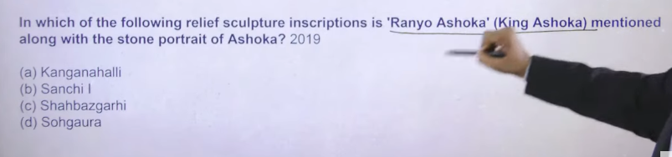
Ans: a
Because jo north idnia ke inscription hai usme ashoka ka naam nahi milta hai
Remaining three are norhten sinscription hai to bachata ke he hai sourht inda ka kanganhalli
To kanganahlili will bhe the answer

15
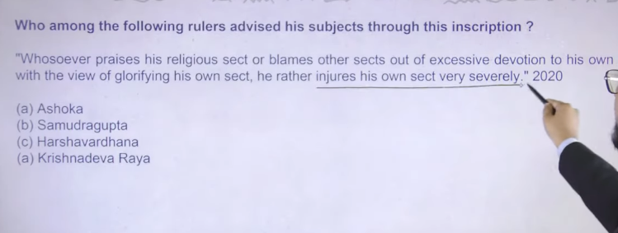his won sect with the view of
Ans: A
Ashoka ke inscription me apko paternalistic attitude dekhne ko milega ke people of different faith and different religion werer there to ashoka ne indirect thretat de the ki apko kay nahi karna hai
To ashoka ne bola ke aagar apko aisa lagta hai ke app apne setct ko glorify karoge aur dusre ke sect ko galyia daloge to isse kya hoga apke he sect ko sabse jayda harm pauchega aisa apko nahi karna hai that’s why the ultimate answer overhere is

📌 Hindi Meaning:
👉 “Jo bhi vyakti apne dharm ki tarif karta hai aur dusre dharmon ki burai karta hai, sirf apne dharm ko bada dikhane ke liye, wo actually apne hi dharm ko nuksan pahunchata hai.”

🔍 Easy samajh:
- Apne religion ko zyada support karna 👍
- Dusre religion ko bura bolna ❌
👉 Aisa karne se:
- Log respect nahi karte
- Jhagde badhte hain
- Aur apna hi dharm badnaam hota hai

📖 One-line:
👉 Dusre dharmon ki burai karke apne dharm ko bada dikhana galat hai—isse apne hi dharm ko nuksan hota hai. 👍
whosoever means
👉 Whosoever = jo bhi / koi bhi vyakti
📖 One-line:
👉 Whosoever = jo bhi insaan 👍
whosoever praise his religious sect or blames other sects out of excessive devotion to his own with the view of glorifying his own sects he rather injuries his own sect very severely kya matlab hai iska tukdo me karke each line ka matlba bato
Chalo is sentence ko tukdo me tod ke samajhte hain 👇

📌 1. Whosoever praise his religious sect
👉 Jo bhi apne dharm ki tarif karta hai

📌 2. or blames other sects
👉 ya dusre dharmon ki burai karta hai

📌 3. out of excessive devotion to his own
👉 sirf apne dharm ke zyada lagav (bhakti) ki wajah se

📌 4. with the view of glorifying his own sect
👉 apne dharm ko bada / mahaan dikhane ke liye

📌 5. he rather injures his own sect very severely
👉 wo asal me apne hi dharm ko bahut nuksan pahunchata hai

📖 Final simple meaning:
👉 Jo insaan apne dharm ko bada dikhane ke liye dusre dharmon ki burai karta hai, wo apne hi dharm ko nuksan karta hai. 👍

16
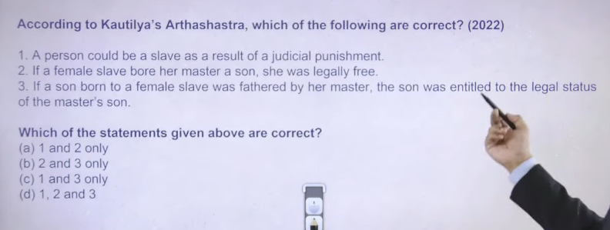

Ans: b

Slave and slavery wala jo concept hai throughout ancient midiveal india ye koi birth se related concept nahi tha salve koi bhe ho skata hai ameer bhe ho skta hai gareeb bhe ho skta hai judicial punishment se bhe ho skta hai ya loss of property se bhee ho skta hai to slave is something that is not related to birth to chankya ne yahe batya ke via judicial punishment a person can became slave

Agar apk exploint krke bacha nikal rahe ho to female slave is free is correct
In that socity slave system is not too much harsh
Then agar beta ko apne paas rakhna hai to beta have status of beta only not slave

Parrution is celibritya thing in jainsim that aperon is die by fast is paar bahut bade controversy bhe hue the ek bacceh ne parution karke khud ko mar lyia tha there after death is celibriated by mother and fateher
Ye parution jo hai salekhna hai iska earliest refrence ya instance humko chandrgupta maurya se mila hua hai
Fast until you die one fast se koi nahi marta hai you have carry out fast till death

Paithan wala area jiska pahle naam prathesthan tha in midividial india the capital was shifted toward a bit north to aurangabaad became the center in maharasta ek jamane me aurangabaad ka nam daulatabaad tha yye queist famous area hai earliest capital hua karta tha satvahana ka in medival india yadav rulers were there and uske baad to saltanat ke hath he lag gaee pure ke pure capital ultimately aurengzed died in Aurangabad

Check santhara and parution
Ajeeveka fatalist hai fatalist means pure duniya chod do niyate me jo likha hai wahe milega karm mat karo
Inka maanan tha jo destiny melikha hai wo milega he founder is makkhali gosala makkhali gosalal was the contemporary of gautam Buddha makhali goosalaihas also the good relaitn with ajatsatru

Q17. What are the 7 dynasties of Magadha?-

Ans. The seven dynasties are Brihadratha, Pradyota, Haryanka, Shaishunaga (Sisunaga), Nanda, Maurya, and Shunga
The primary seven dynasties that ruled the ancient Indian kingdom of Magadha, in chronological order, were the Brihadratha, Pradyota, Haryanka, Shaishunaga (or Sisunaga), Nanda, Maurya, and Shunga dynasties. These dynasties oversaw the rise of Magadha from a regional power to the center of a vast empire, spanning from the pre-Buddhist era through the rise of major empires.
- Brihadratha Dynasty: The earliest dynasty, founded by Brihadratha, with Jarasandha as a key figure.
- Pradyota Dynasty: Ruled after the Brihadrathas, noted in Puranic traditions.
- Haryanka Dynasty: Founded by Bimbisara, who expanded the kingdom significantly, followed by Ajatashatru and Udayin.
- Shaishunaga Dynasty: Founded by Sisunaga, who defeated the Avanti kingdom and stabilized the region.
- Nanda Dynasty: Founded by Mahapadma Nanda, this dynasty is known for its massive military strength and great wealth.
- Maurya Dynasty: Founded by Chandragupta Maurya after defeating the Nandas, it brought much of India under one rule.
- Shunga Dynasty: Founded by Pushyamitra Shunga after the end of the Mauryan empire.
Following the Shungas, subsequent dynasties like the Kanvas, Kushanas, and Guptas also held power in the region, but these seven constitute the core sequential dynasties of the early Magadhan empire

